Screenshot Library

Table of Contents

Logging In/Welcome Screen 5

Main Window (sysadmin) 6

Creating an Assessment for an Unscheduled Visit 6

Create Assessment(s) for Appointment(s) 11

Top-to-Bottom Assessment (Veteran Experience) 14

eScreening Welcome Screen (customizable) 15

Acceptance and Action Questionnaire-II 15

Adult Attachment Questionnaire 16

Advance Directive 17

Adverse Childhood Questionnaire 17

AUDIT 18

AUDIT-C 18

AV Hallucinations 18

Bam-R 20

Barriers to Care Questionnaire 21

Basic Demographics 22

Basic Pain 22

BMI Over 24 23

Body Pain Map 23

Brief COPE Inventory 27

BTBIS 28

Caffeine Use 28

CD-RISC-10 29

Common Psychotropic Medications 29

Contact 30

DAST-10 30

DERS 31

Deployment Risk and Resiliency Inventory 34

Eating Attitudes Test 45

Education, Income, & Employment 47

Emotional Reactivity Scale 47

Epworth Sleepiness Scale 49

eScreening Quality Assessment 50

Exposures 51

Five Facet Mindfulness Questionnaire 52

GAD-7 Anxiety 54

Goals 54

Homelessness Clinical Reminder 54

Identification 54

International Physical Activity Questionnaire 55

ISI 55

MDQ 57

Medical History 58

Medications 61

Military Deployments & History 61

MST 62

Needs Vesting Exam 62

NURS PACT NARRATIVE 63

OEF/OIF Clinical Reminder 64

OOO Infect & Imbedded Fragment Clinical Reminder 64

Opiate Risk tool 65

Other Health Symptoms 66

PC-PTSD 67

PCL-5 (weekly) 67

PCL – 5 Modified 21 Item Version 67

PCL-C 69

PHQ Anxiety 70

PHQ-15 71

PHQ-9 72

Pain Assessment Guide 73

Pain Chart 74

Pain Medications 77

Past Social History 79

Pragmatic Concerns 79

Premenstrual Symptoms Screening Tool 80

Presenting Mental Health Issues 81

Presenting Problems 82

Prior Hospitalizations and Meds 83

Prior MH Treatment 83

PROMIS Emotional Support 84

PROMIS Pain Intensity & Interference 84

PSAS 85

ROAS 87

Service History 87

Service Injuries 88

SF McGill Questionnaire 89

Surgical History 93

Social Environment 94

Spiritual Health 94

Stressors and Distressing Symptoms 95

Therapeutic History 95

Tobacco Cessation Screen 95

Trauma-Related Guilt Inventory 96

Veterans RAND-12 98

VR-12 99

WHODAS 2.0 101

WHOQOL-BREF 104

Completion Screen (Customizable) 108

Users Page 109

Edit User Page 109

Editors Page 110

Manage Batteries 110

Manage Modules 112

New Module 112

Edit Existing Modules 112

Question Types 113

Manage Formulas 120

Manage Templates 120

Manage Sections 122

Manage Rules 123

Dashboard 124

List View 124

Charts View 124

Assessment Summary Page 125

Veteran Summary Printout (customizable) 125

Review Assessment Preview 126

Health Factor Titles 133

Save to VistA 134

Assessment Search Page 135

Veteran Search Page 135

Export Data Page 136

Export Identified Data Prompt 136

Data Dictionary in Excel 137

Data Export in Excel 137

Programs 137

Add New/Edit Program 137

Reports 138

Individual Statistic Report 138

Average Scores for Veterans by Clinic Report 140

Most Common Types of Alerts and Percentages Report 142

Positive Screens Report 143

Top 20 Most Skipped Questions Report 144

eScreening Batteries Report 145

Demographics Report 146

Average Time Per Module Report 148

System Configuration 149

My Account 150

CPRS 150

Generated Note 150

Clinical Reminders 151

TBI Consult 151

# Logging In/Welcome Screen

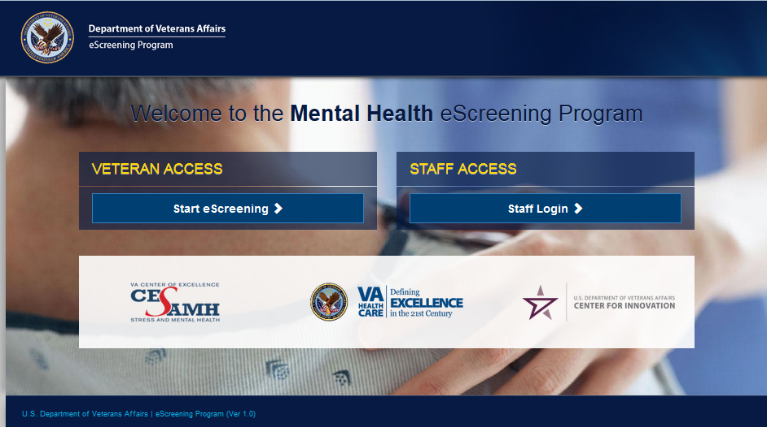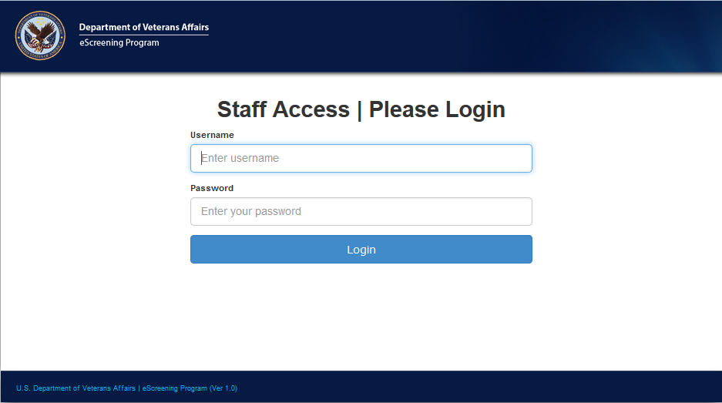

# Main Window (sysadmin)



# Creating an Assessment for an Unscheduled Visit

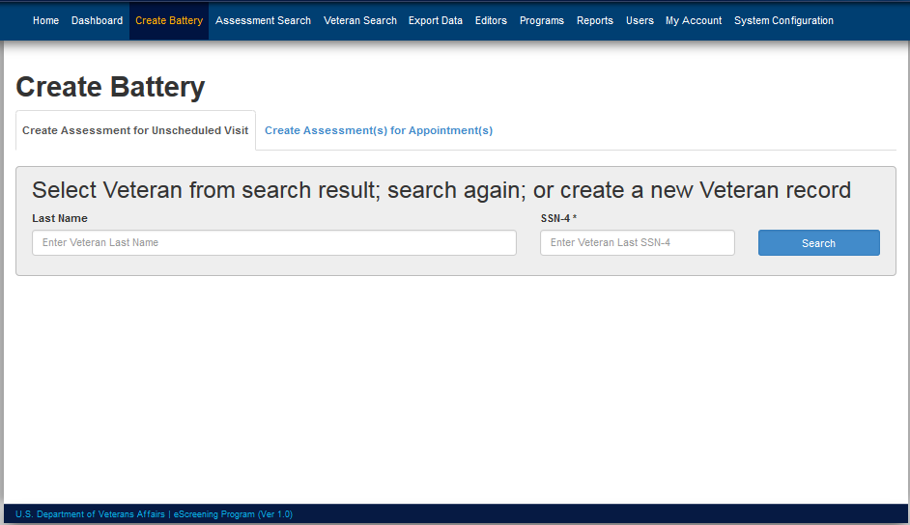

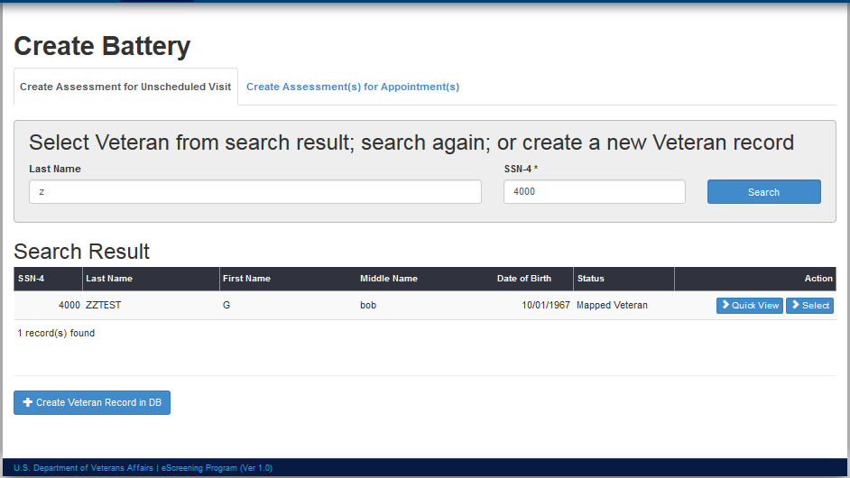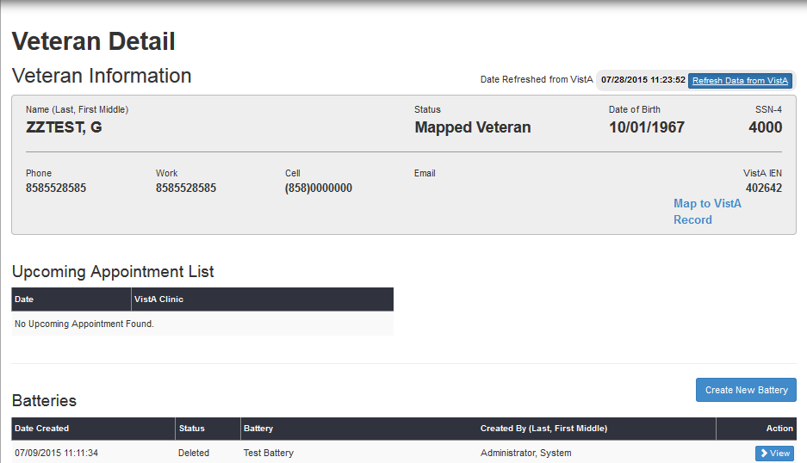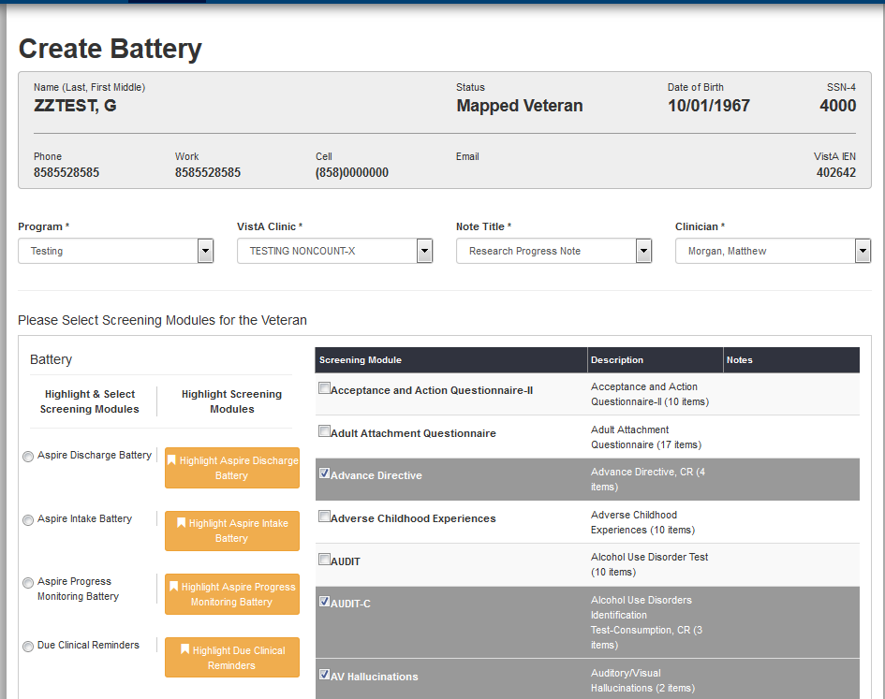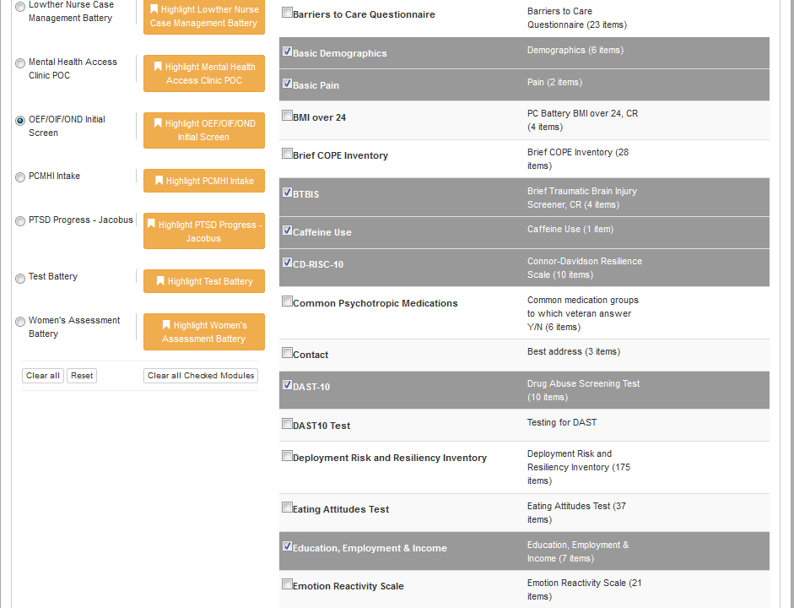

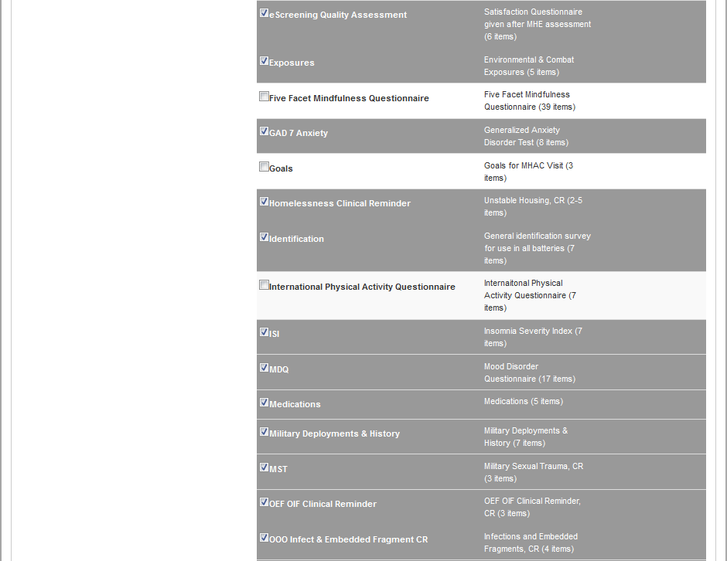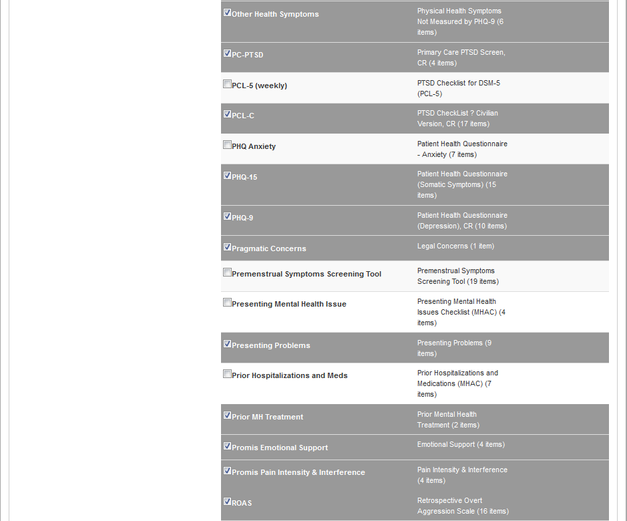

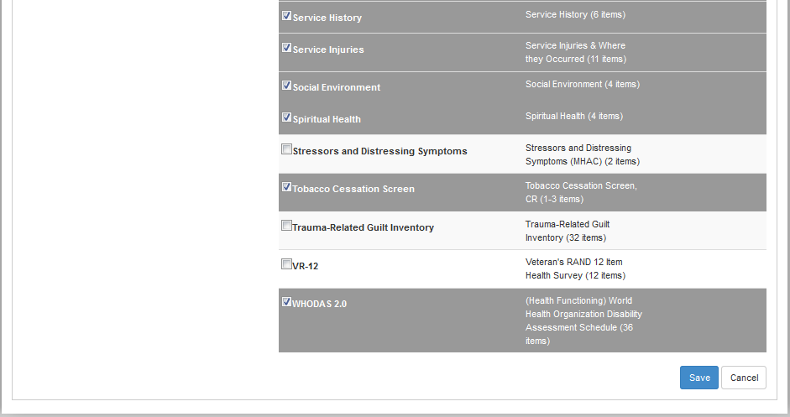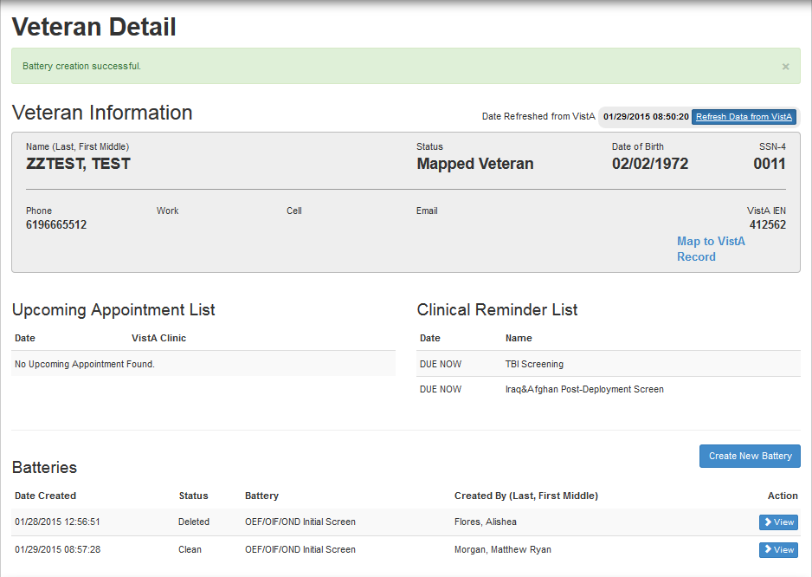

# Create Assessment(s) for Appointment(s)

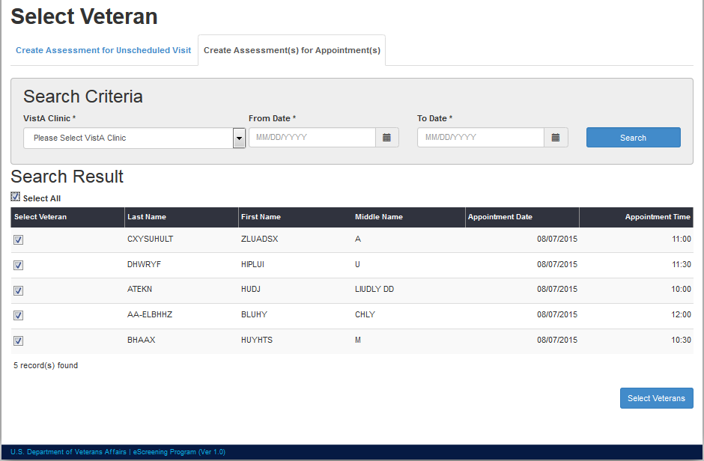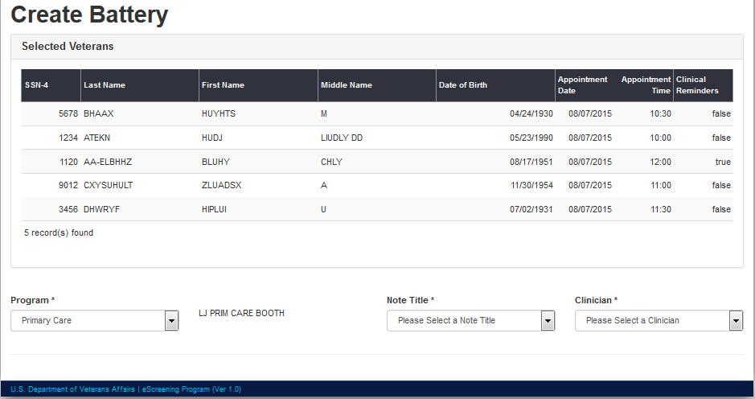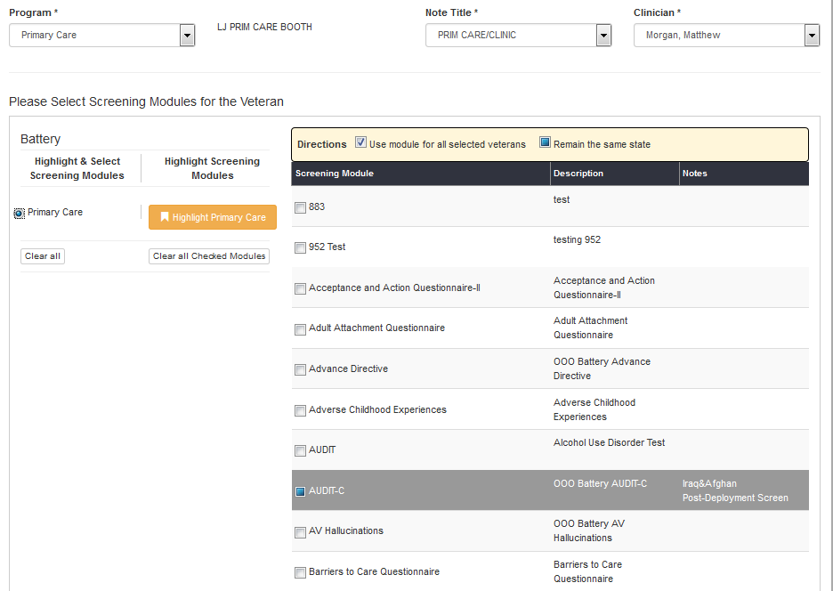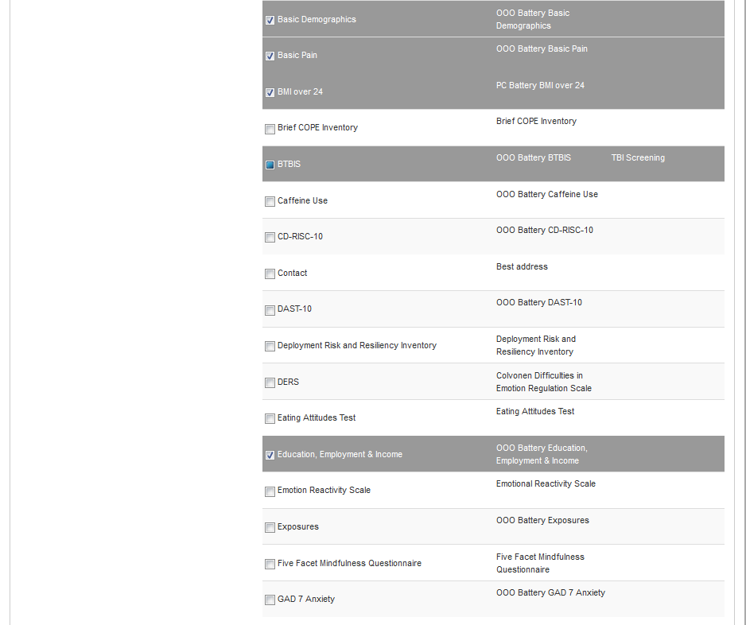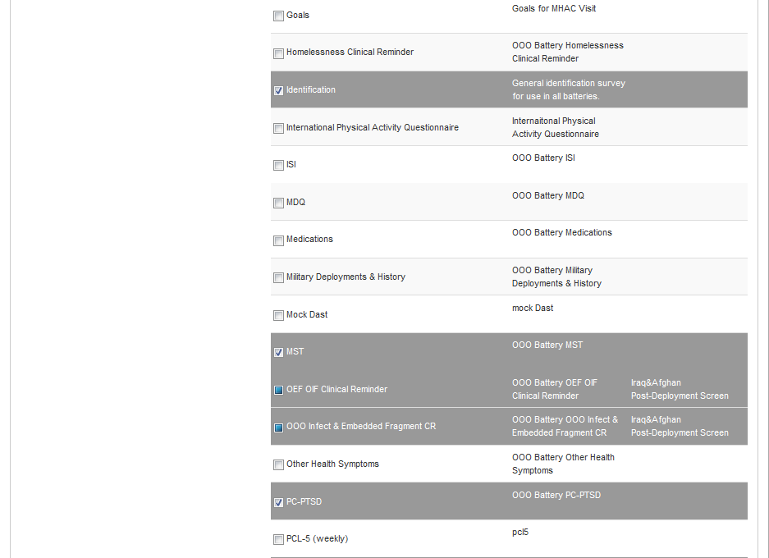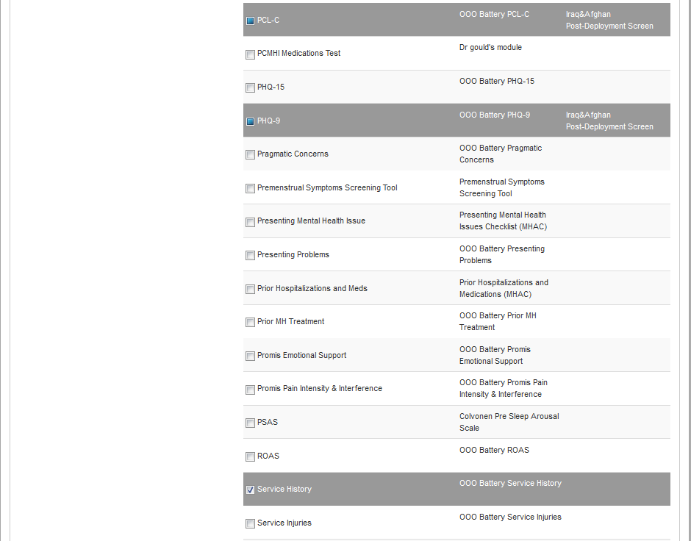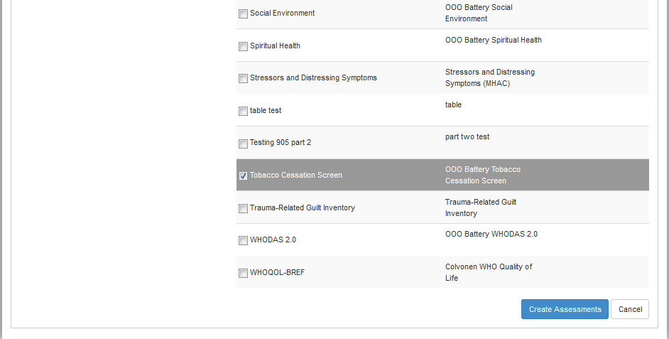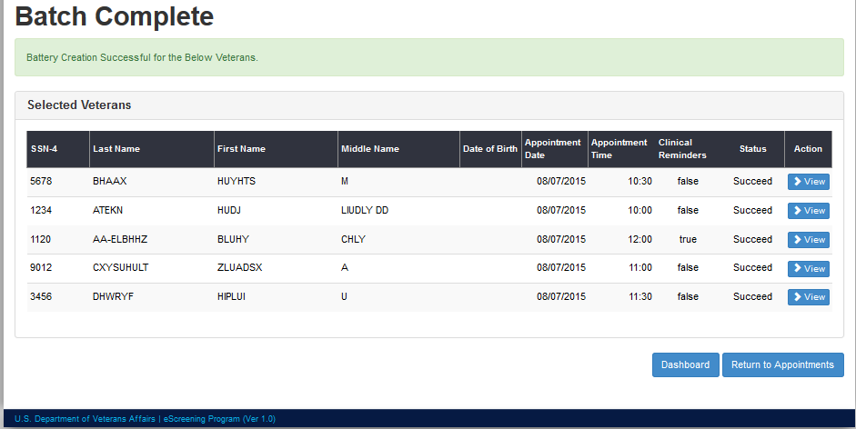

# Top-to-Bottom Assessment (Veteran Experience)

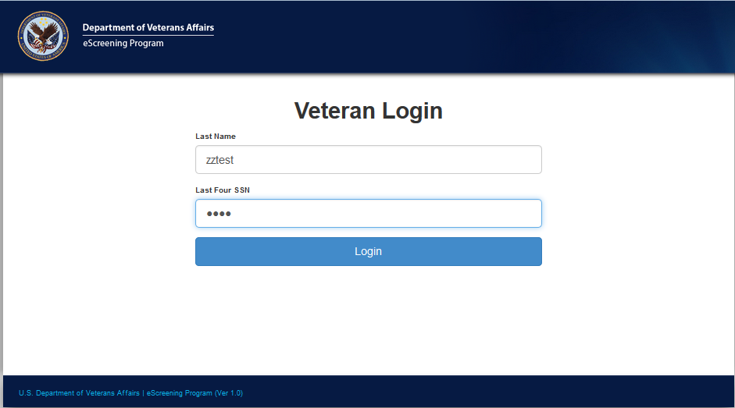

## eScreening Welcome Screen (customizable)



## Acceptance and Action Questionnaire-II

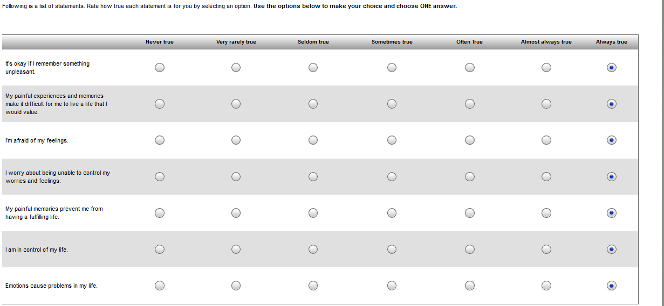 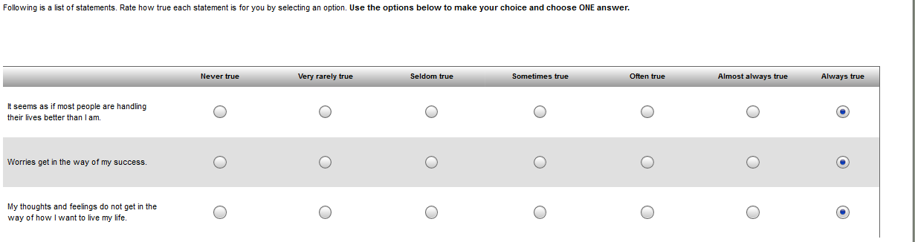

## Adult Attachment Questionnaire

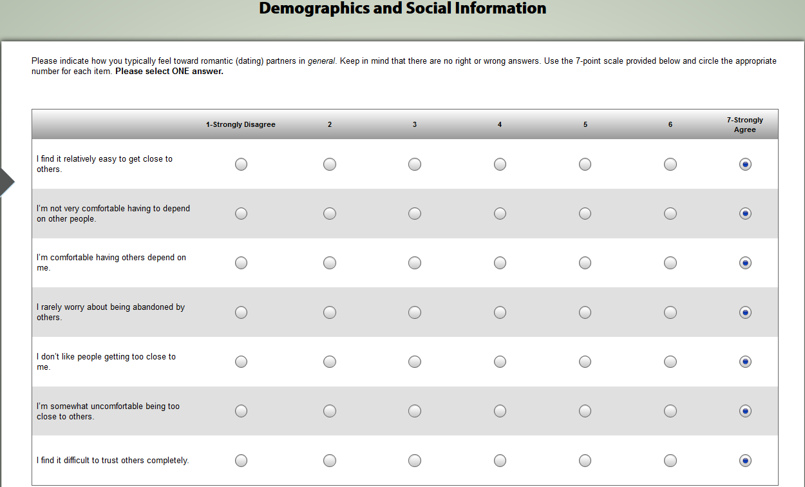

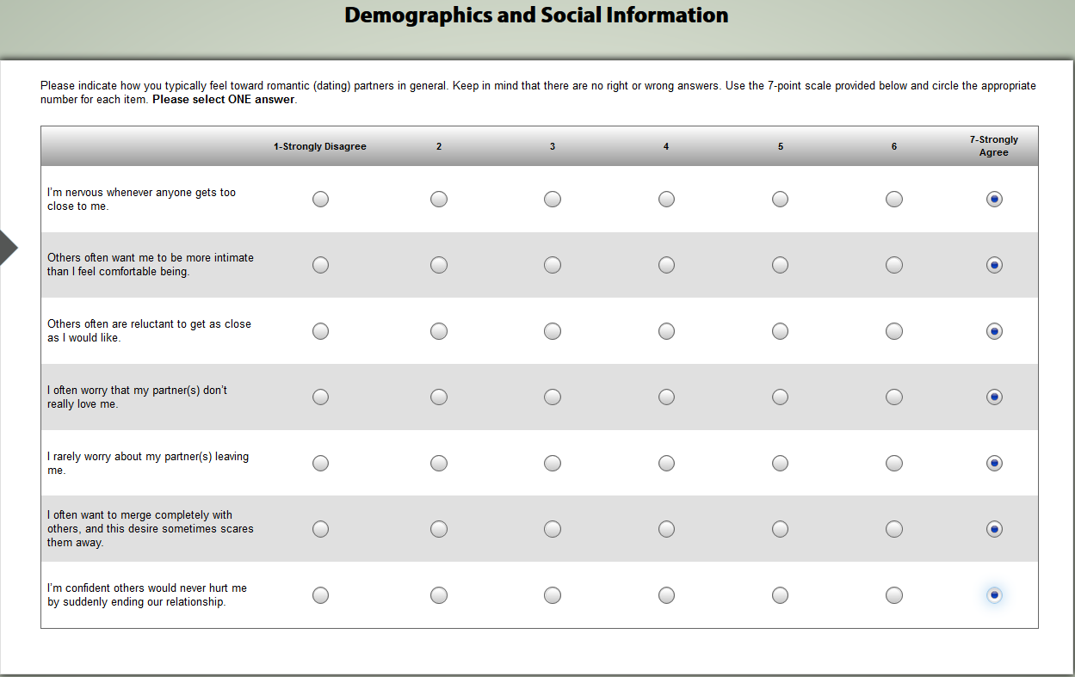

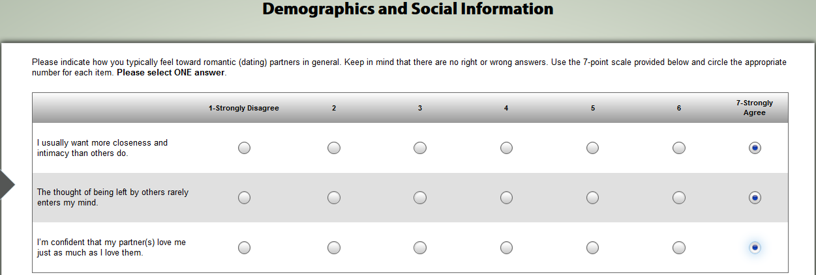

## Advance Directive

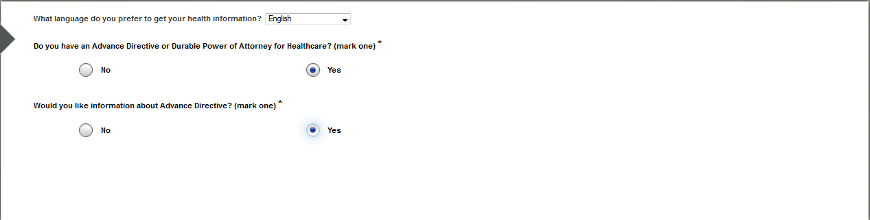

## Adverse Childhood Questionnaire

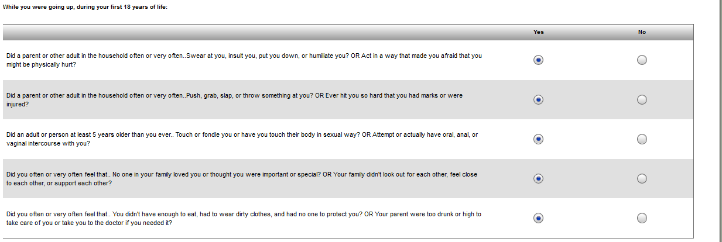

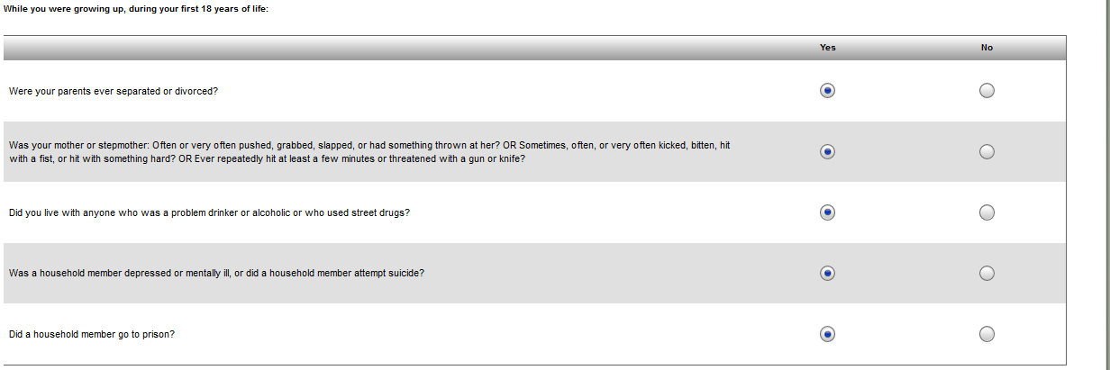

## AUDIT

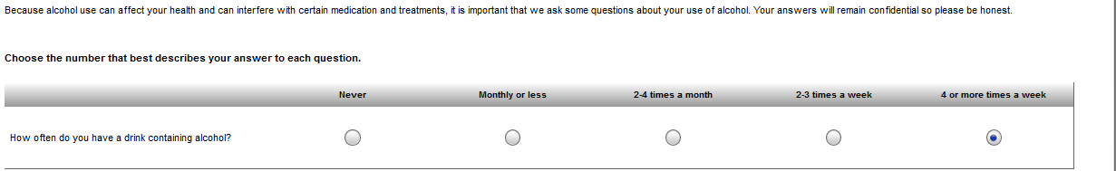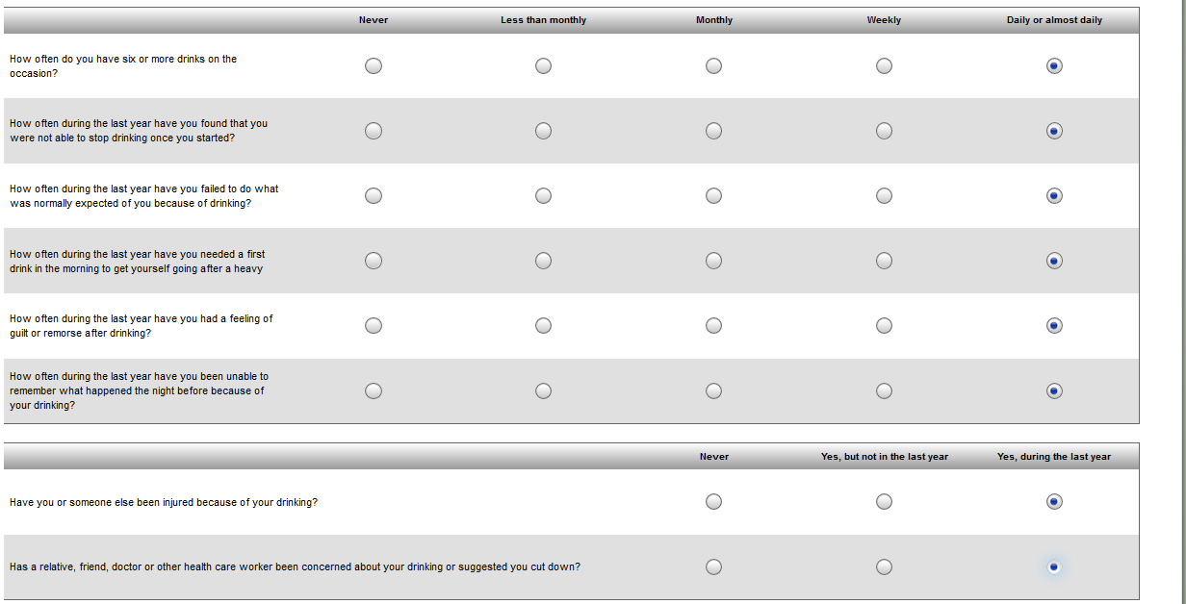

## AUDIT-C

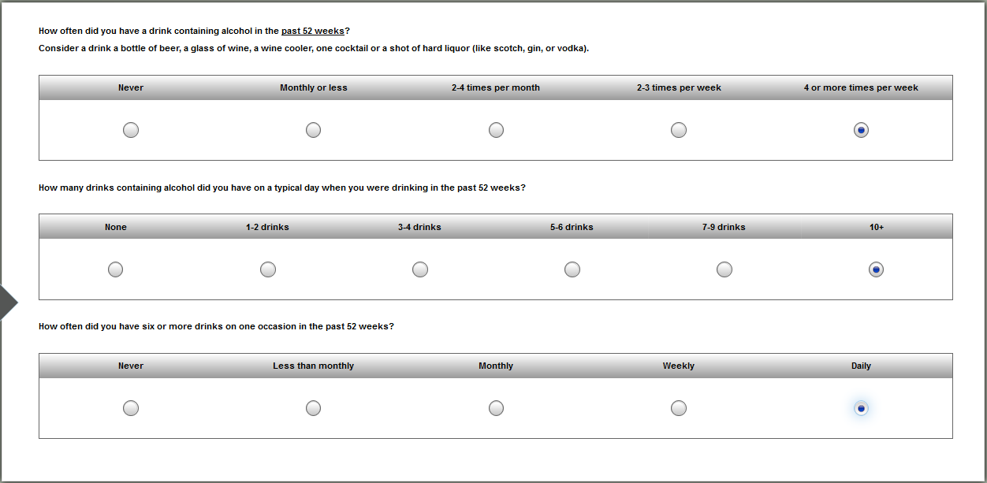

## AV Hallucinations

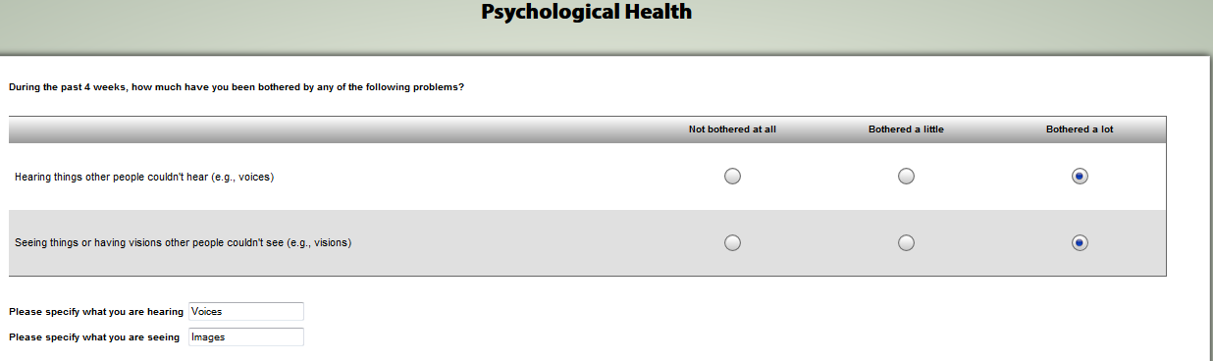

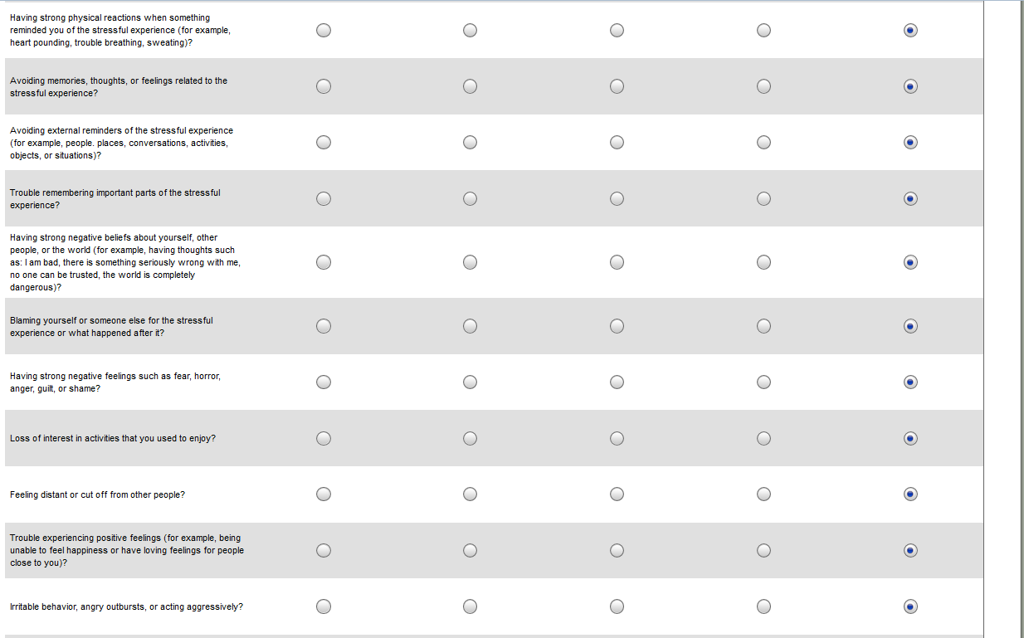 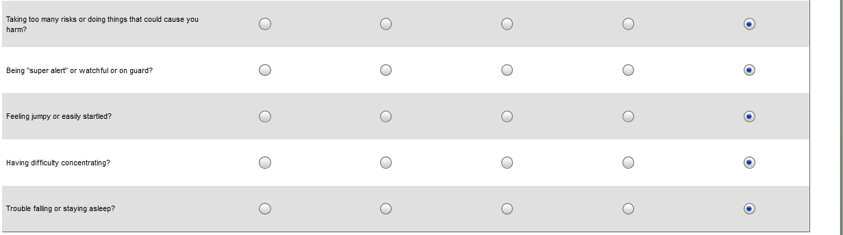

## Bam-R

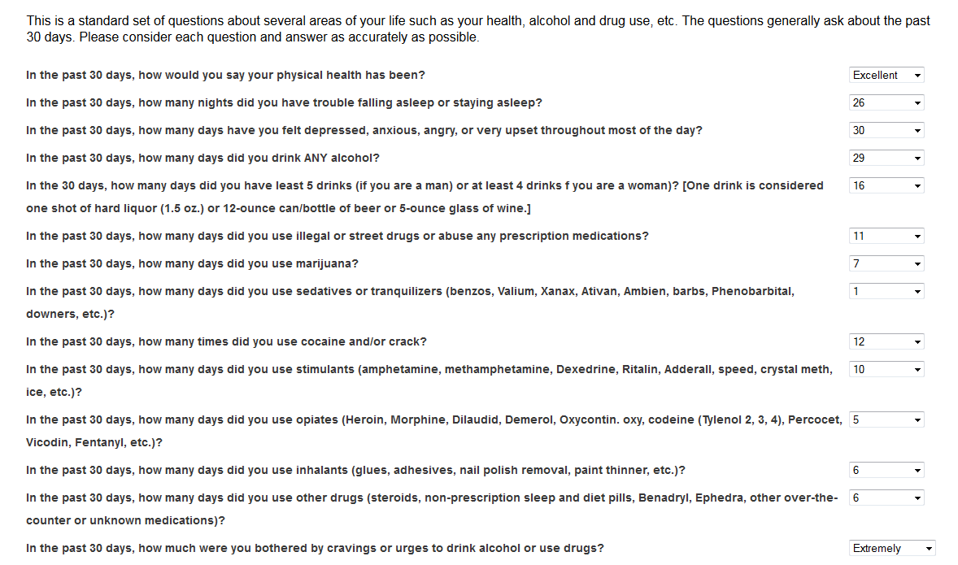 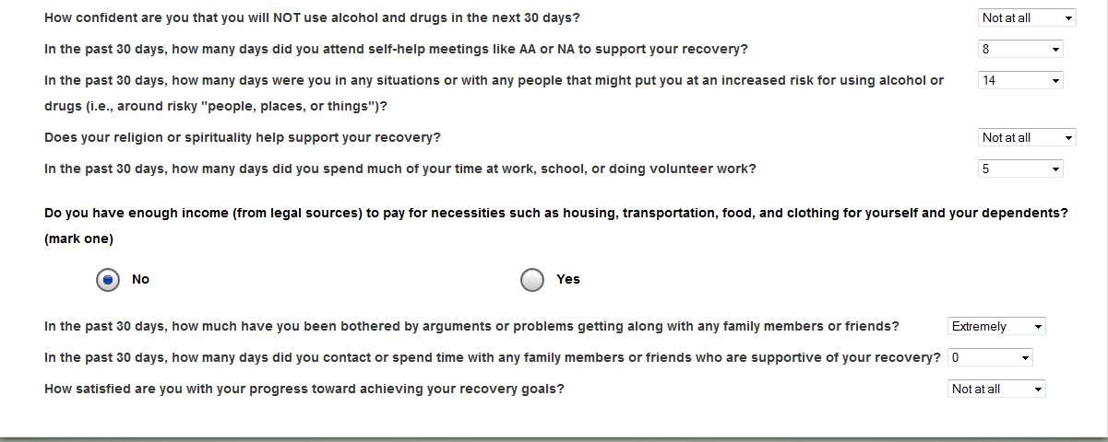

## Barriers to Care Questionnaire

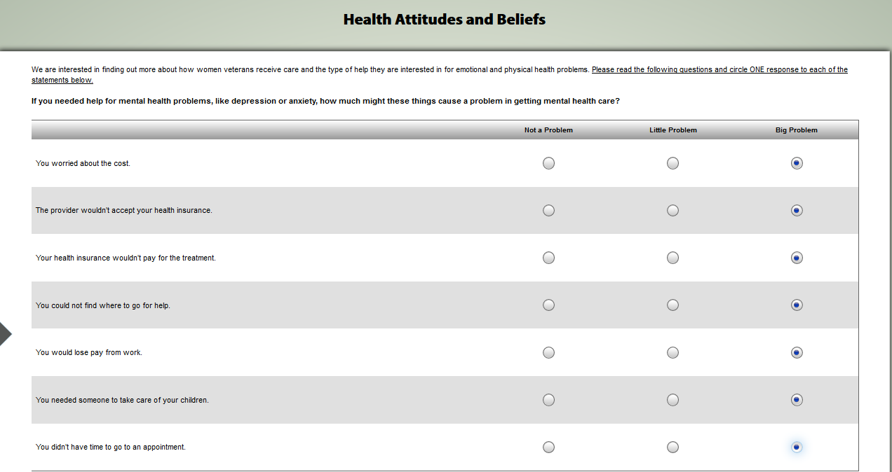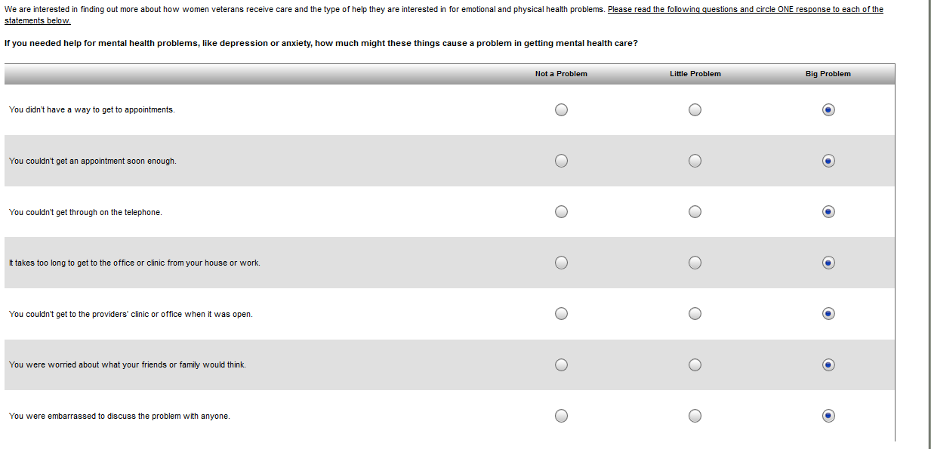

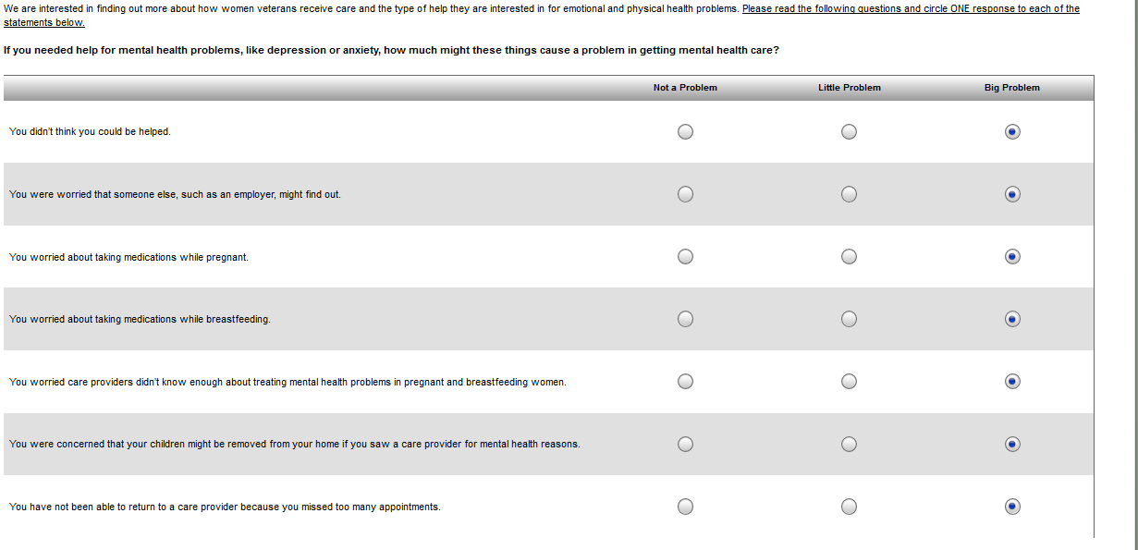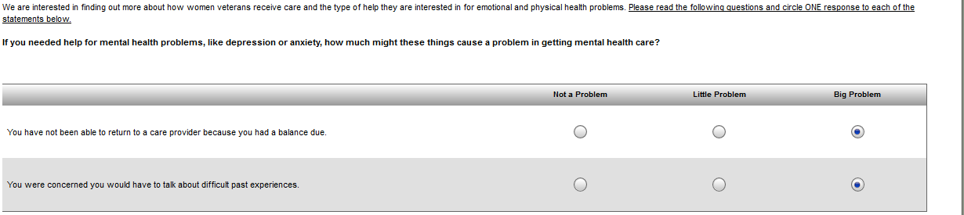

## Basic Demographics

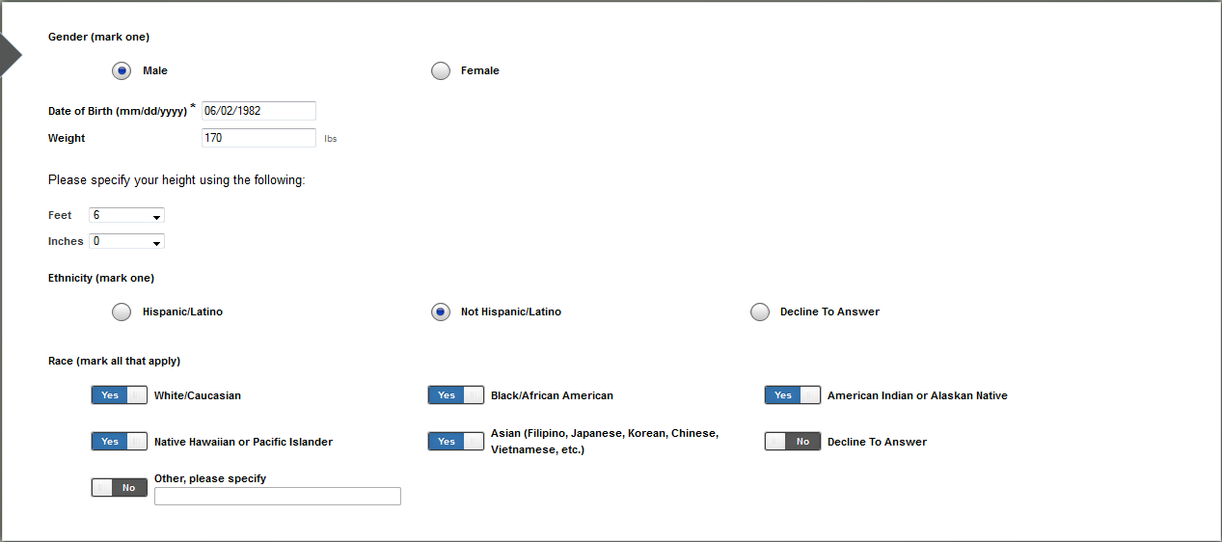

## Basic Pain

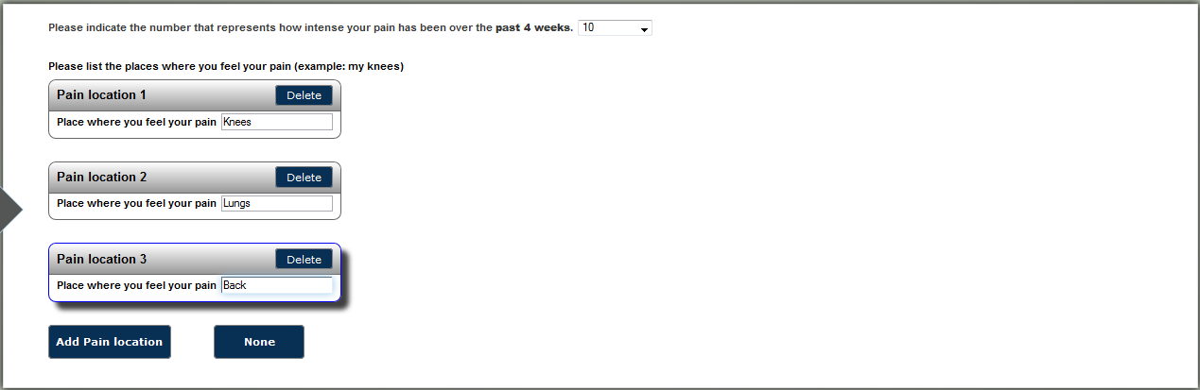

## BMI Over 24

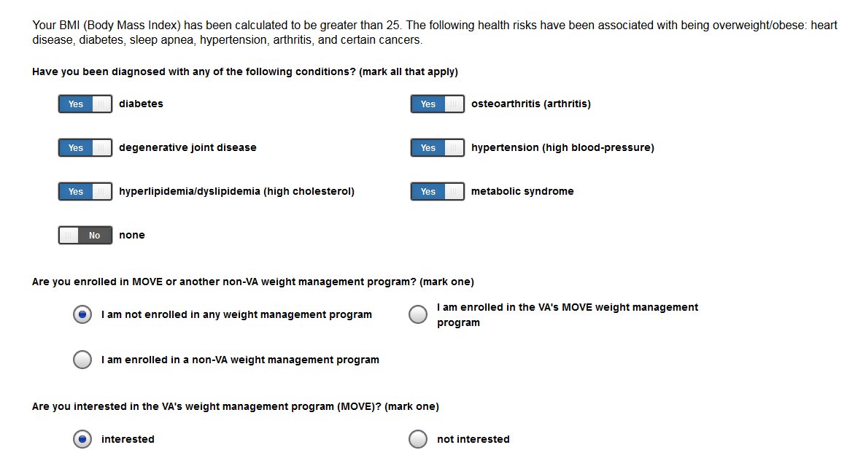

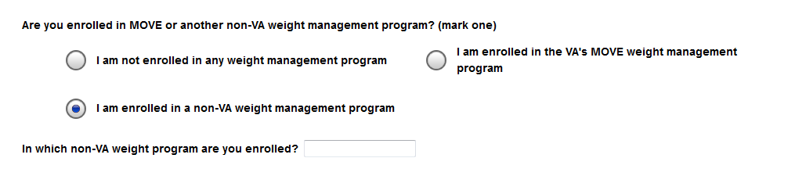

## Body Pain Map

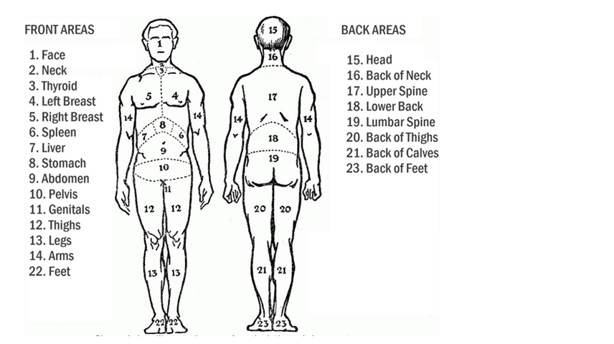

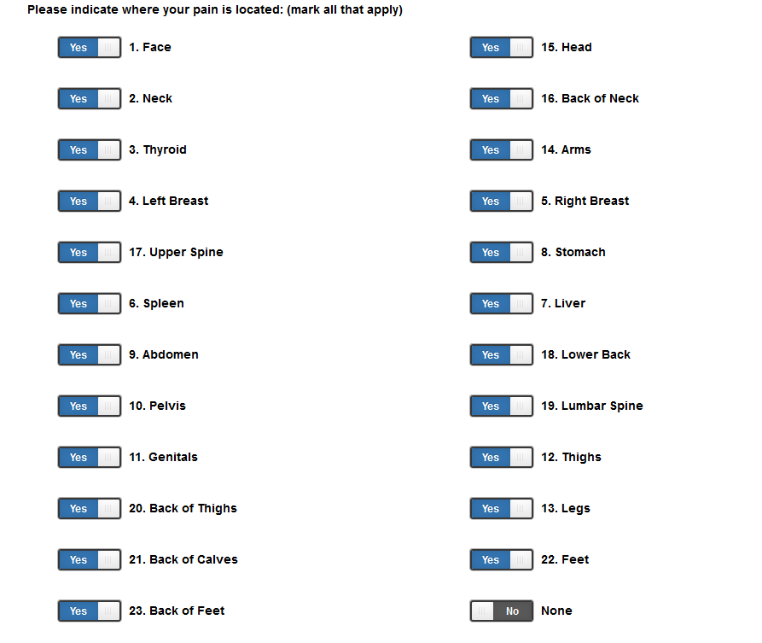

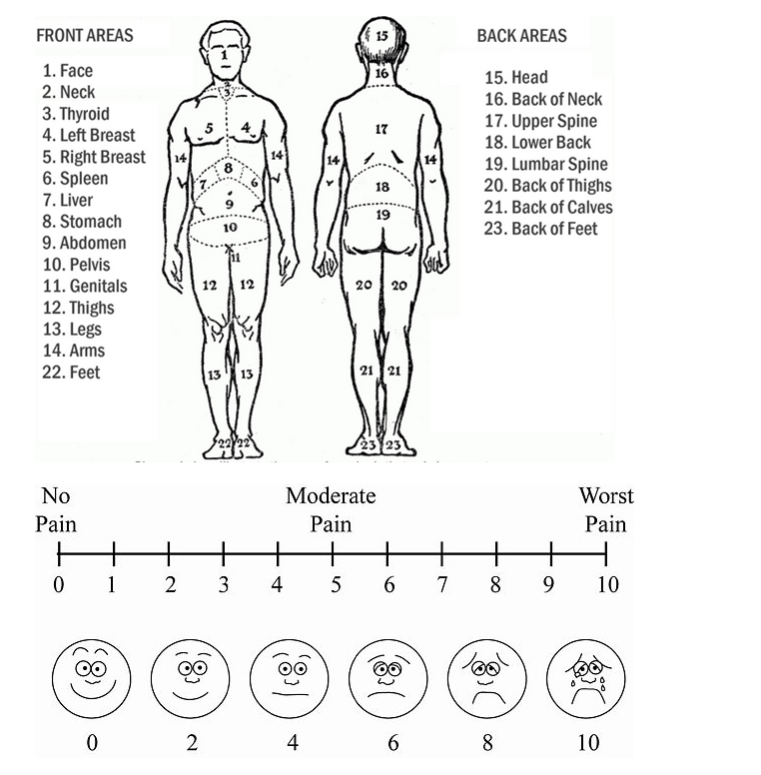 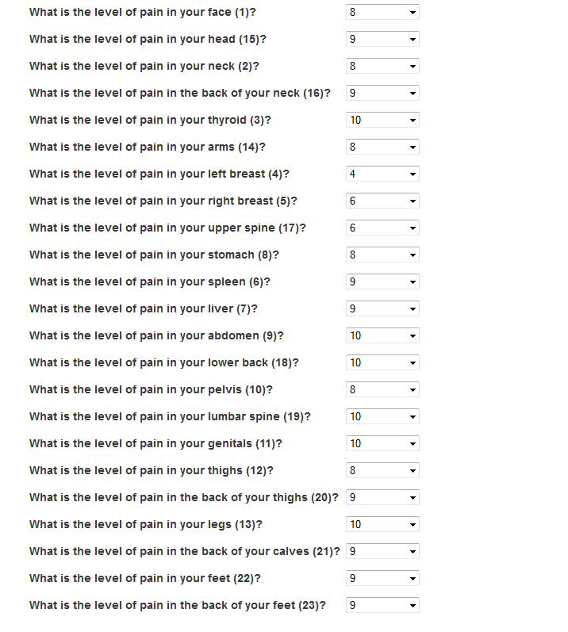

## Brief COPE Inventory

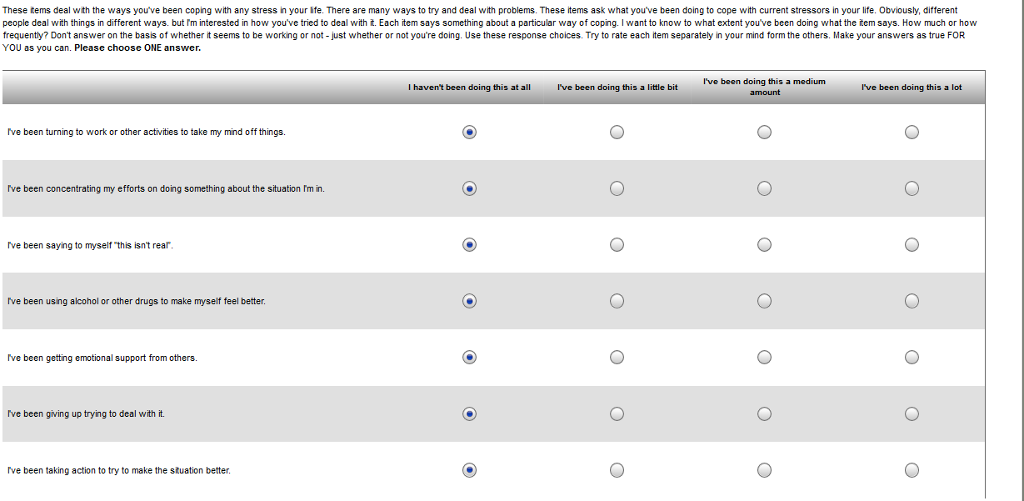 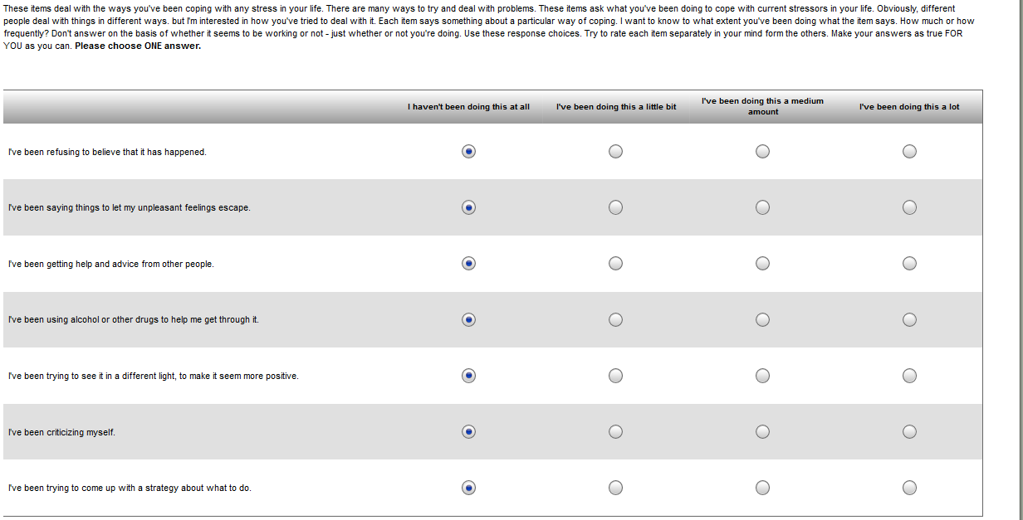 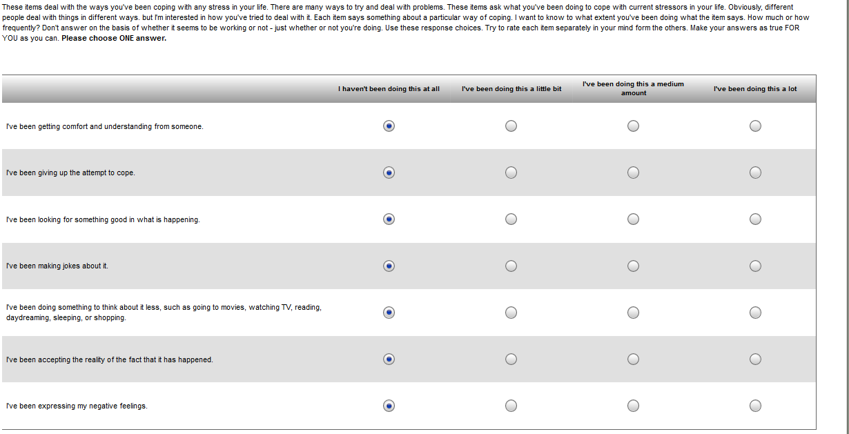

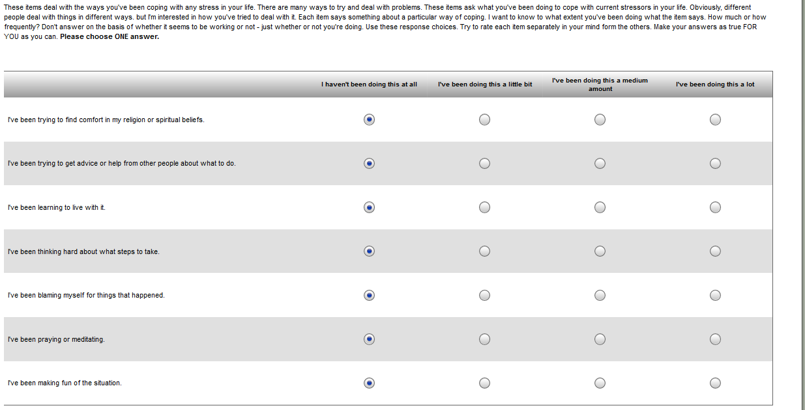

## BTBIS

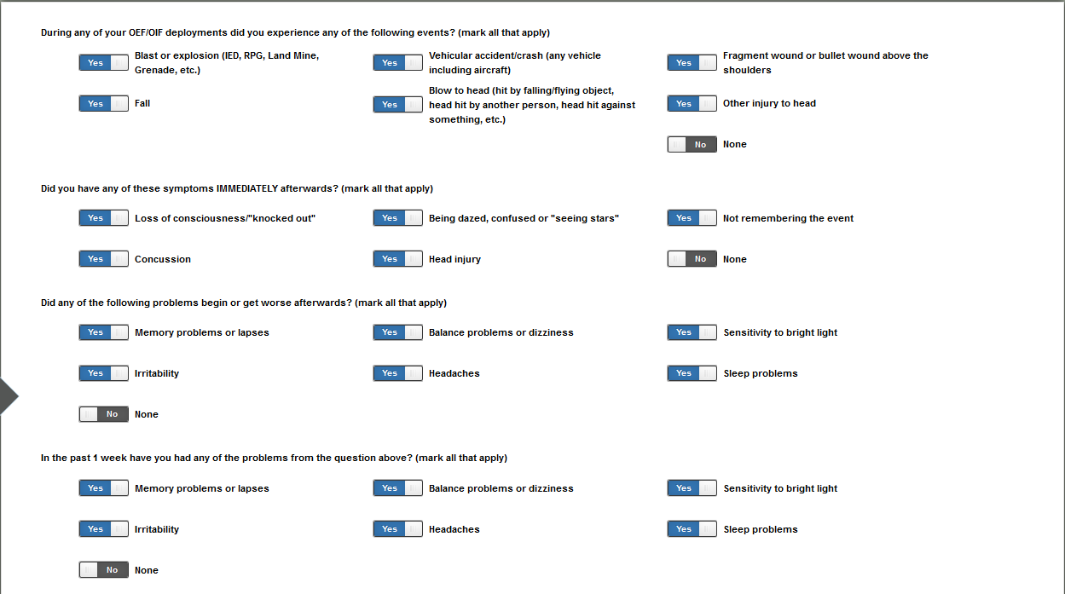

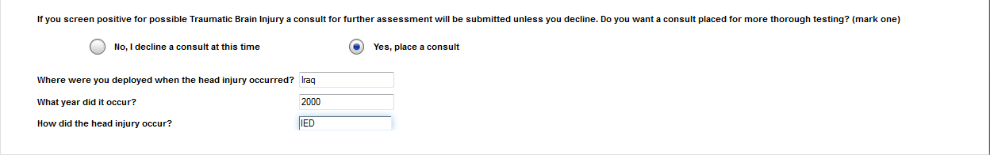

## Caffeine Use

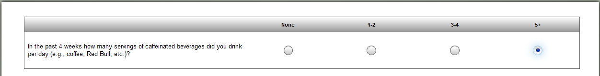

## CD-RISC-10

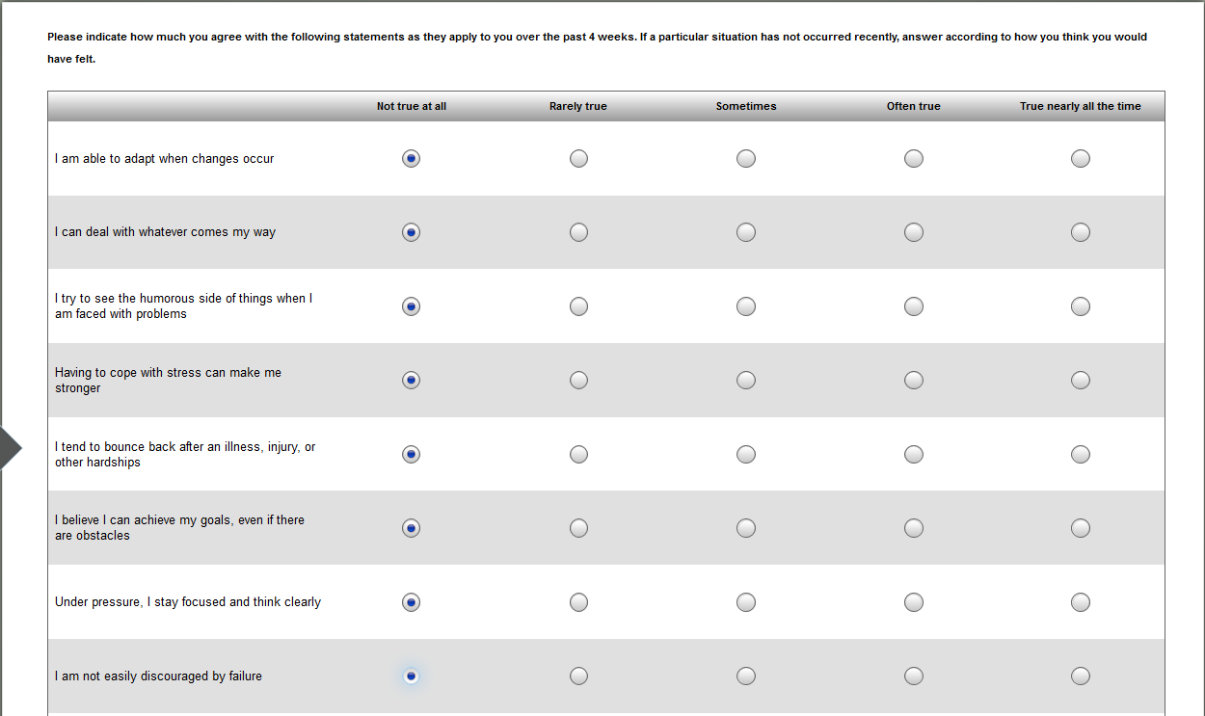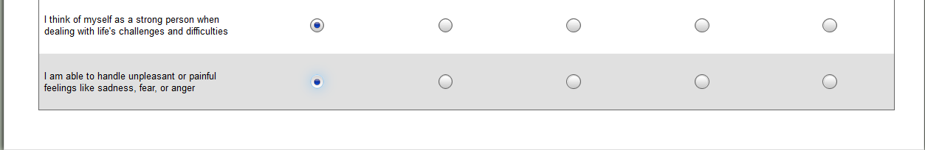

## Common Psychotropic Medications

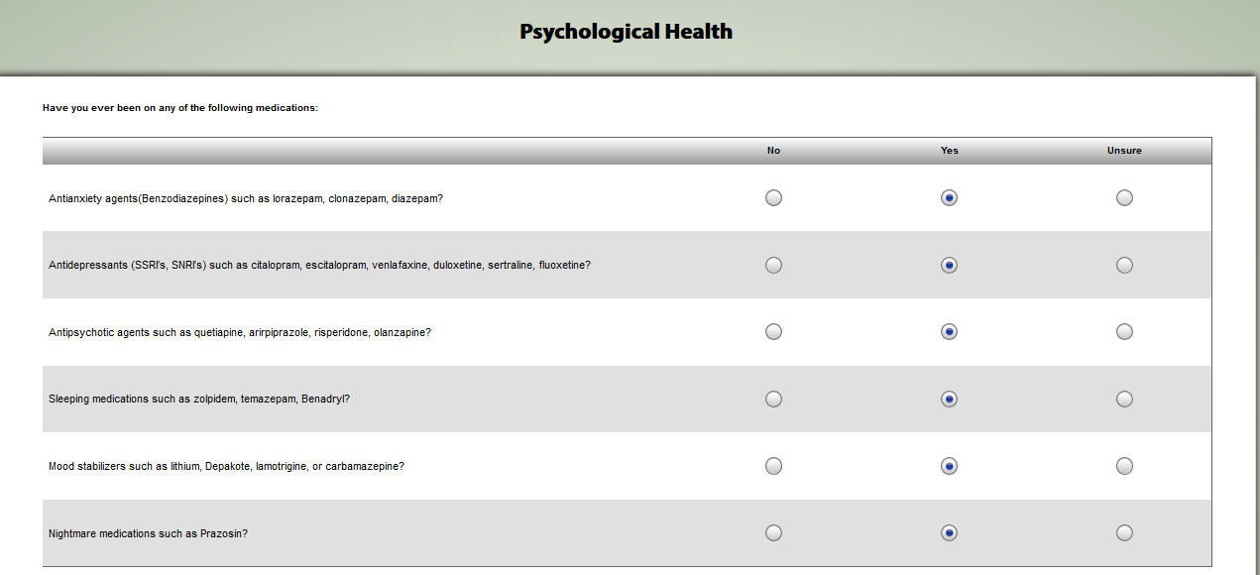

## Contact

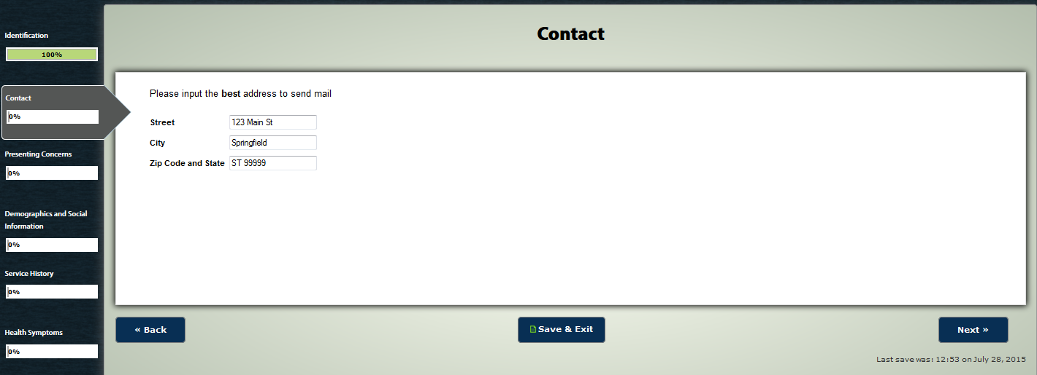

## DAST-10

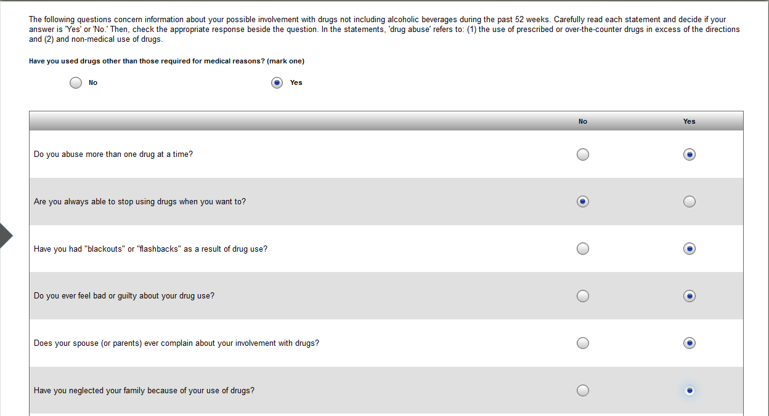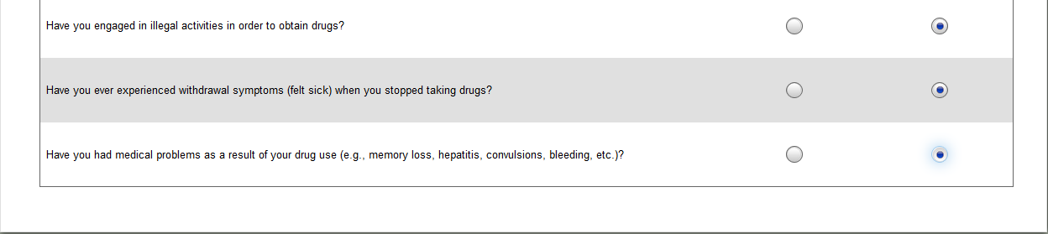

## DERS

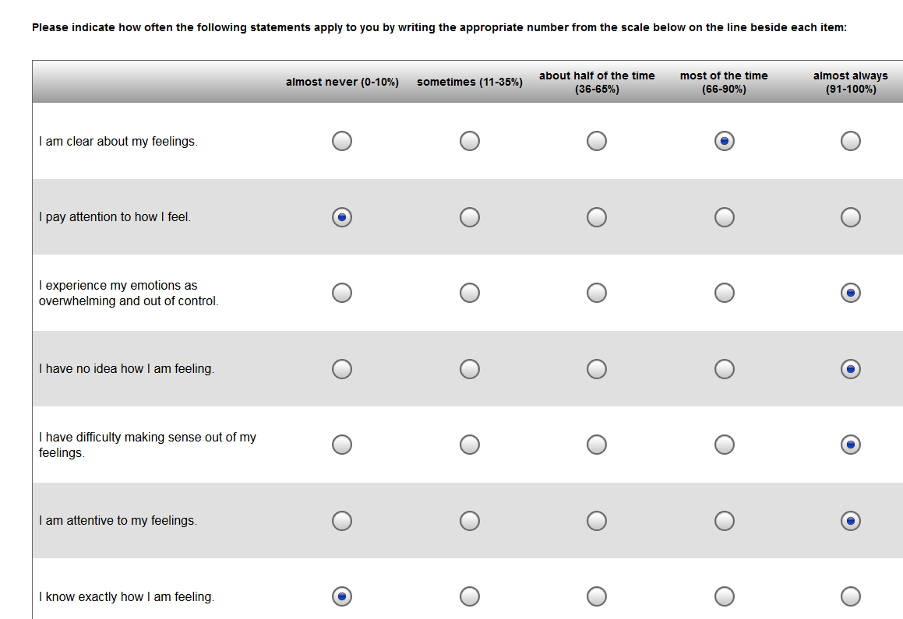 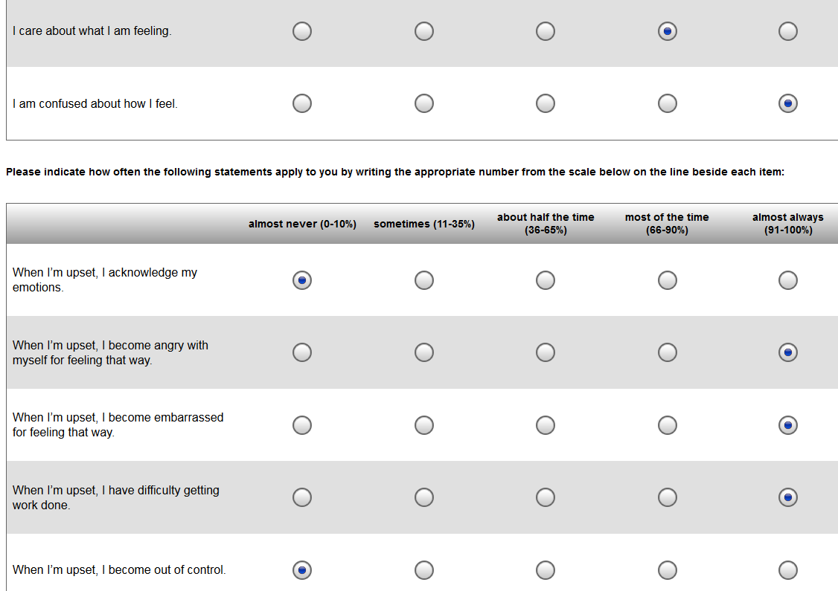

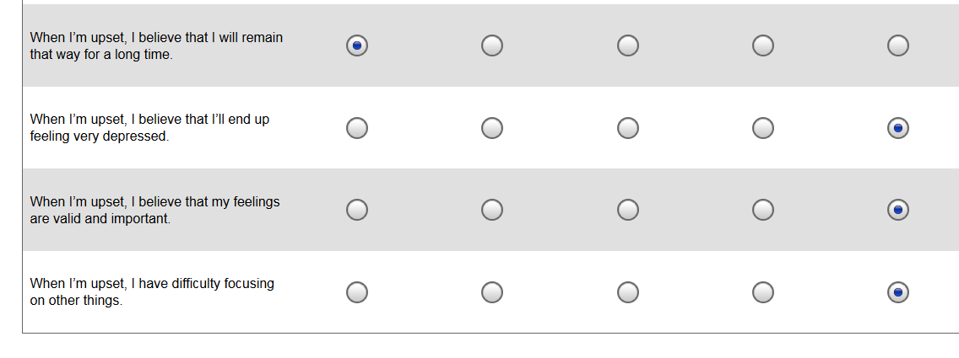 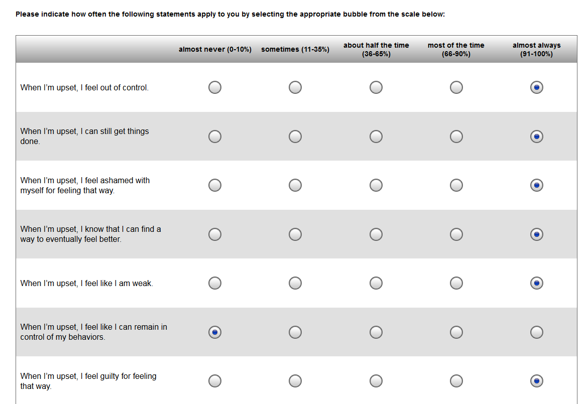

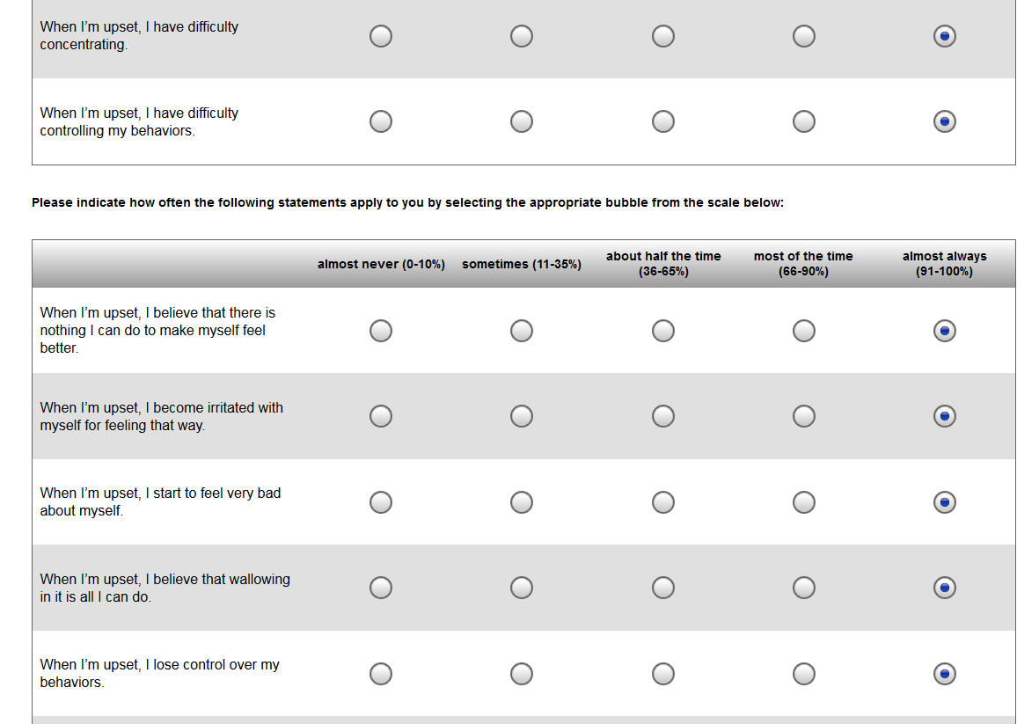 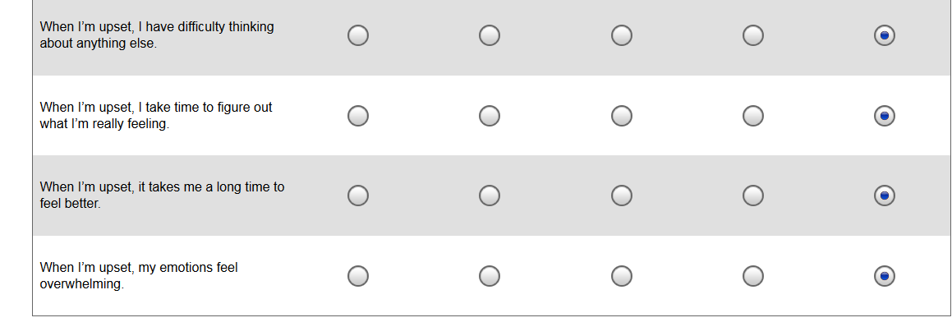

## Deployment Risk and Resiliency Inventory

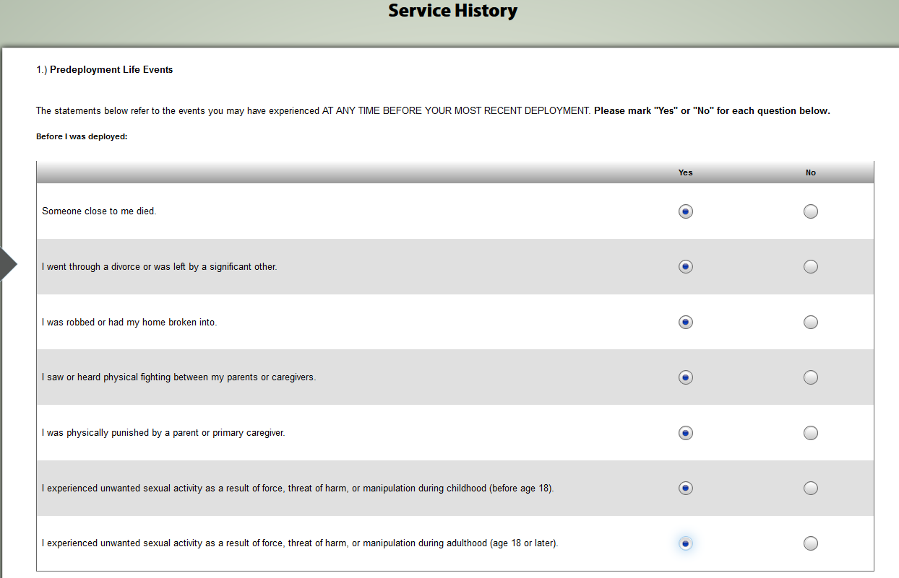

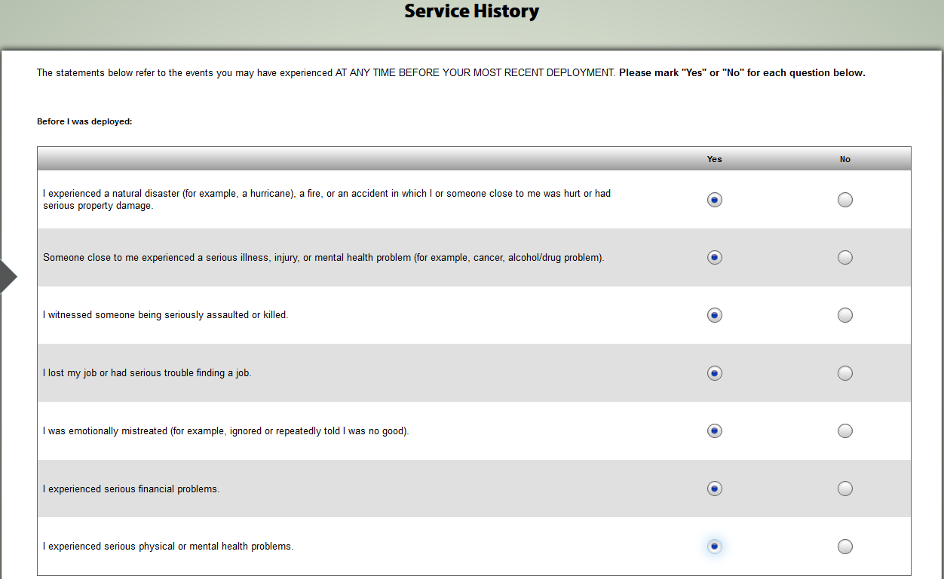

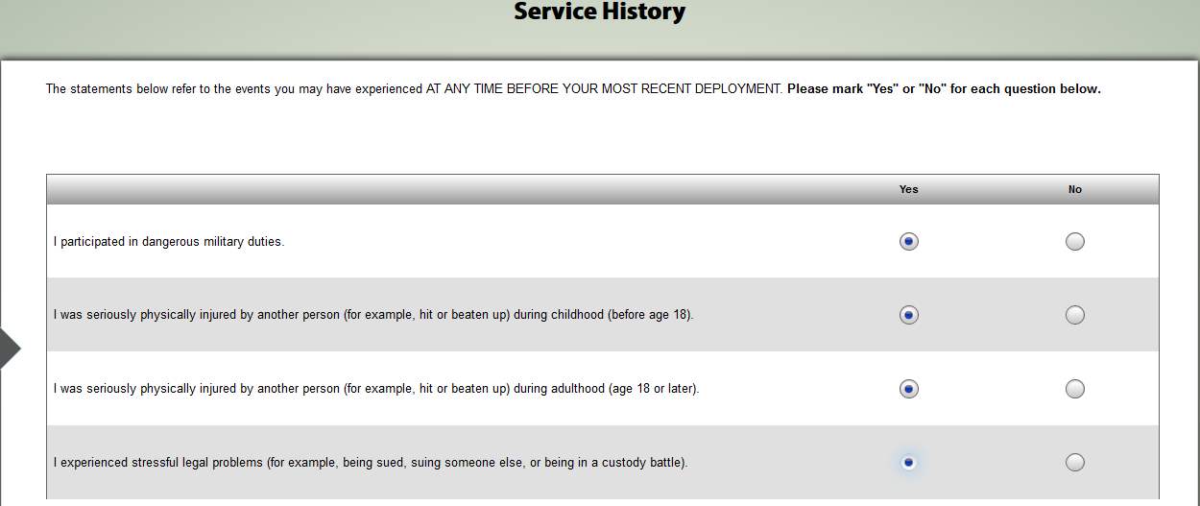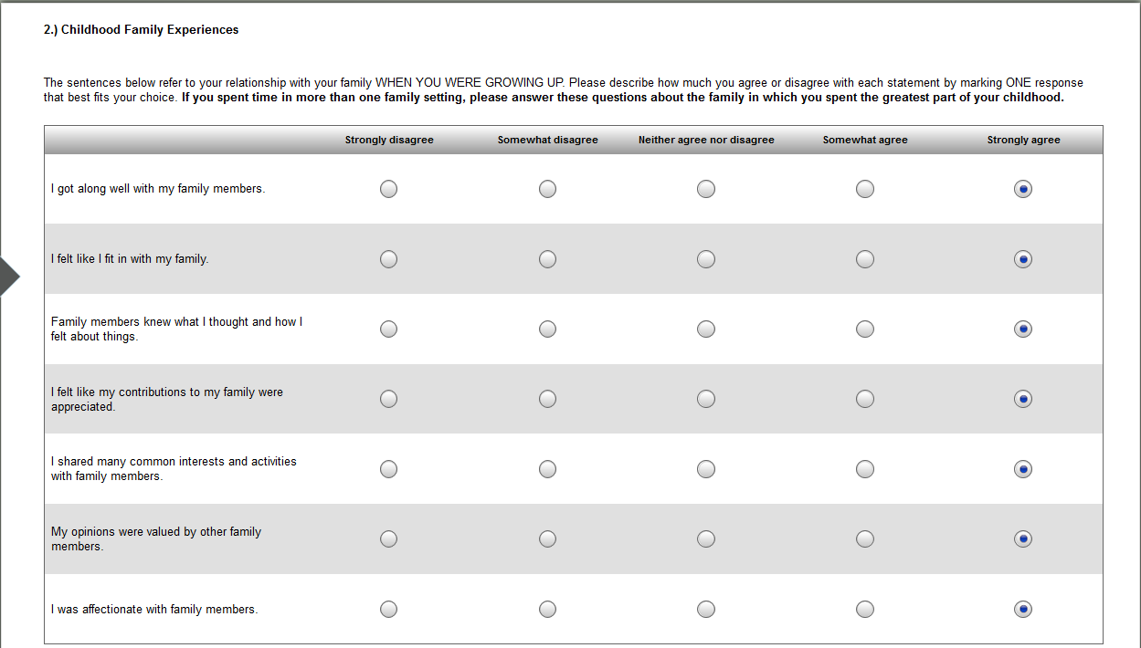

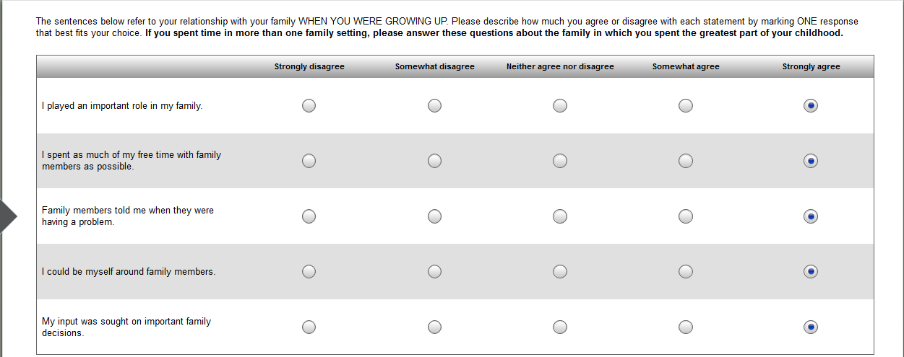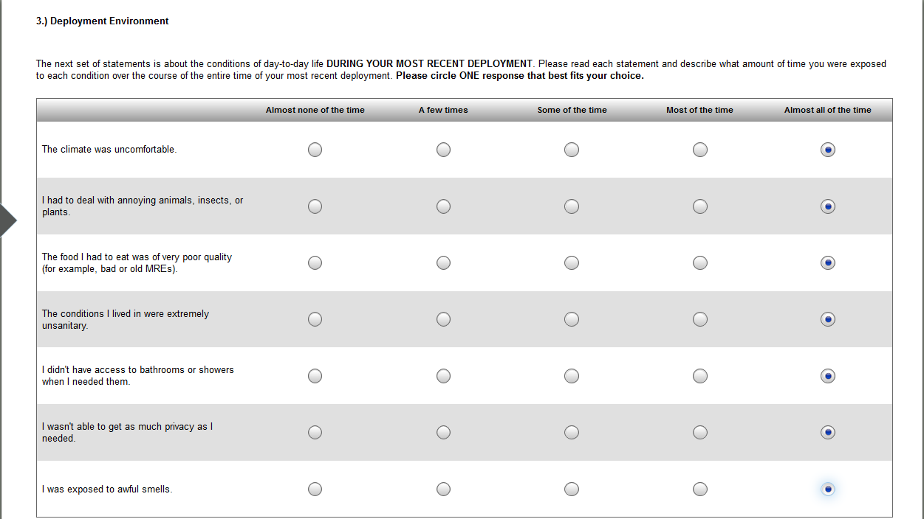

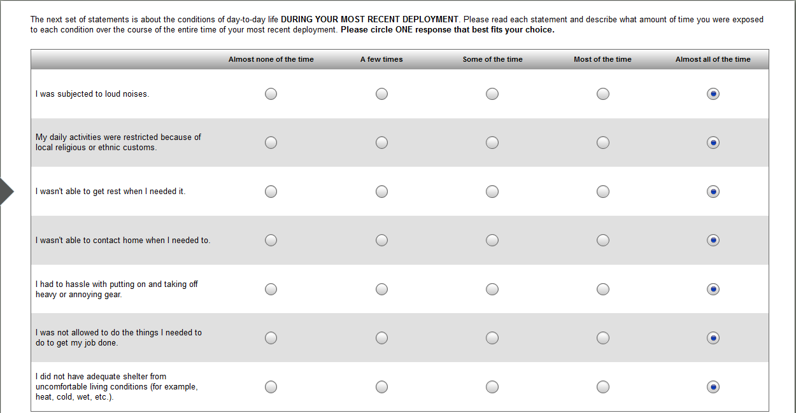

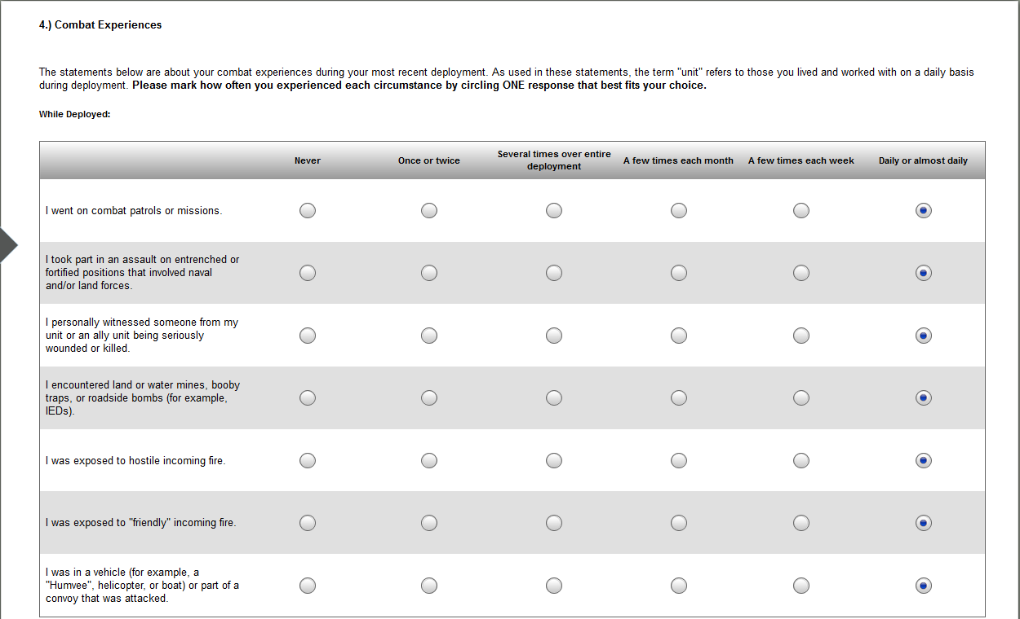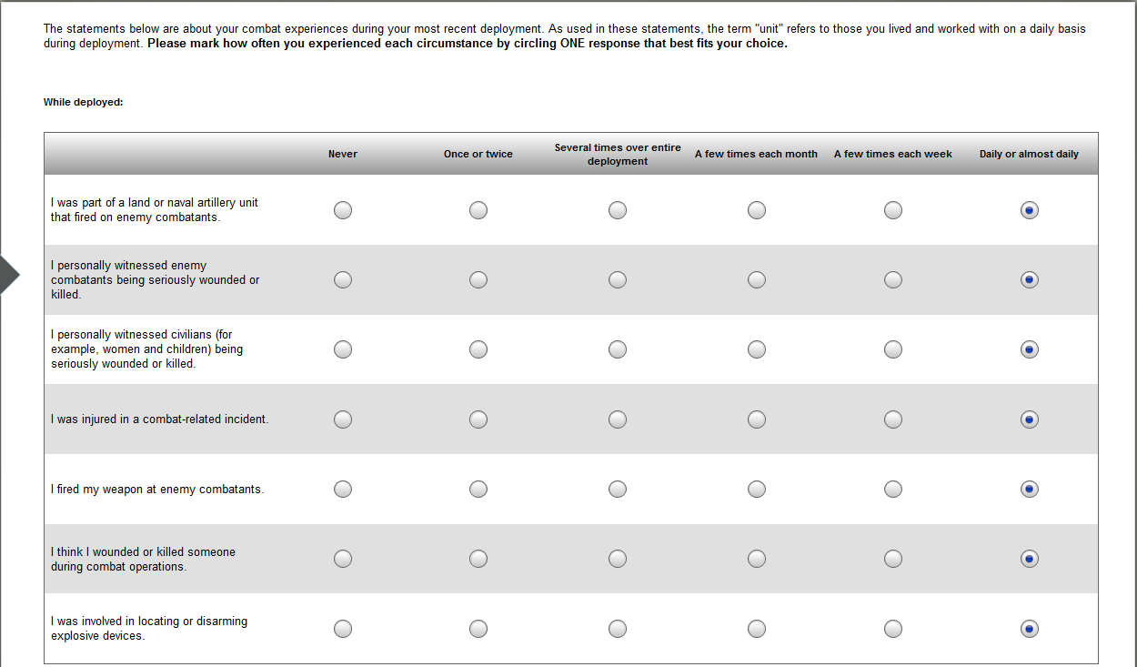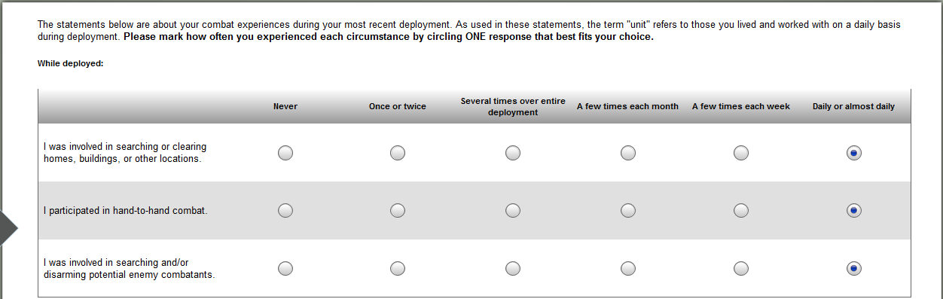

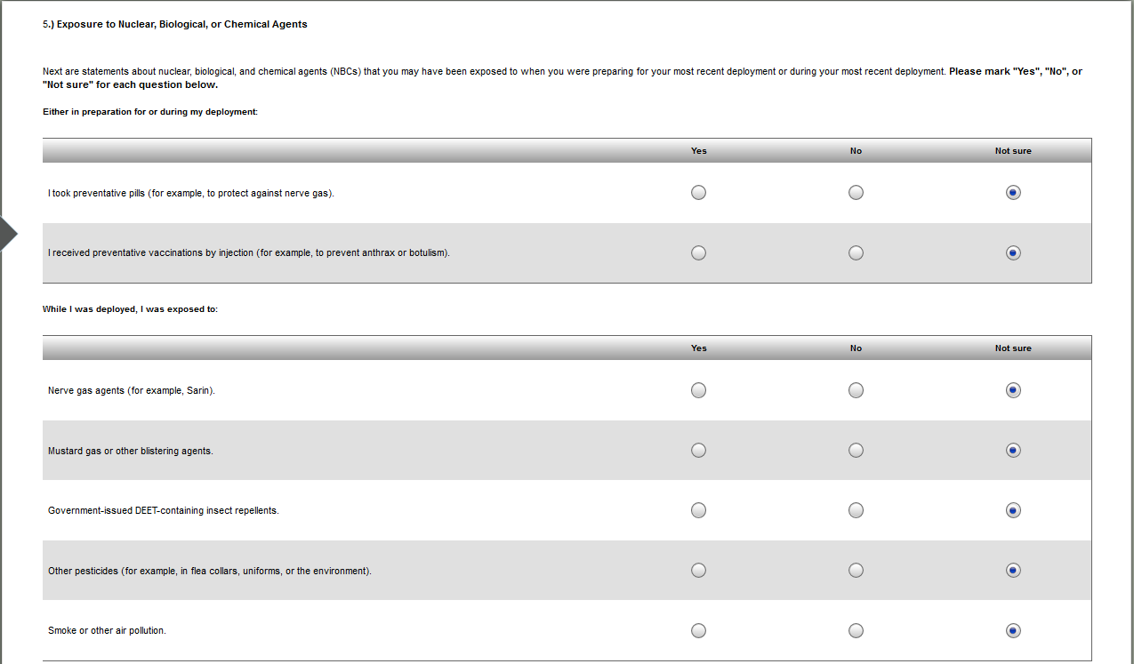

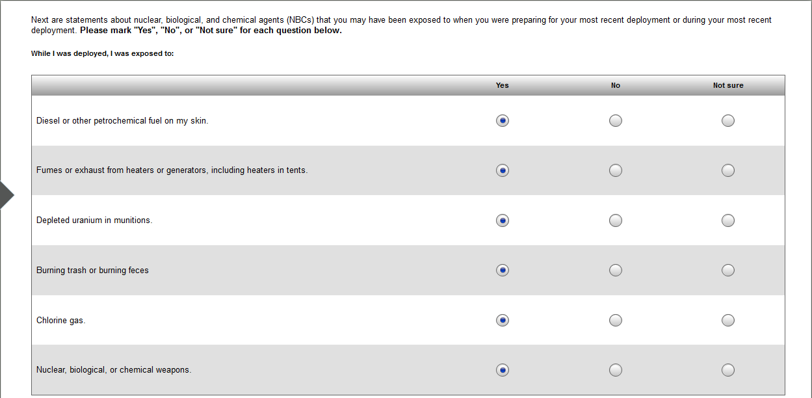

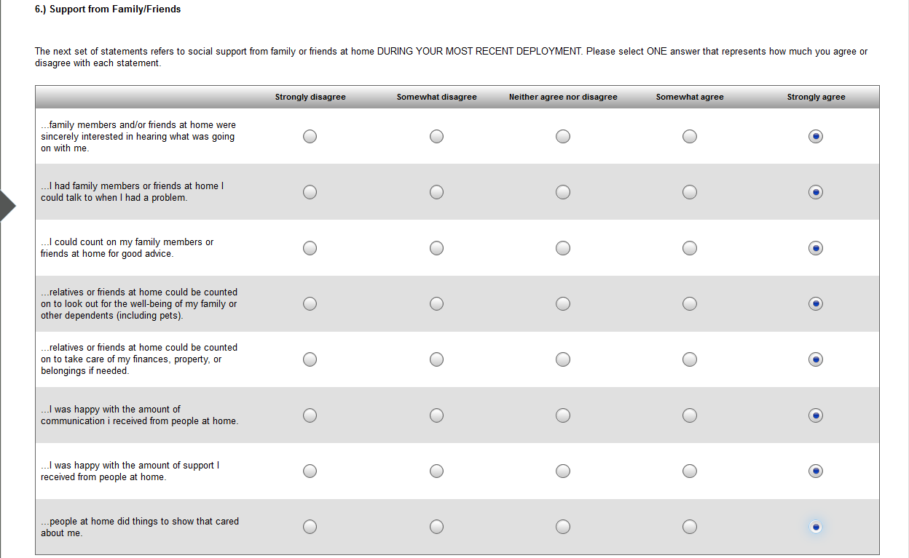

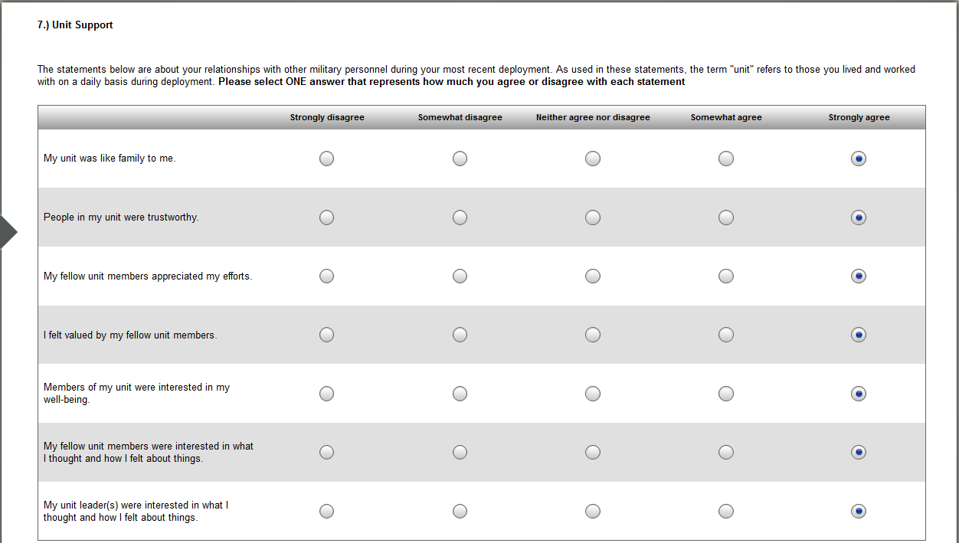

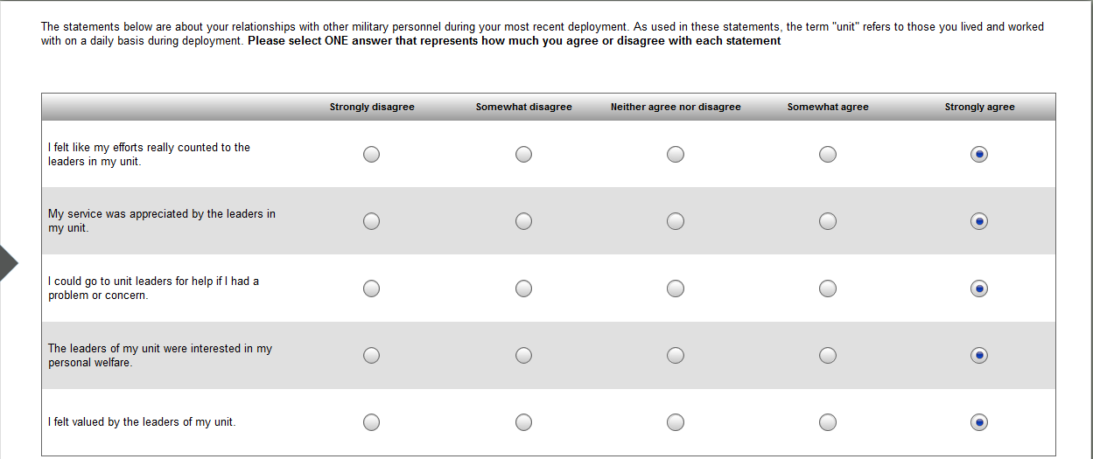

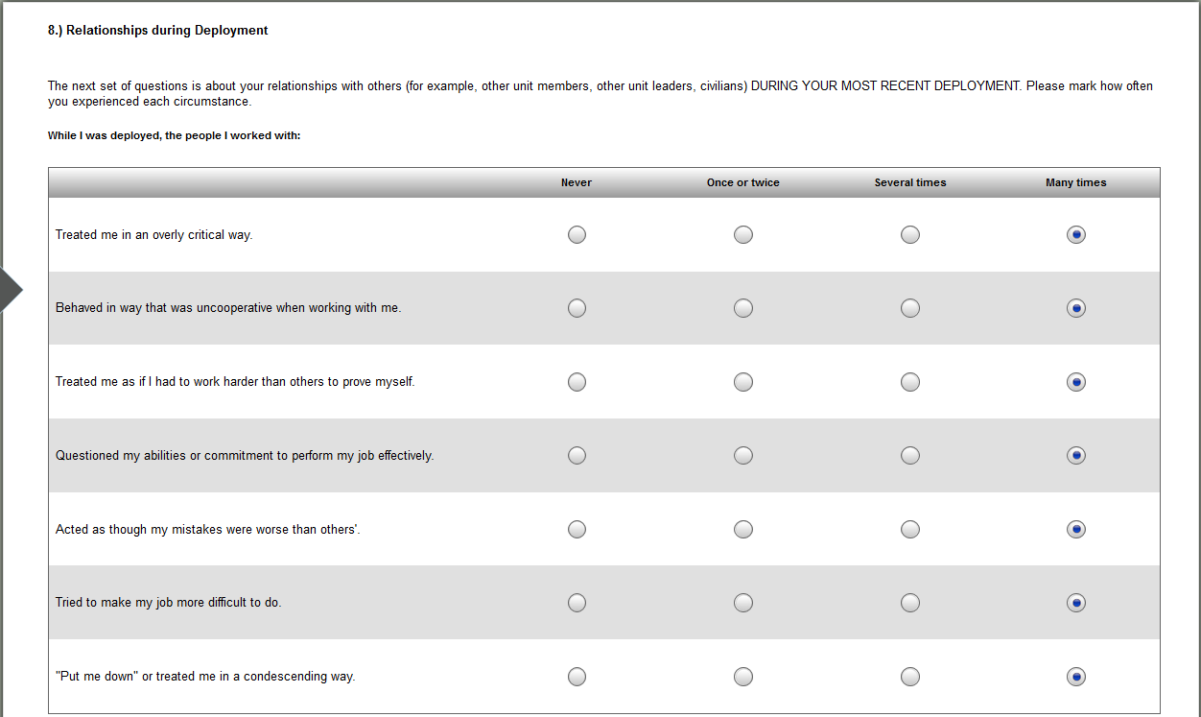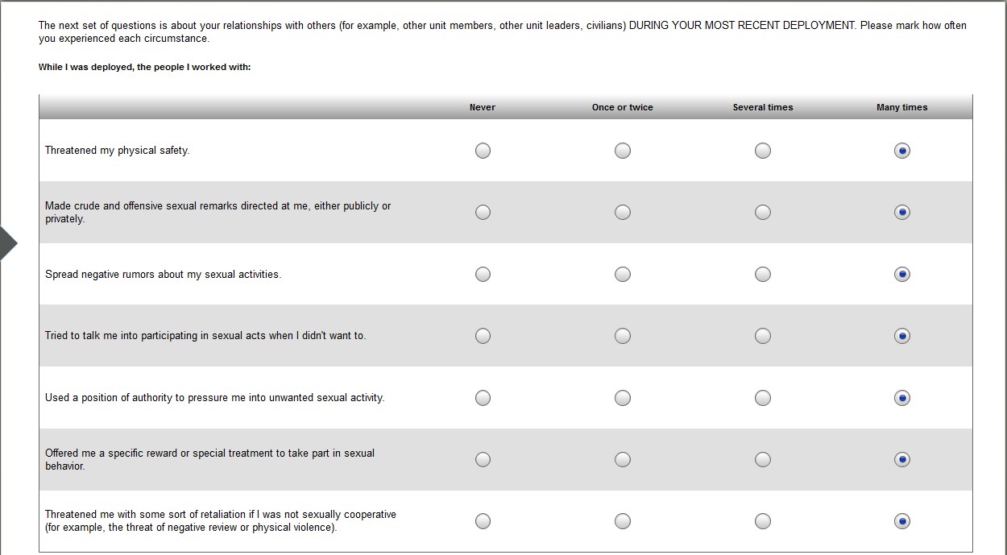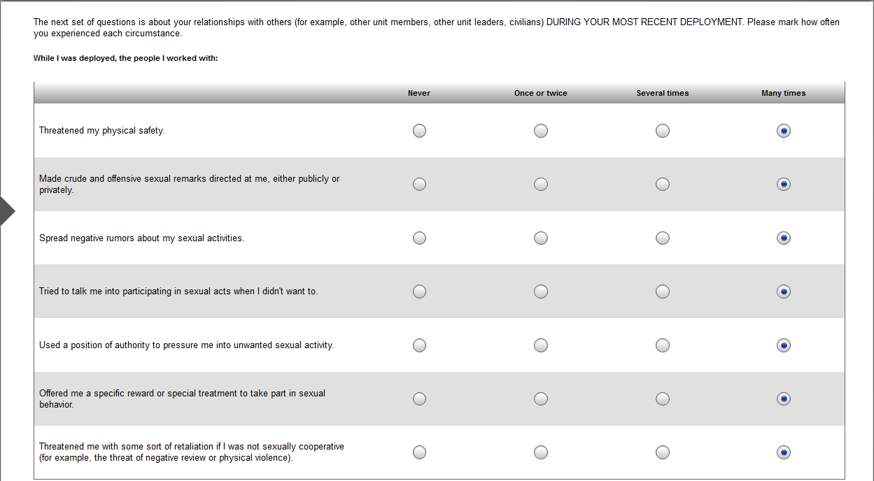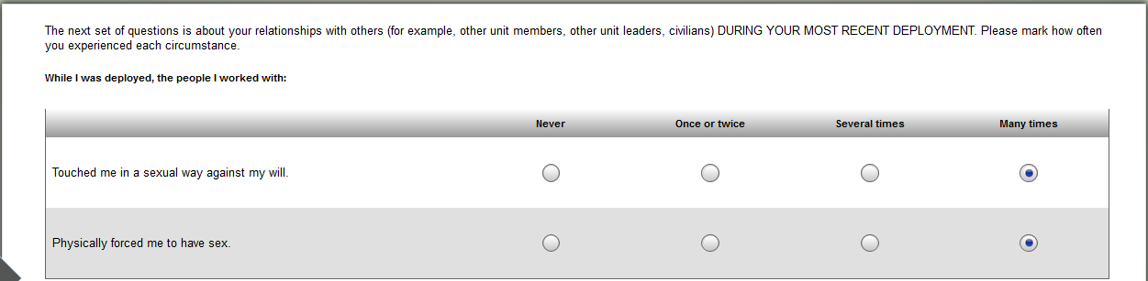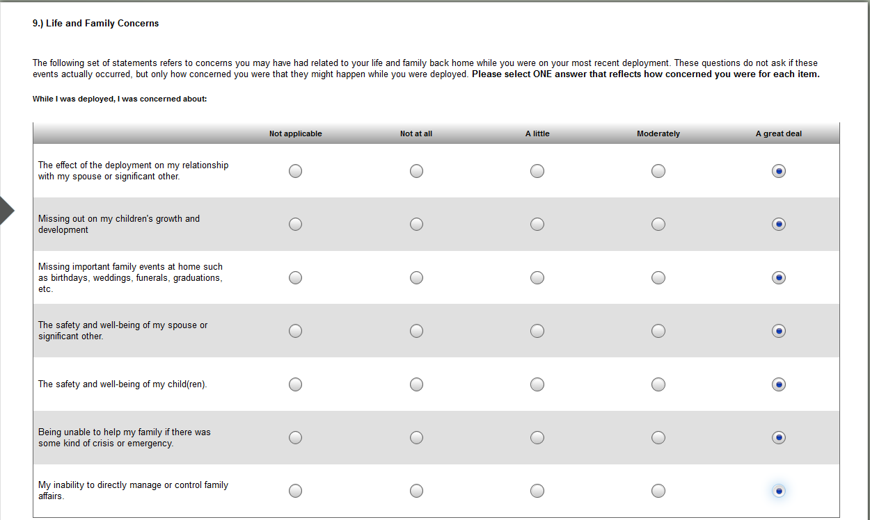

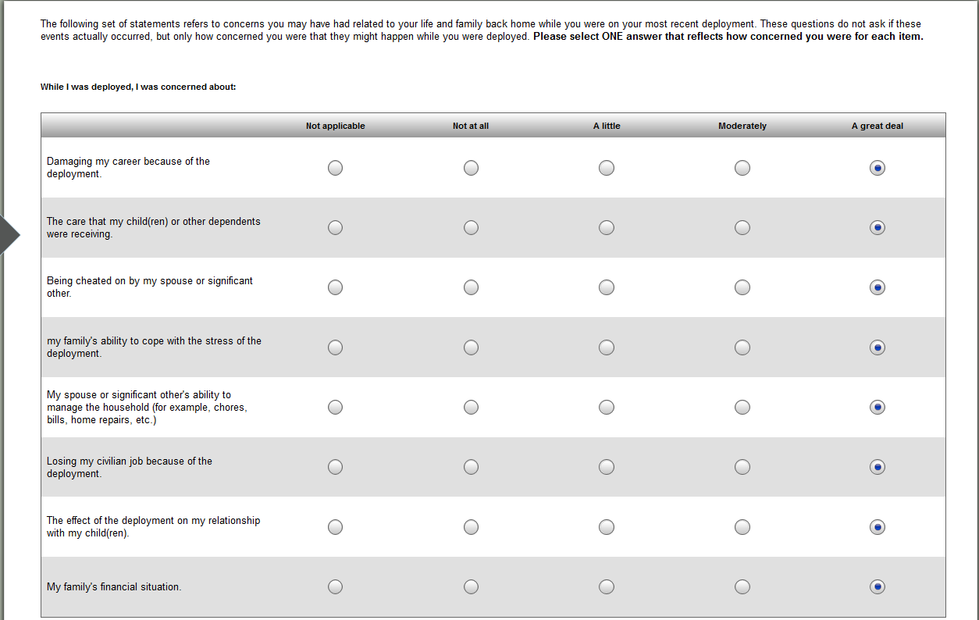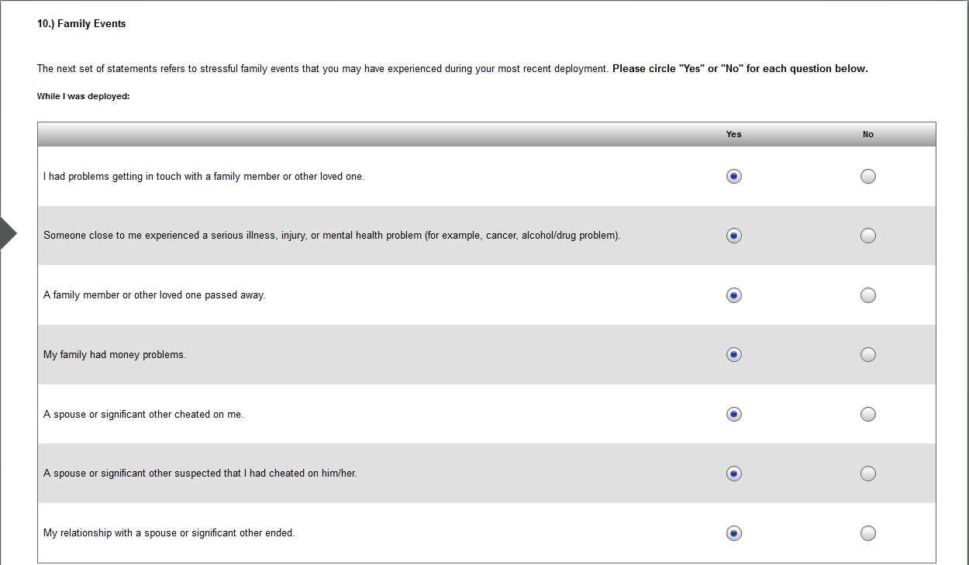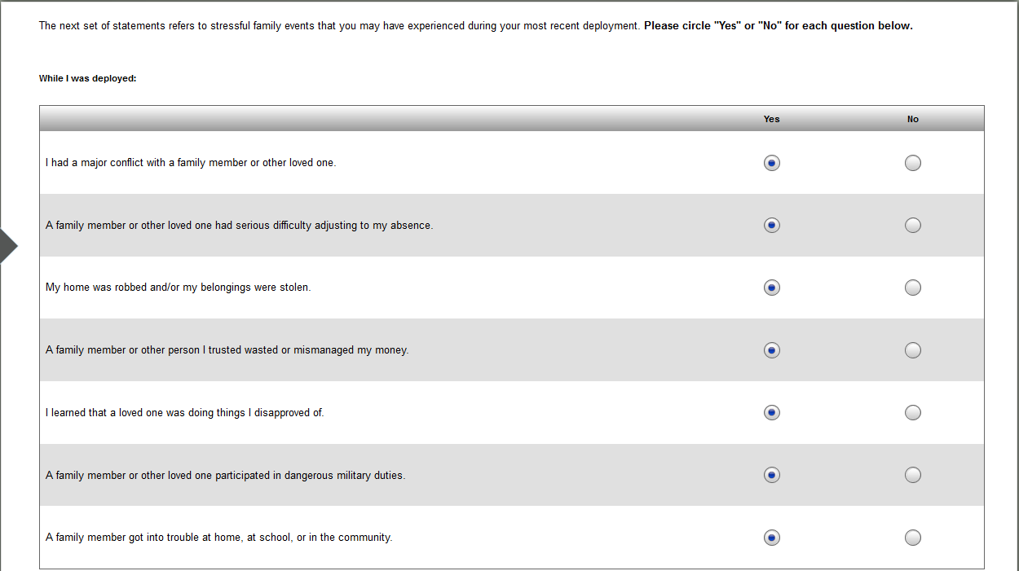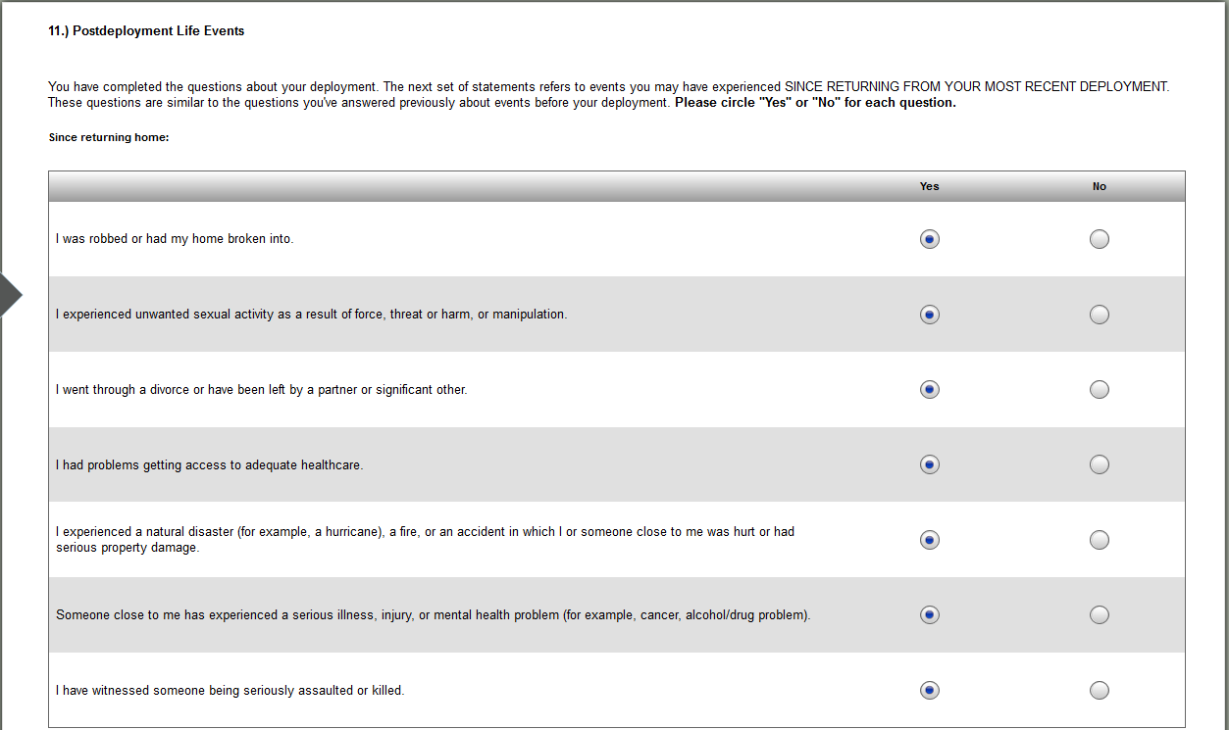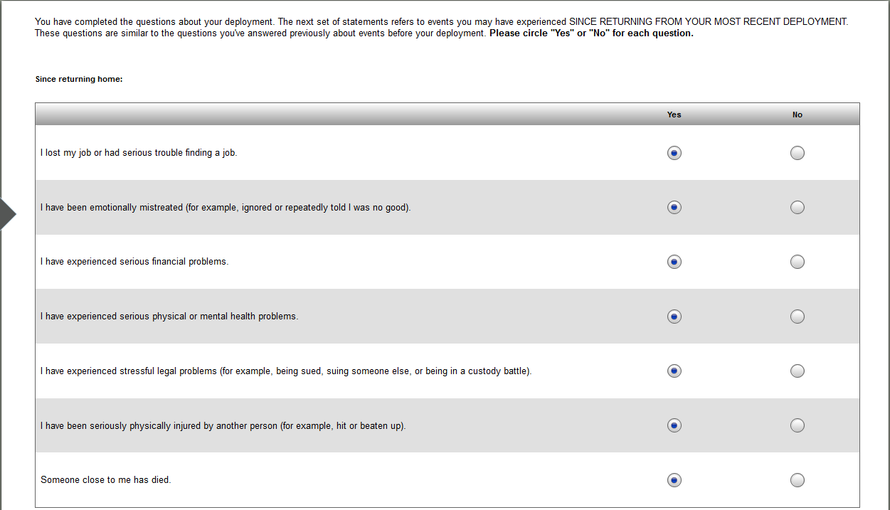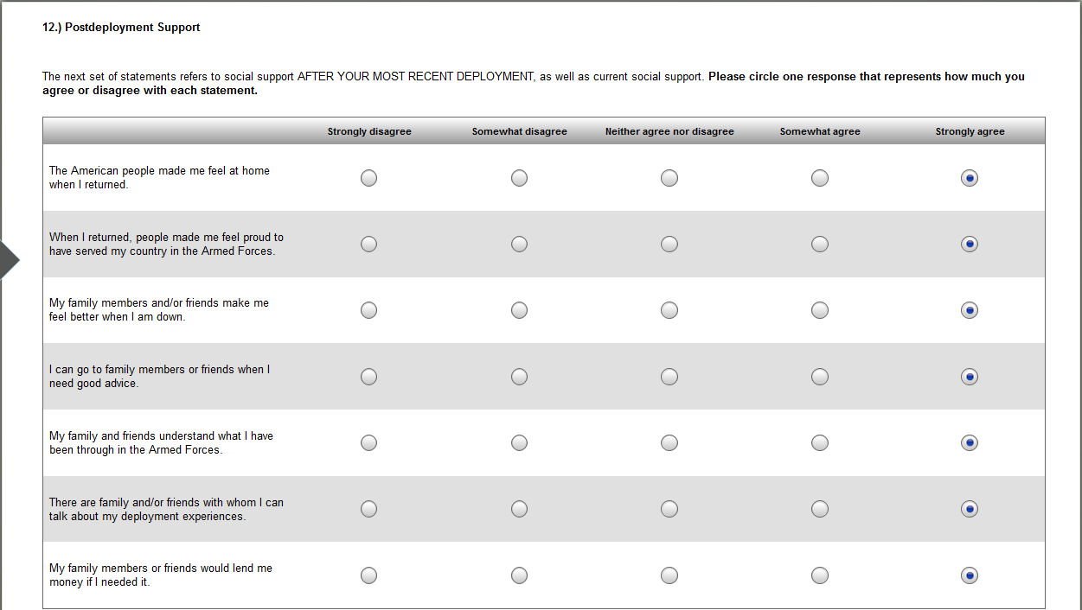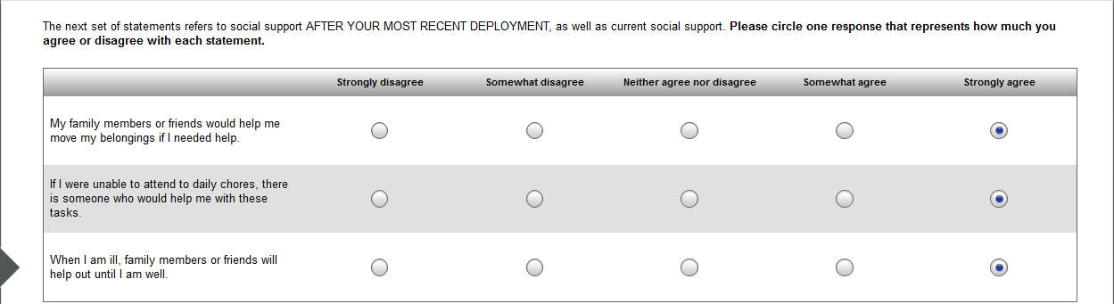

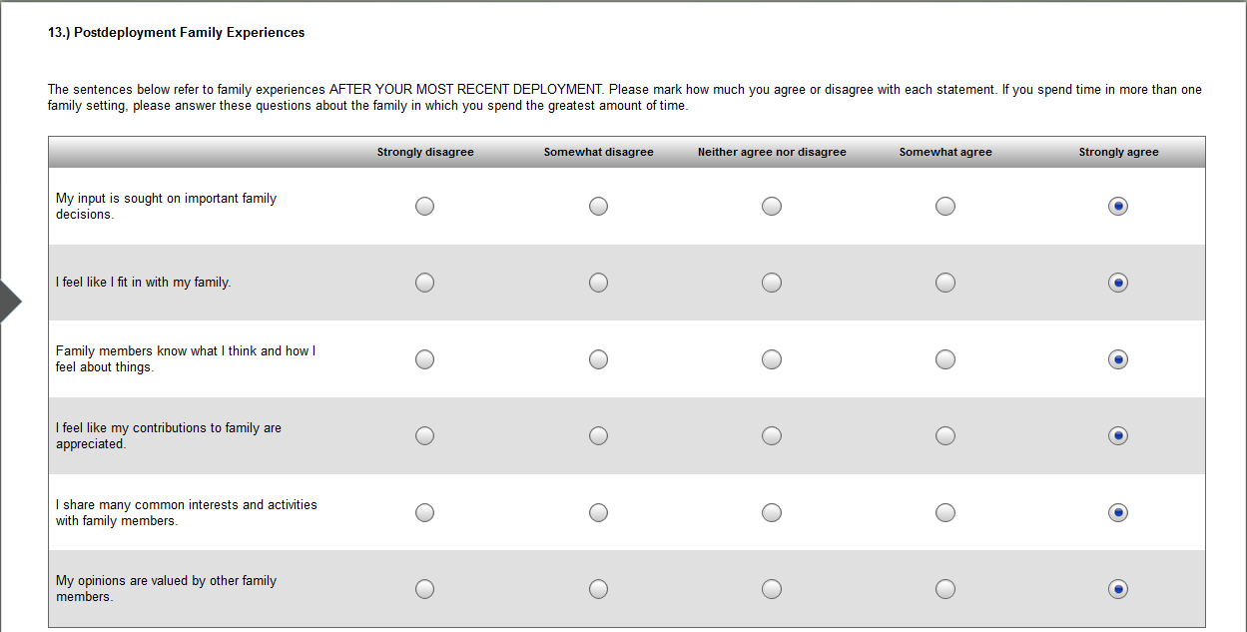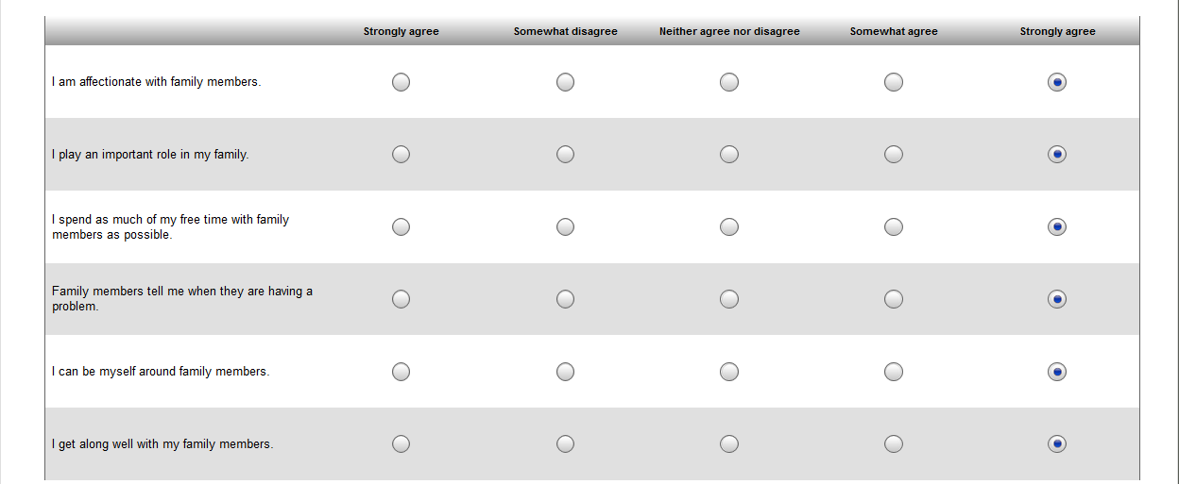

## Eating Attitudes Test

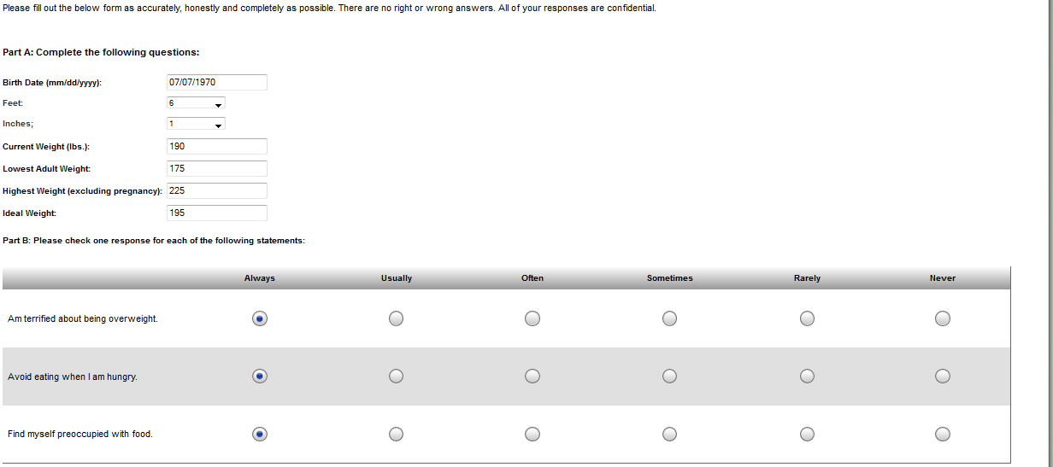

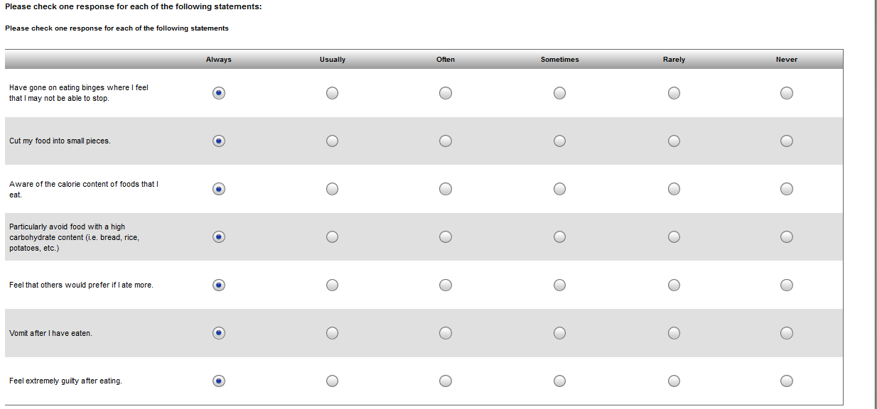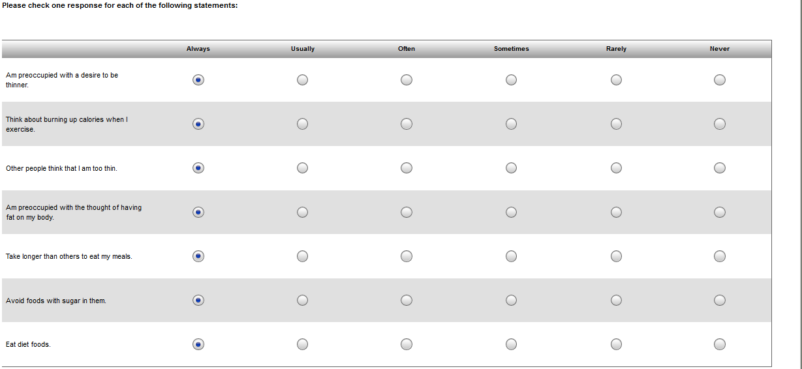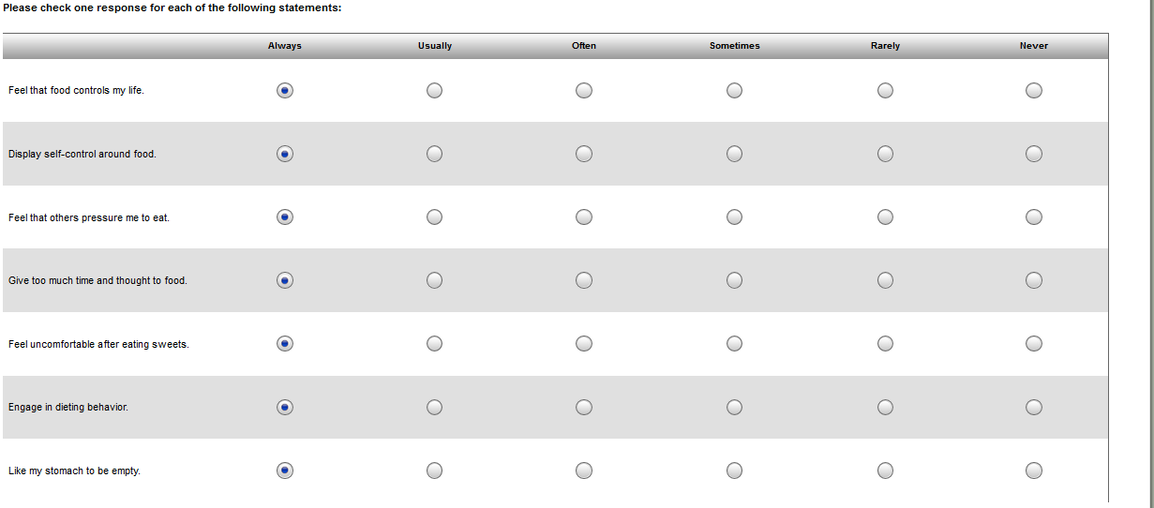

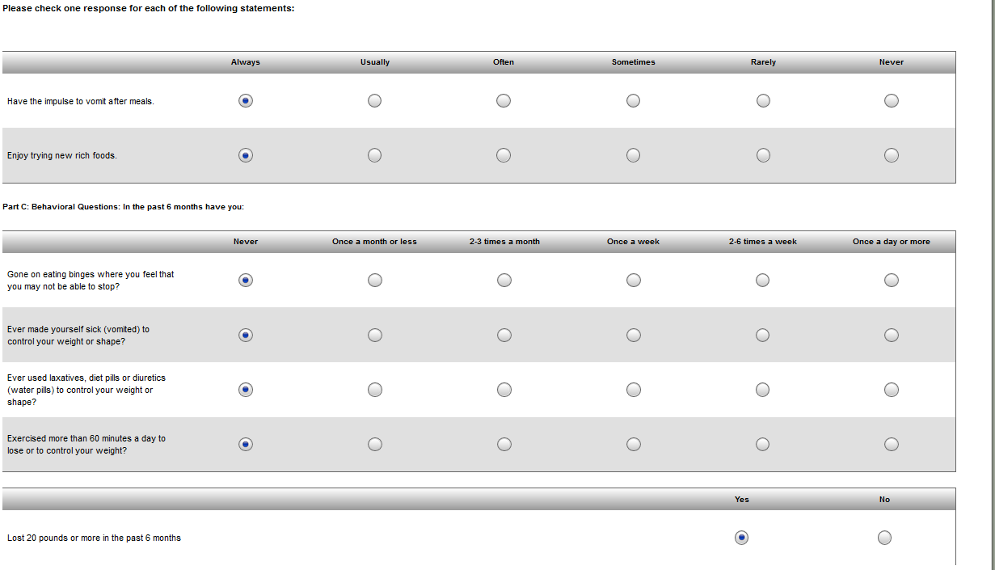

## Education, Income, & Employment

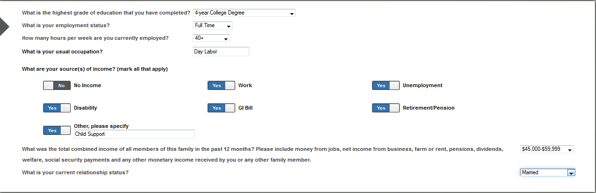

## Emotional Reactivity Scale

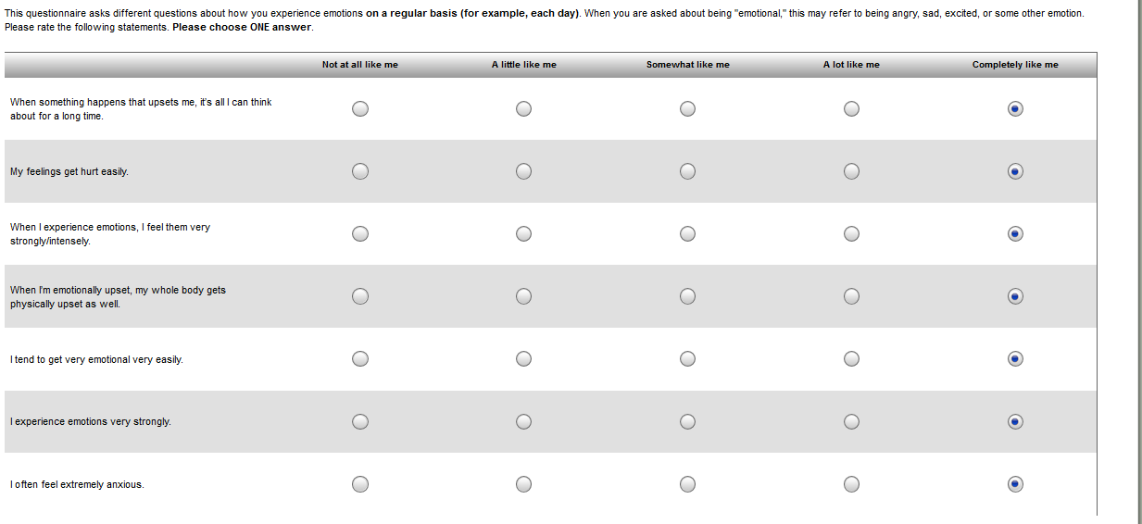

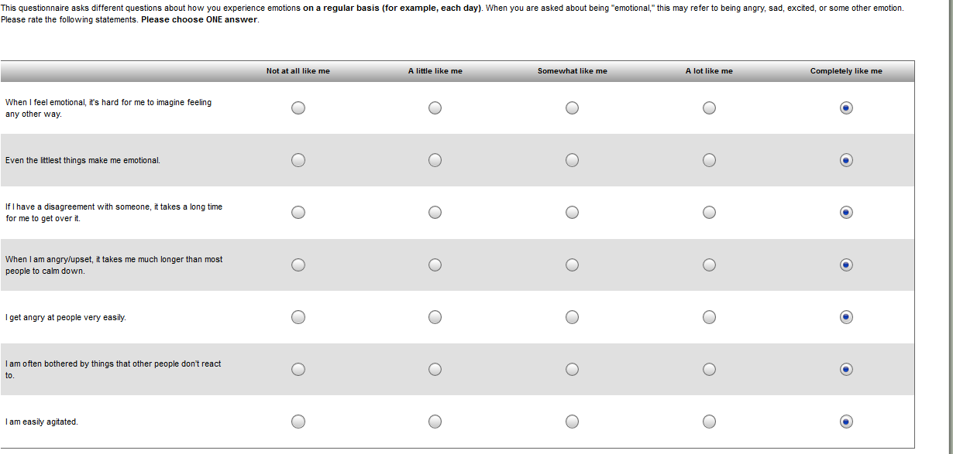 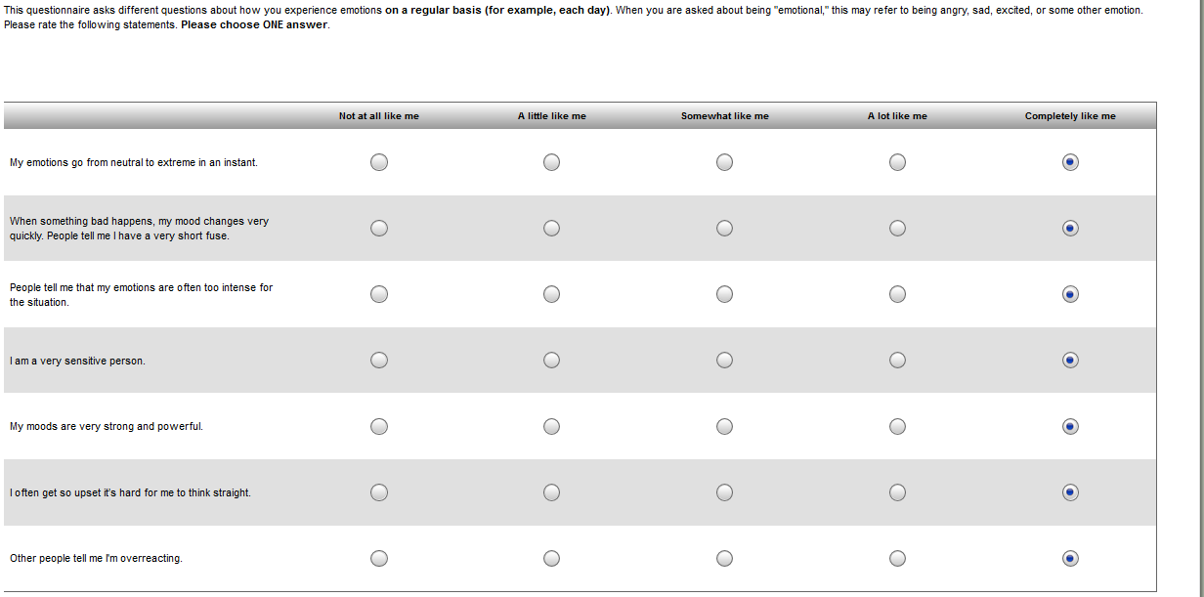

## Epworth Sleepiness Scale

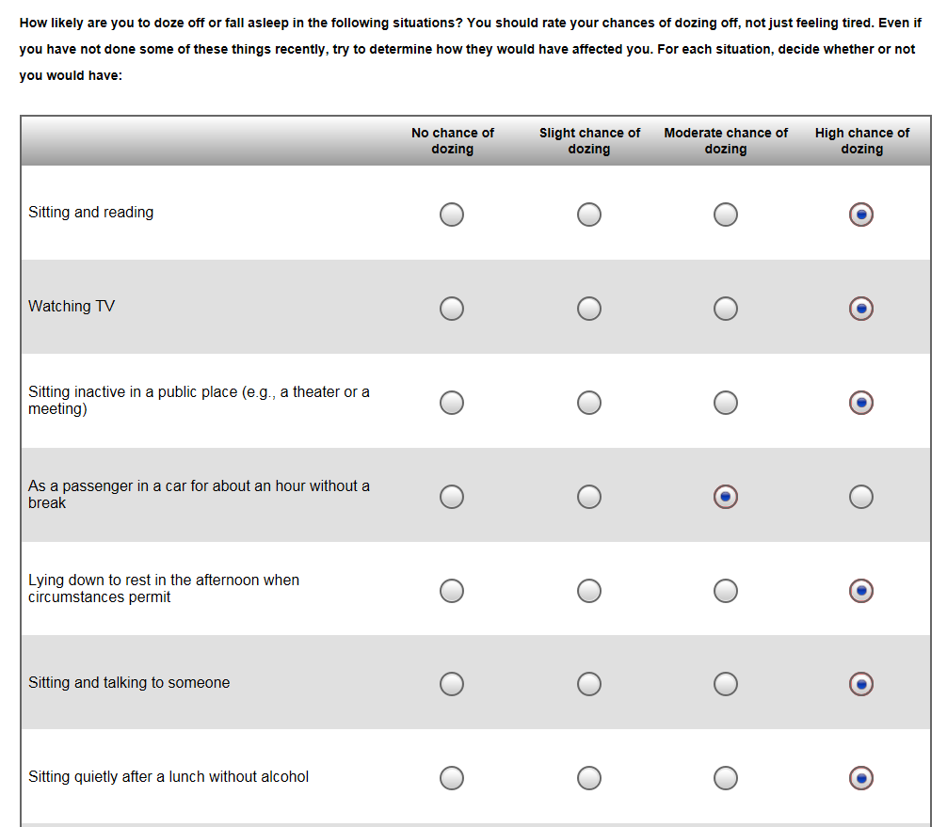

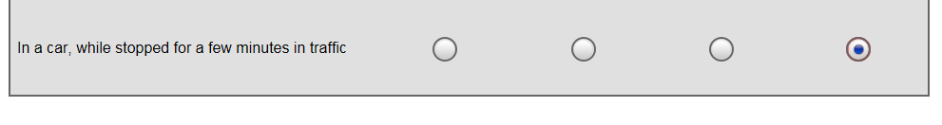

## eScreening Quality Assessment

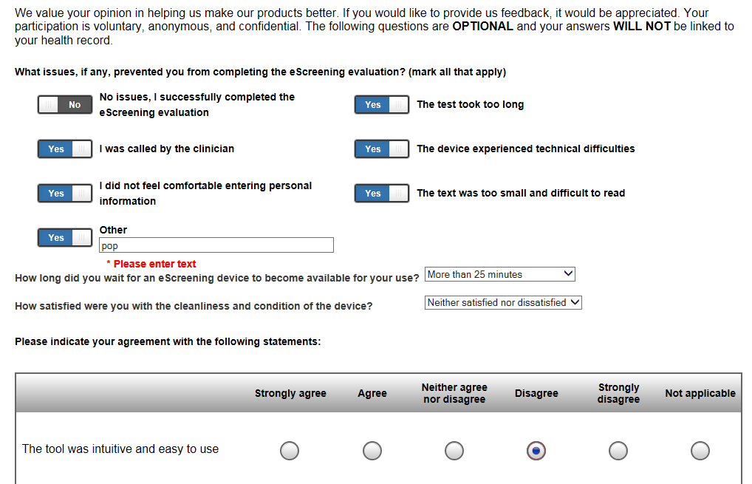

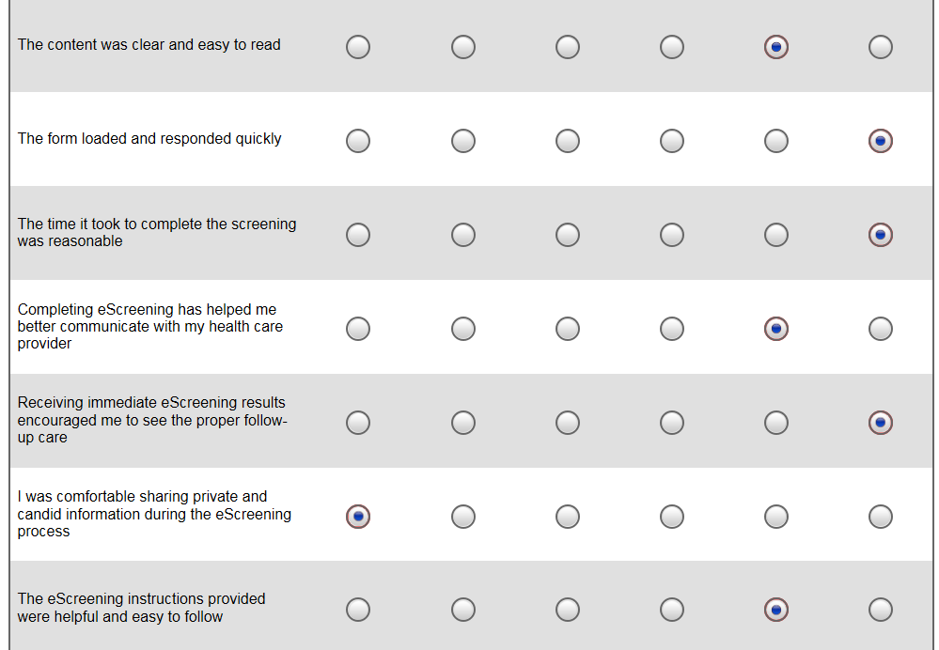

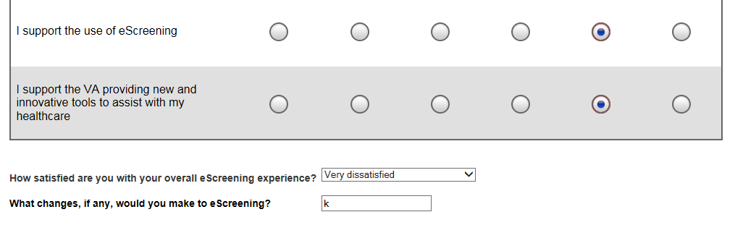

## Exposures

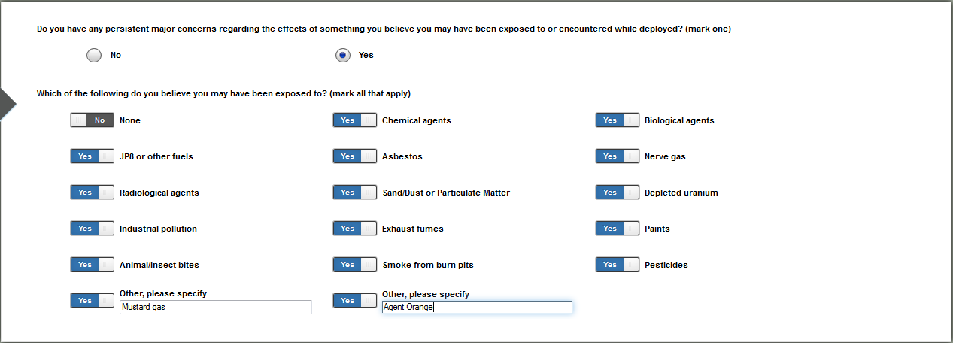

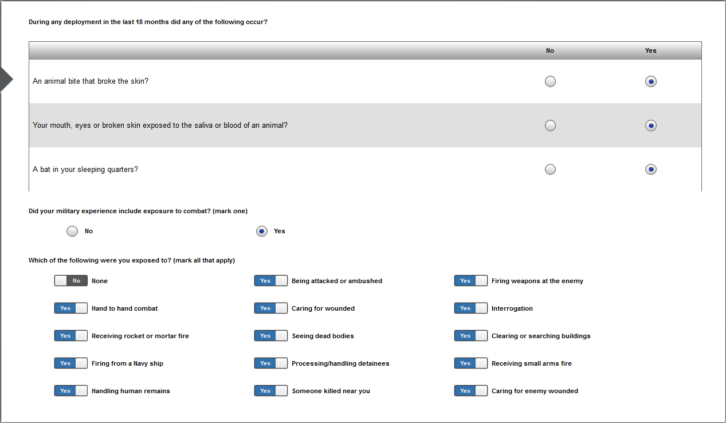

## Five Facet Mindfulness Questionnaire

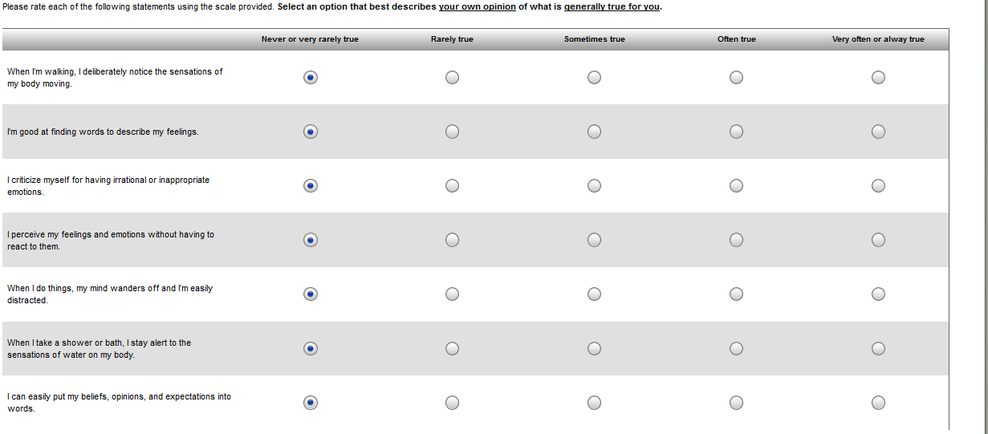 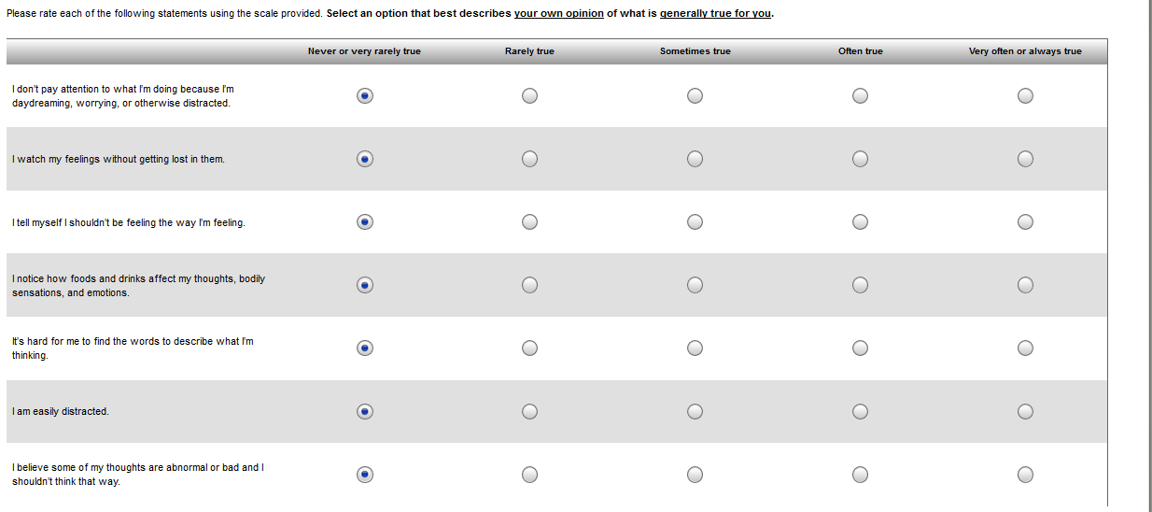 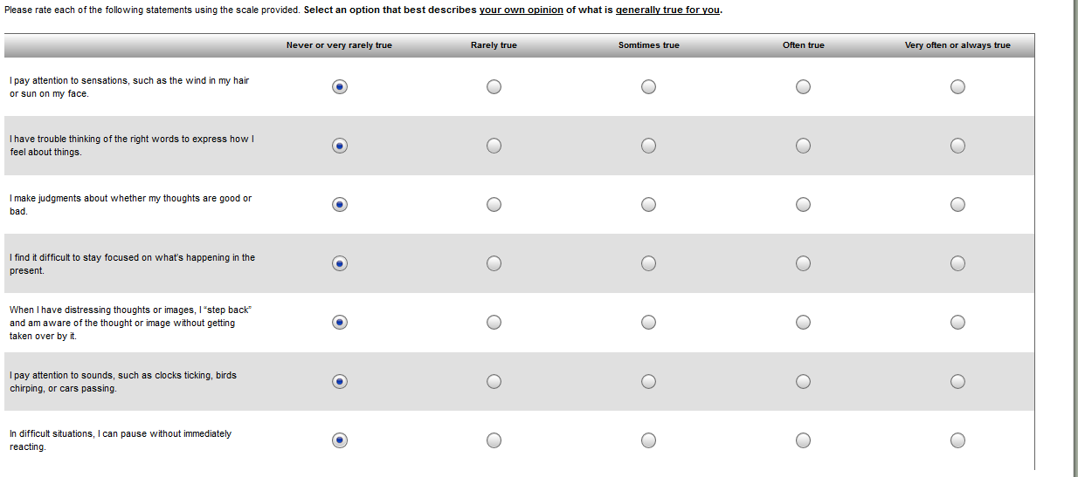 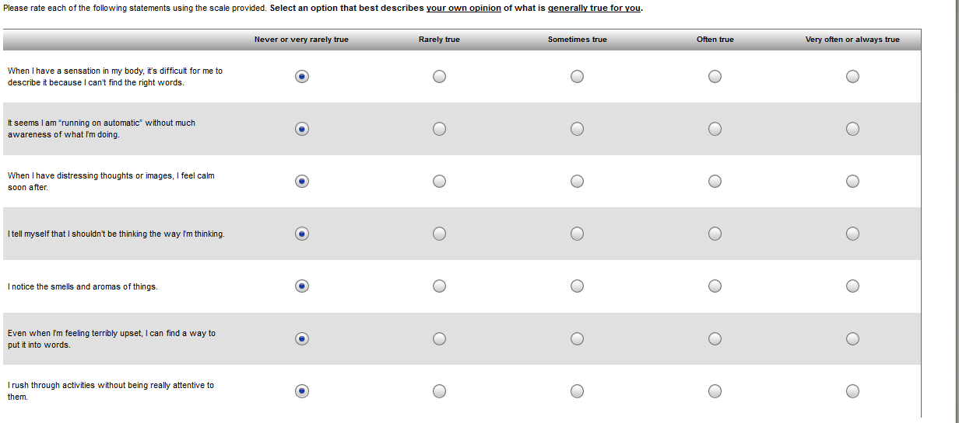 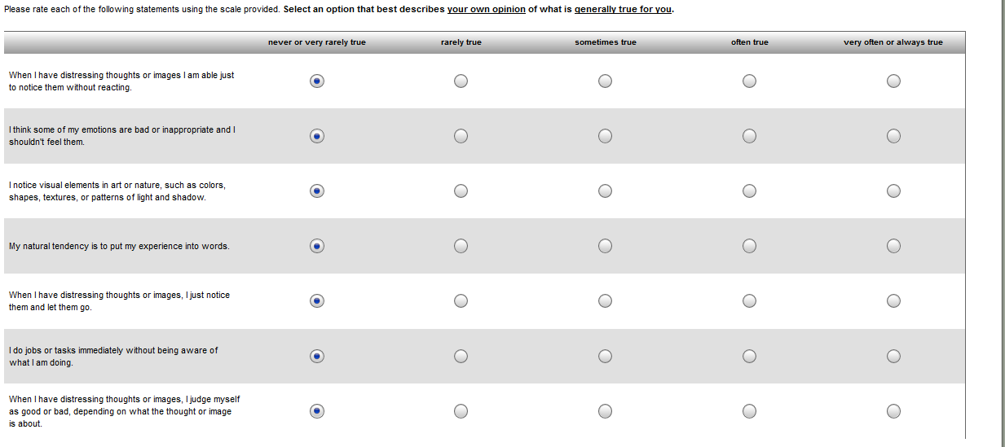 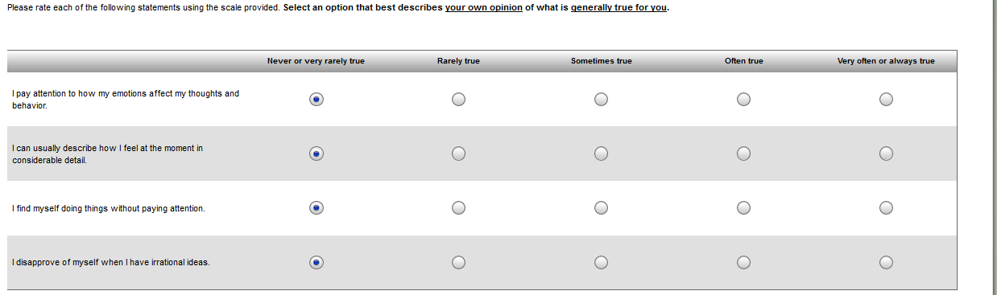

## GAD-7 Anxiety

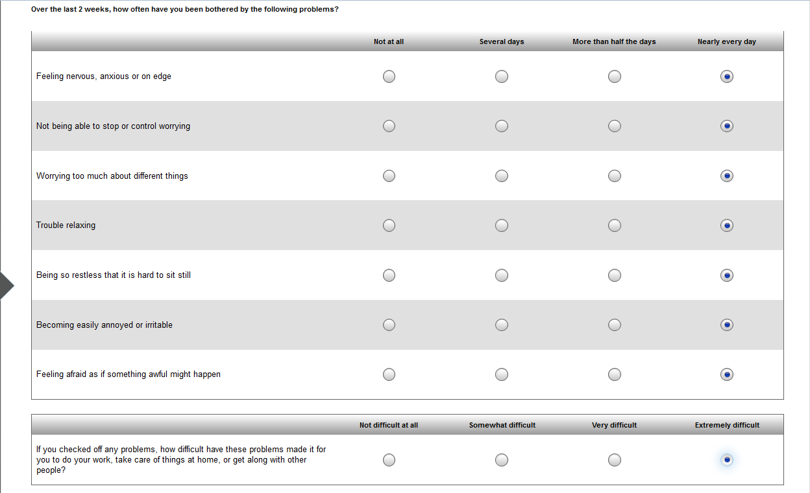

## Goals

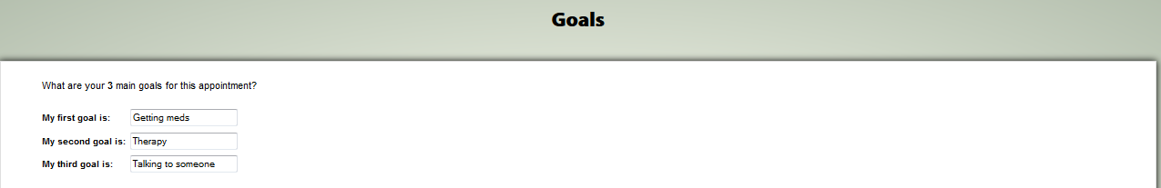

## Homelessness Clinical Reminder

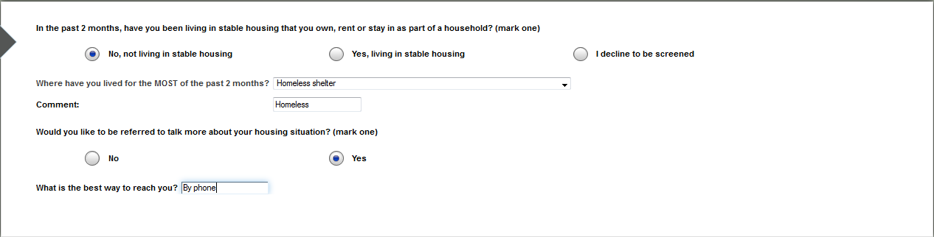

## Identification

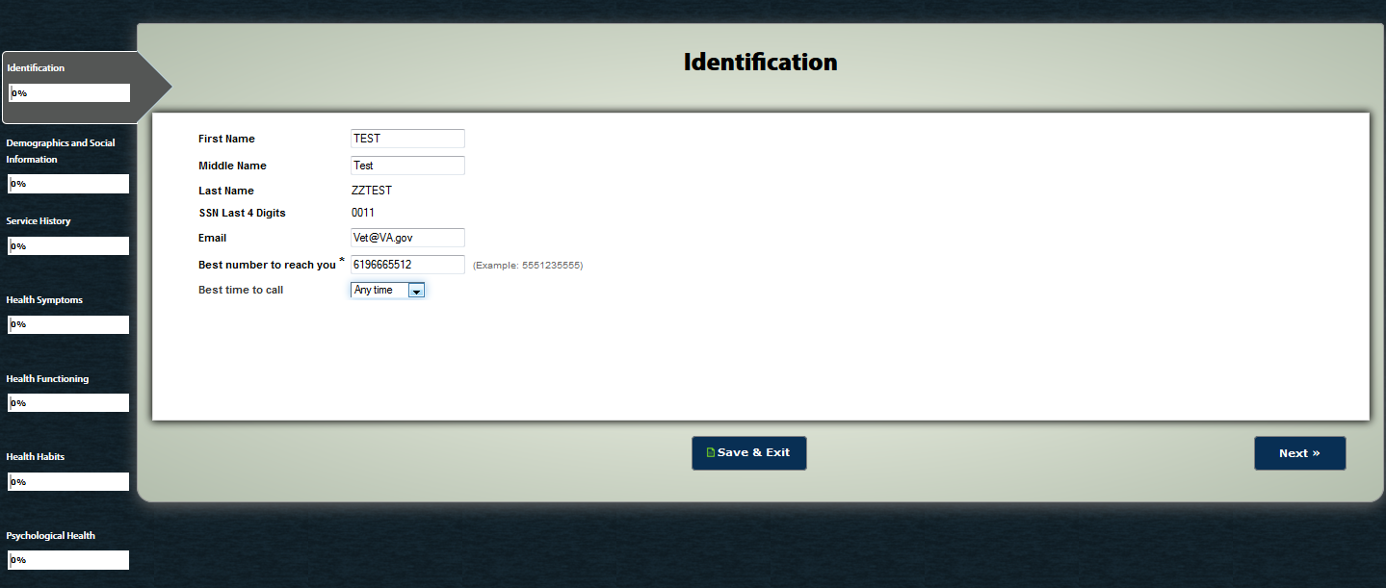

## International Physical Activity Questionnaire

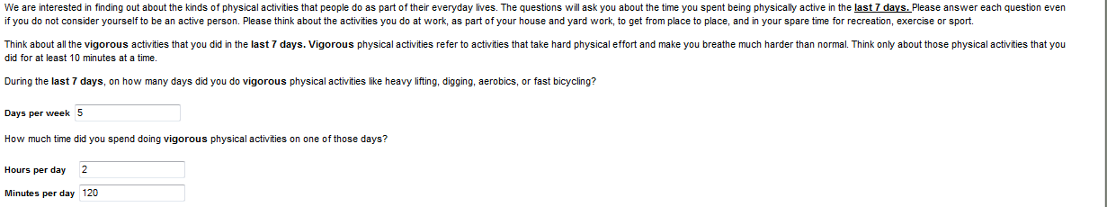 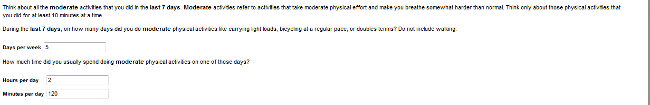 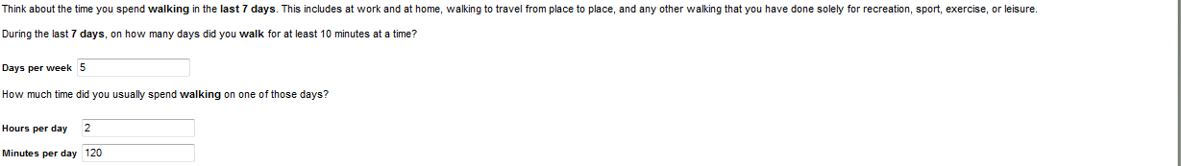 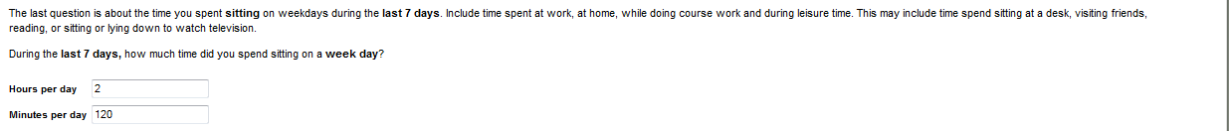

## ISI

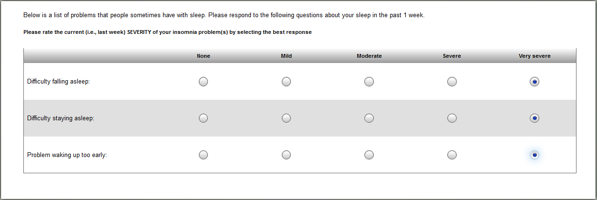

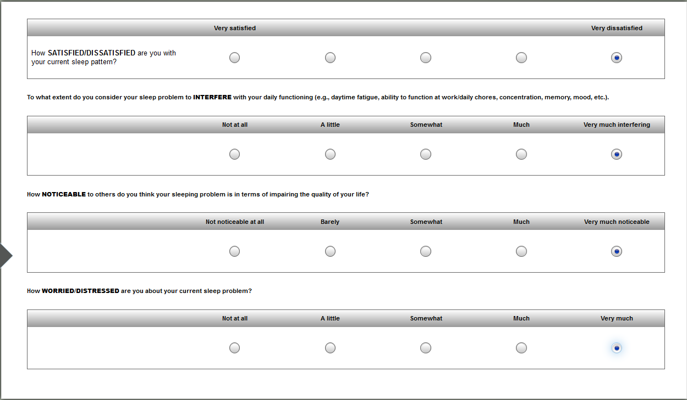

## MDQ

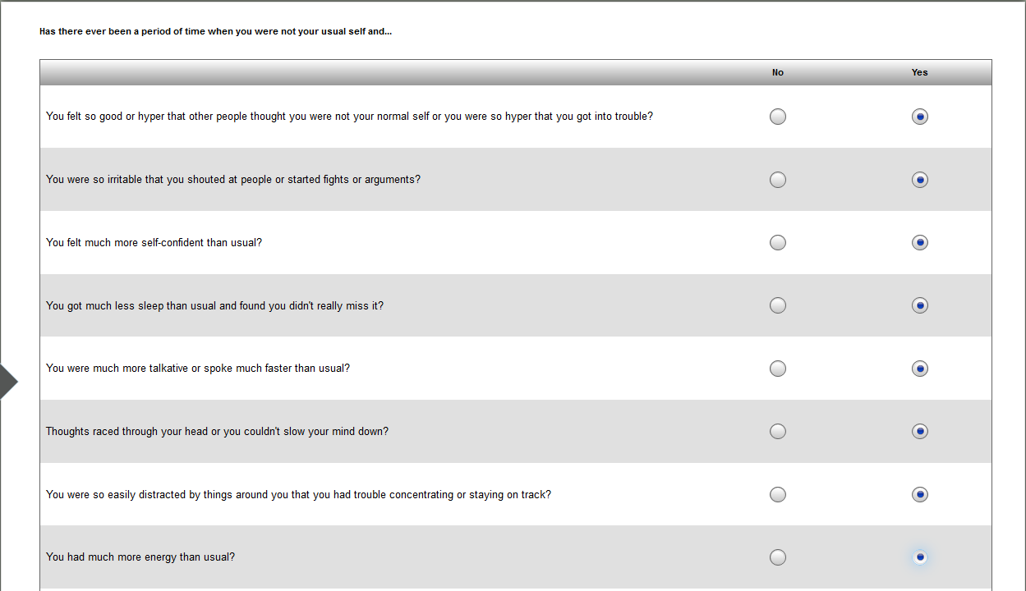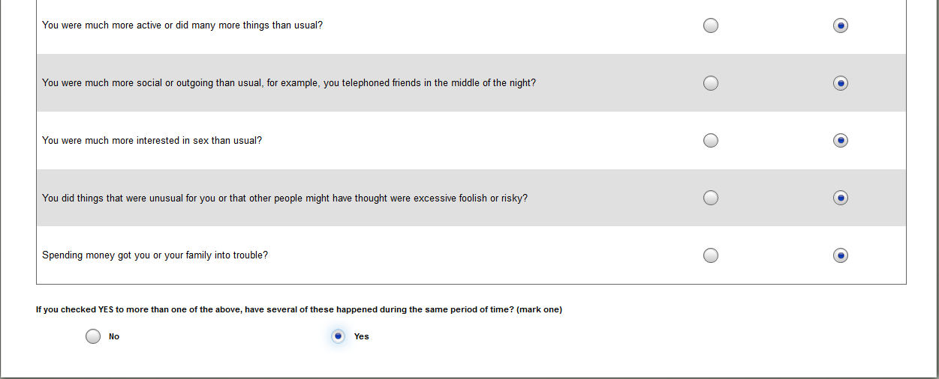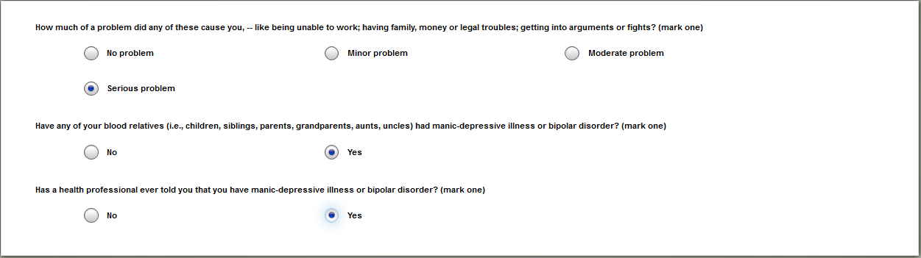

## Medical History

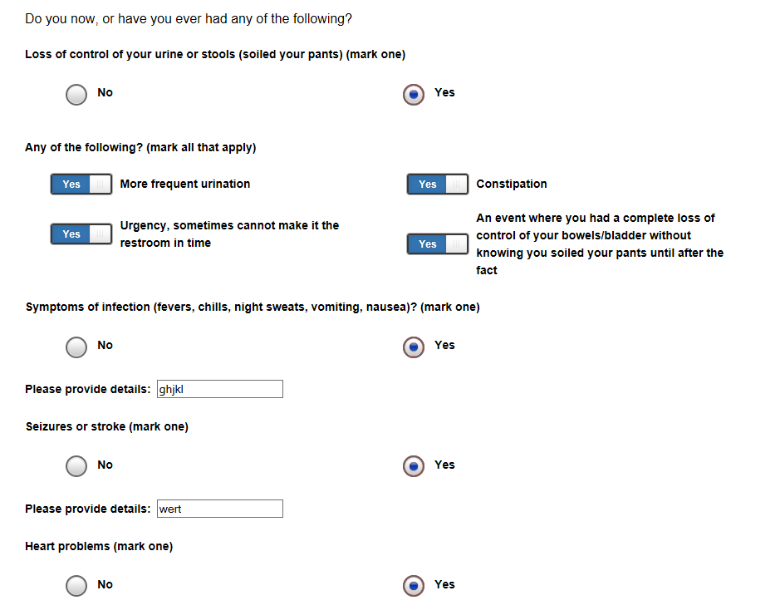

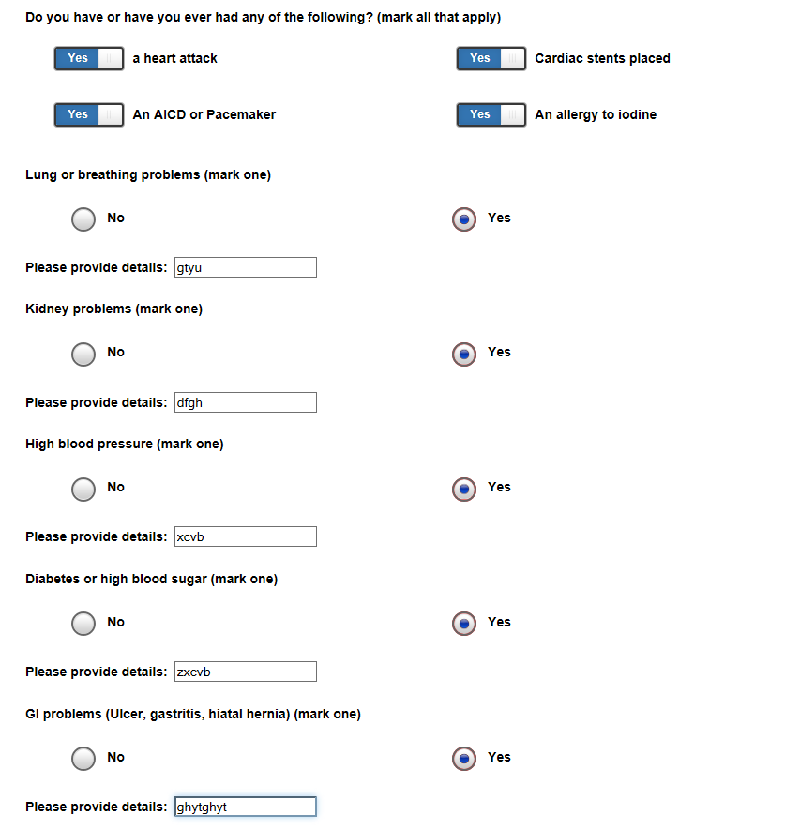 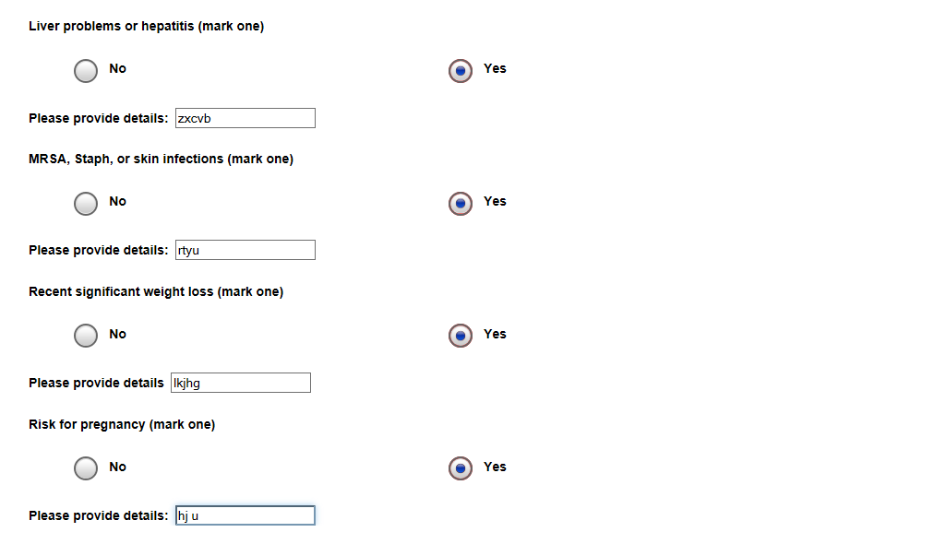 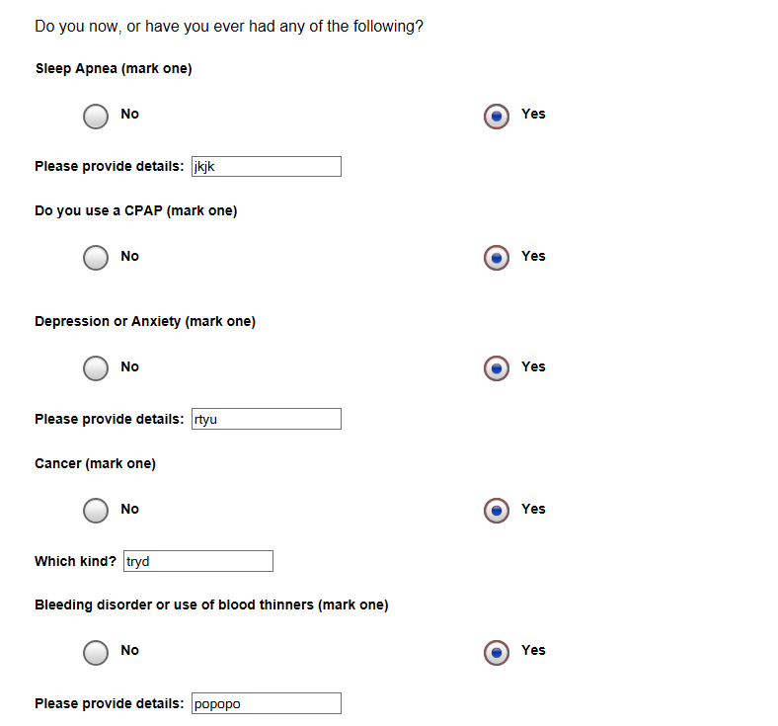 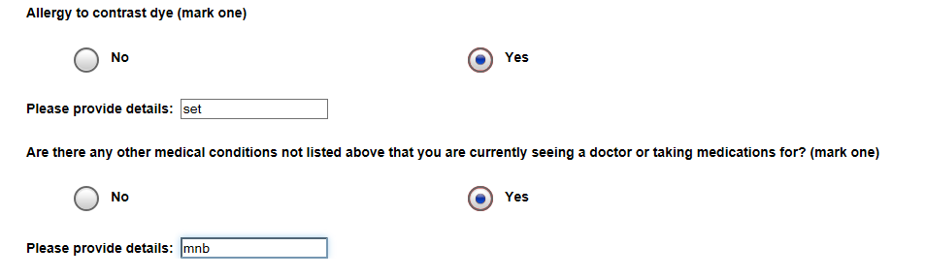

## Medications

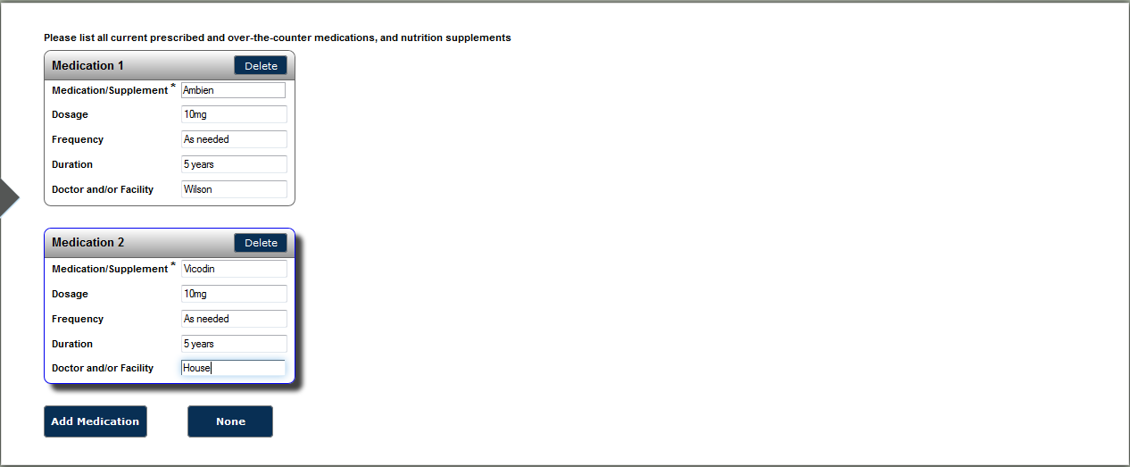

## Military Deployments & History

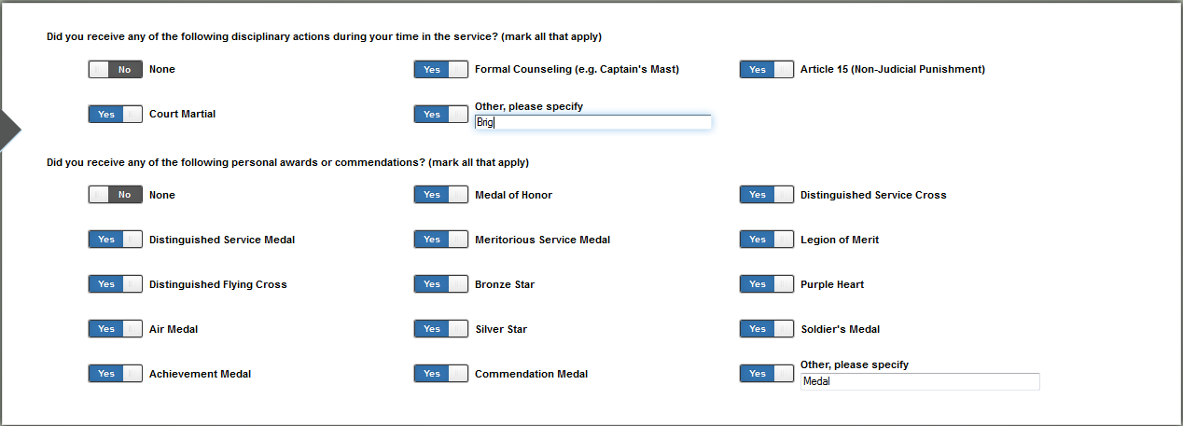

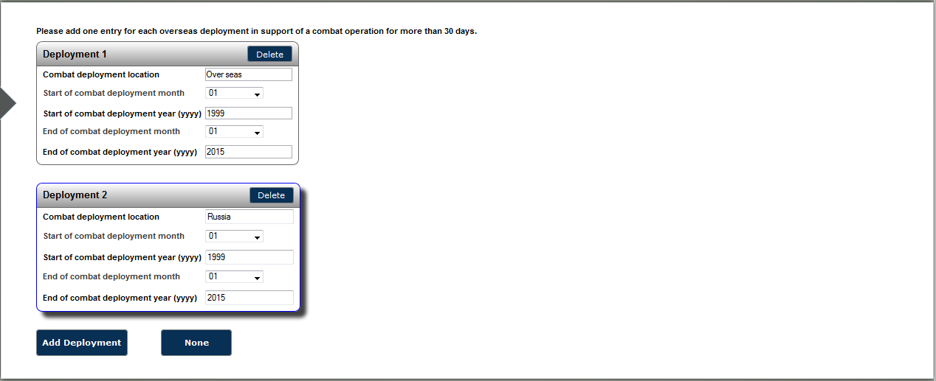

## MST

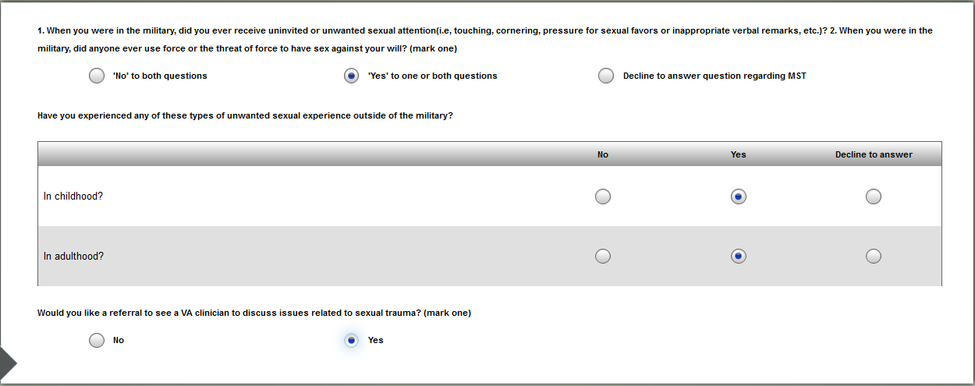

## Needs Vesting Exam

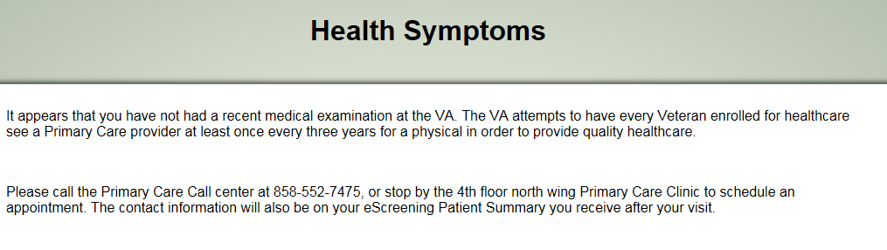

## NURS PACT NARRATIVE

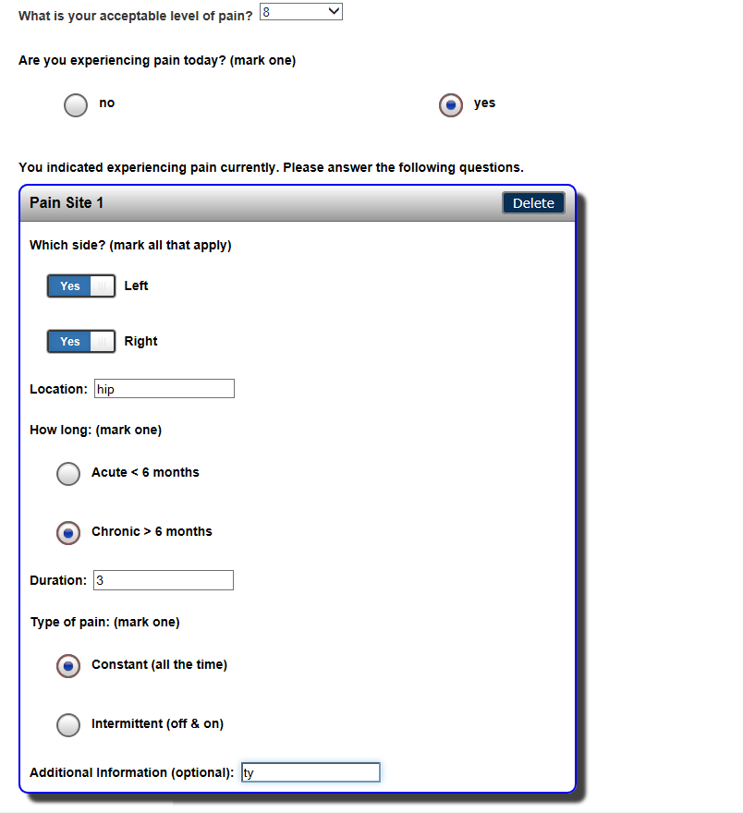

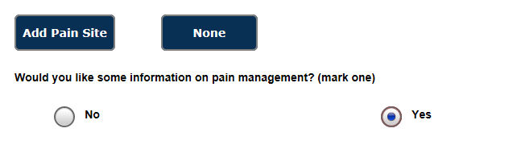

## OEF/OIF Clinical Reminder

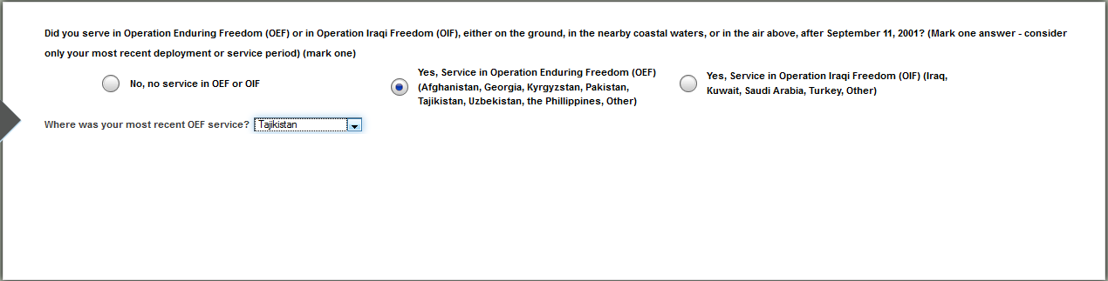

## OOO Infect & Imbedded Fragment Clinical Reminder

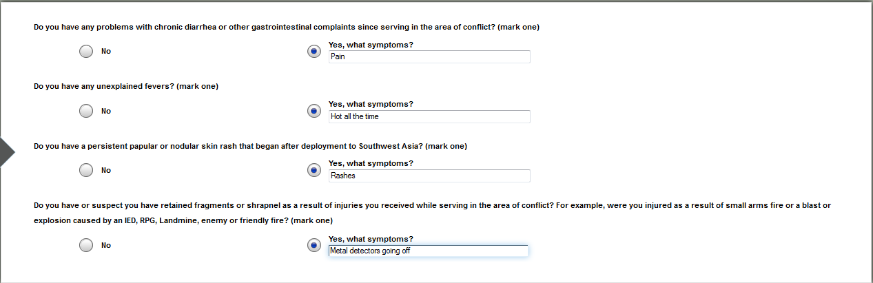

## Opiate Risk tool

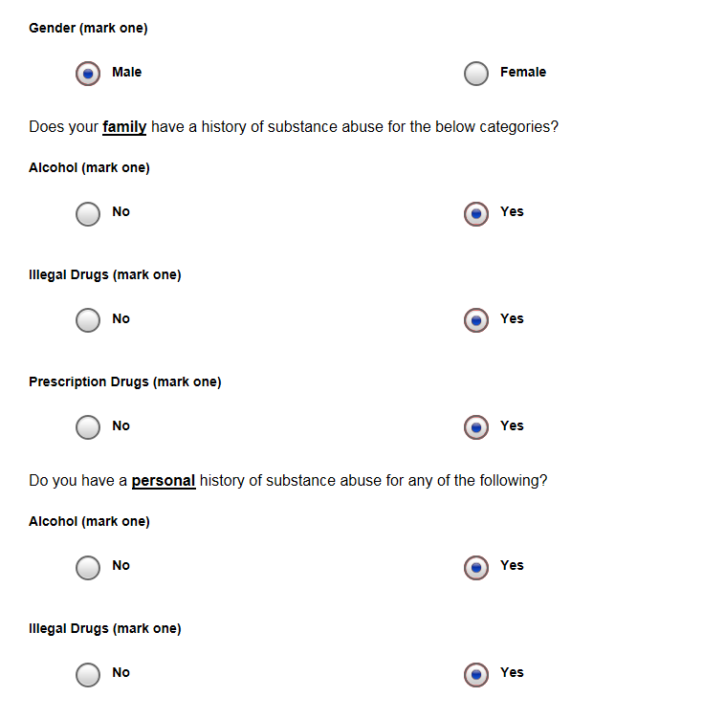

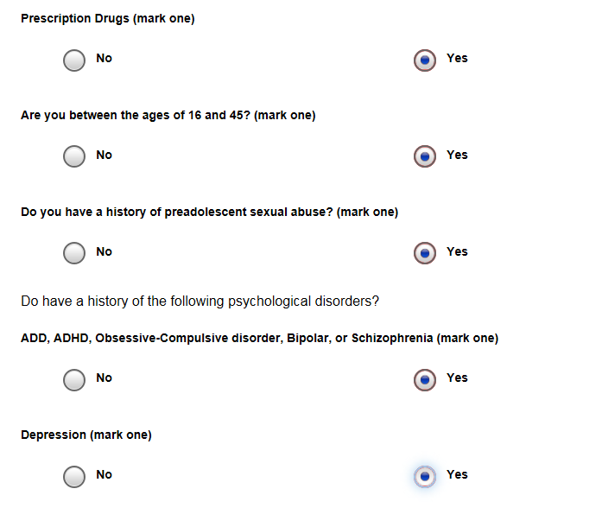

## Other Health Symptoms

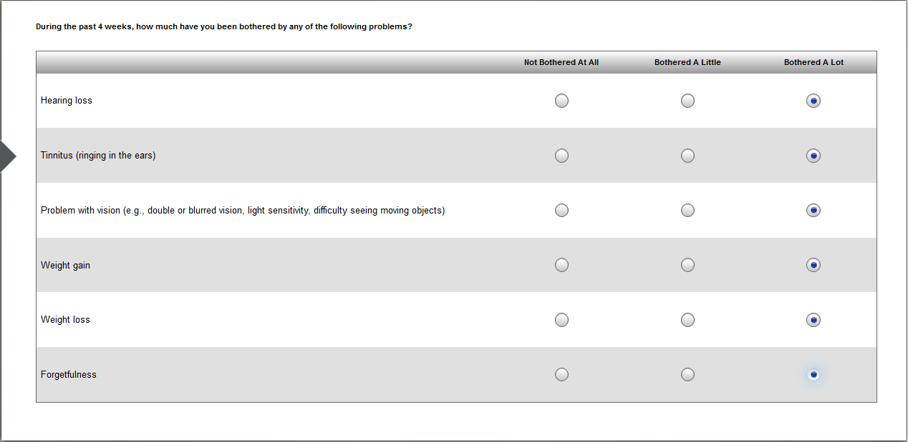

## PC-PTSD

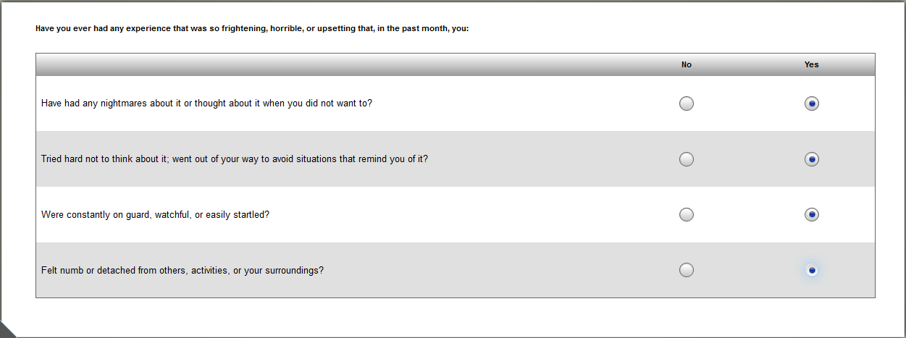

## PCL-5 (weekly)

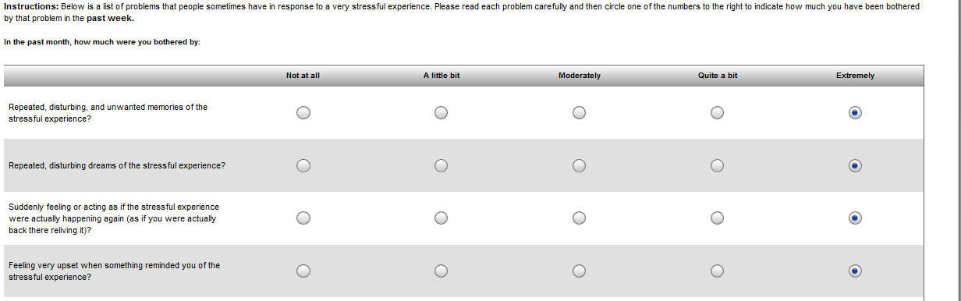

## PCL – 5 Modified 21 Item Version

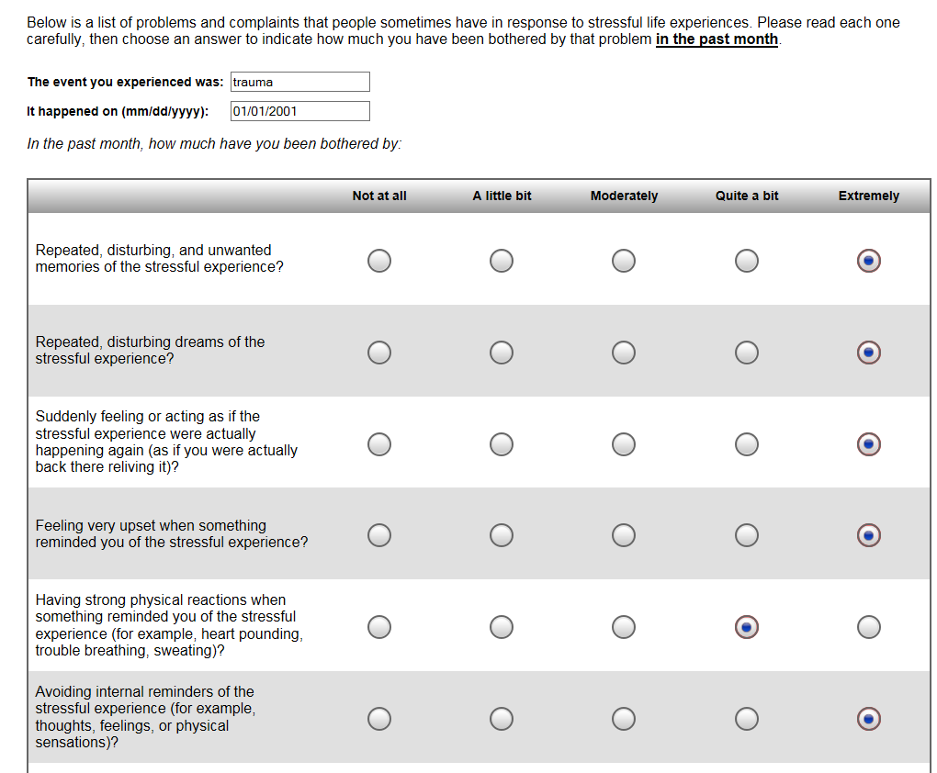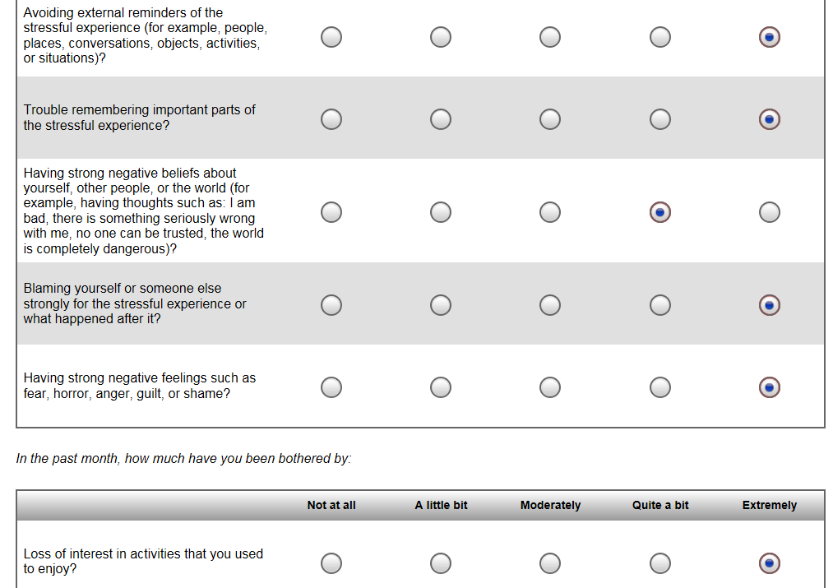

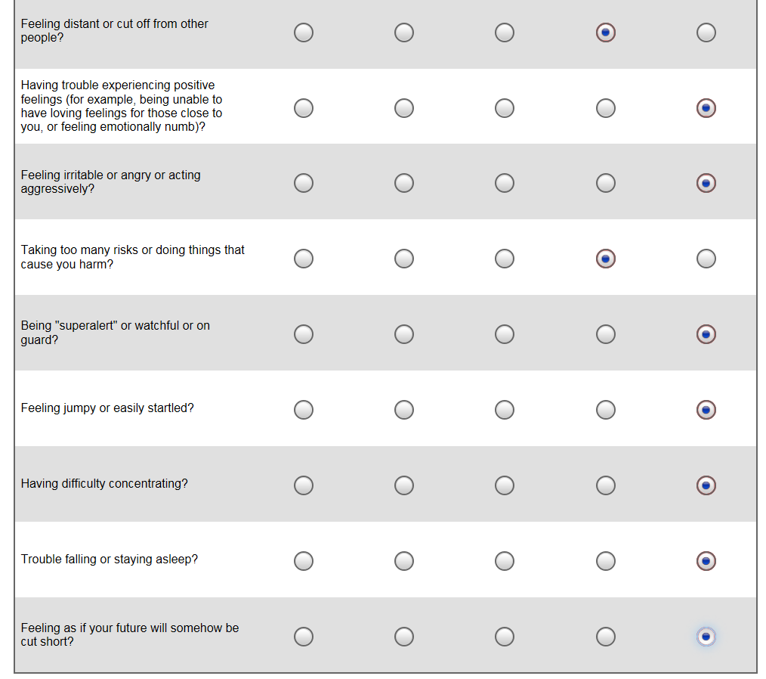

## PCL-C

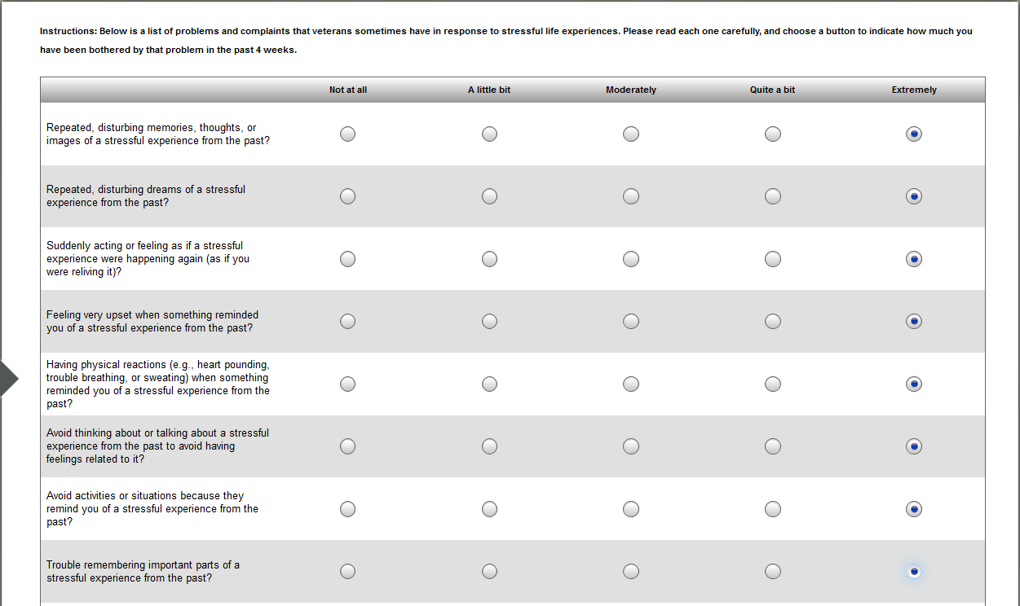

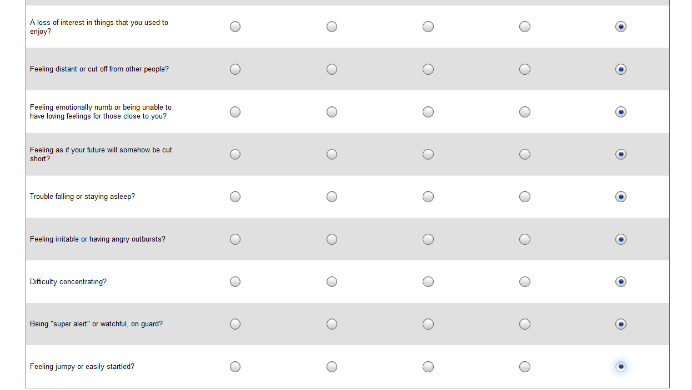

## PHQ Anxiety

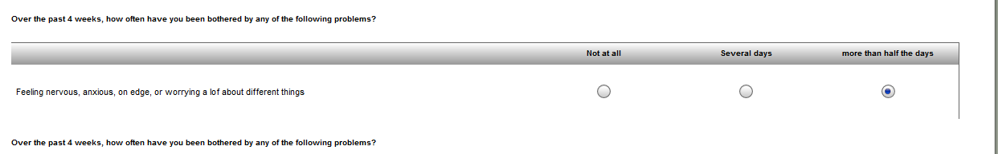 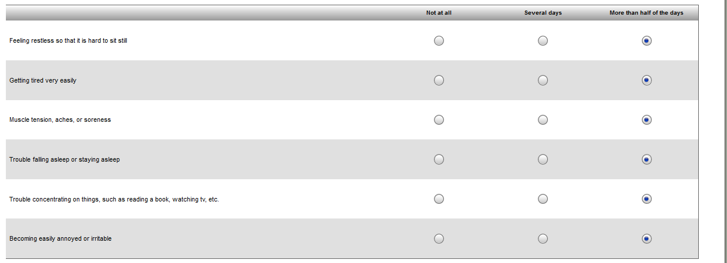

## PHQ-15

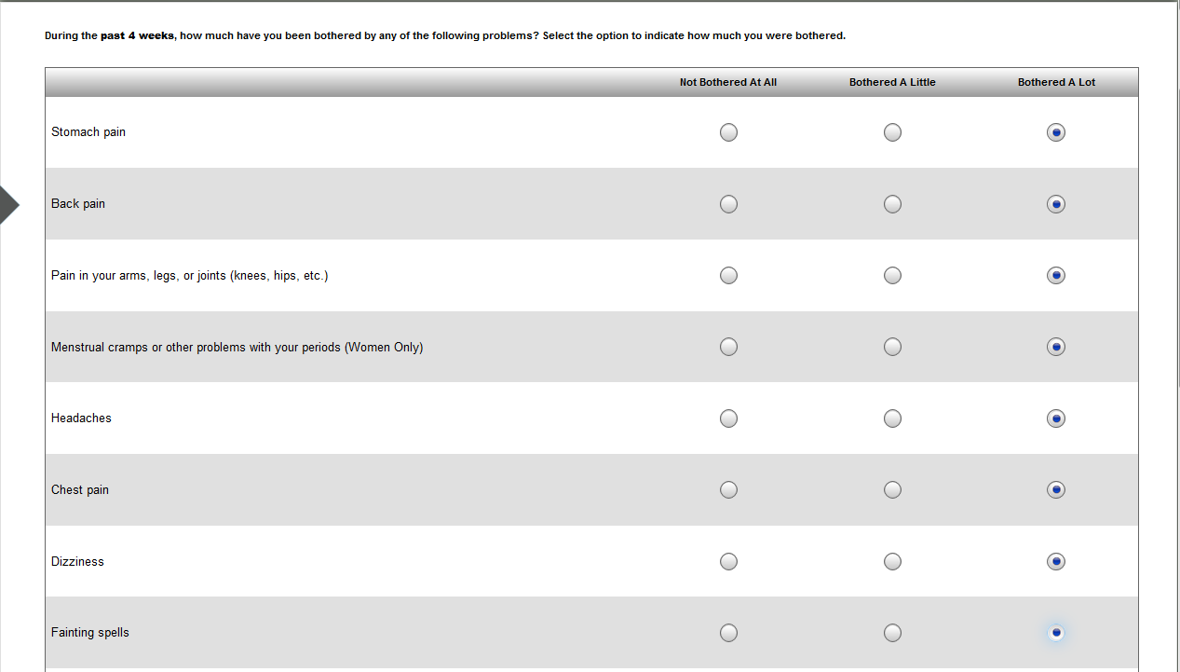

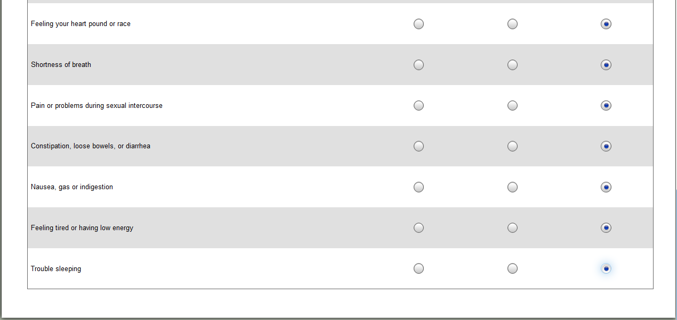

## PHQ-9

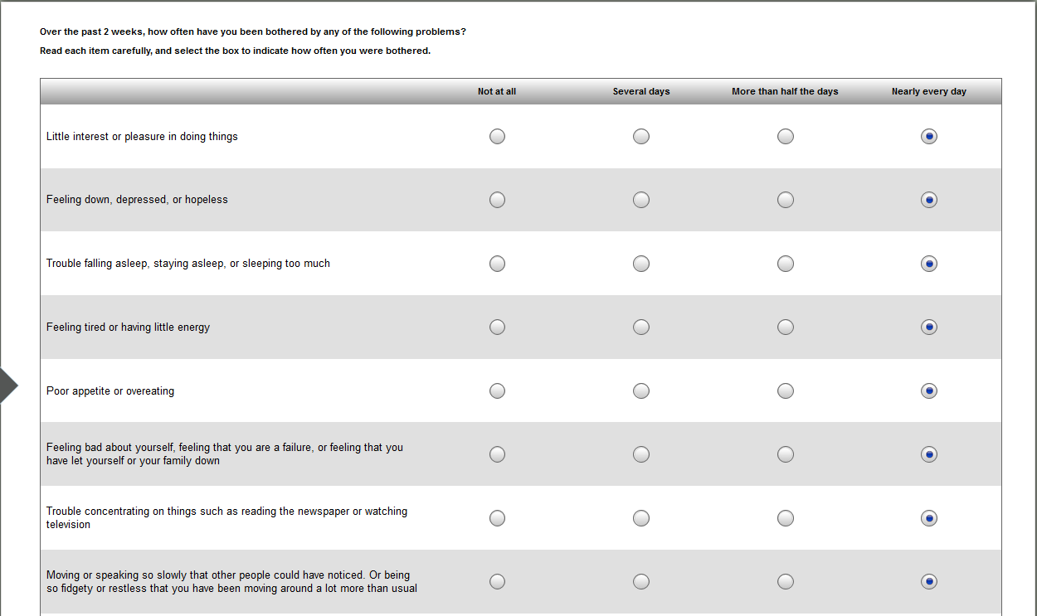

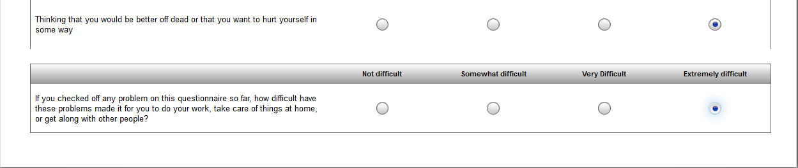

## Pain Assessment Guide

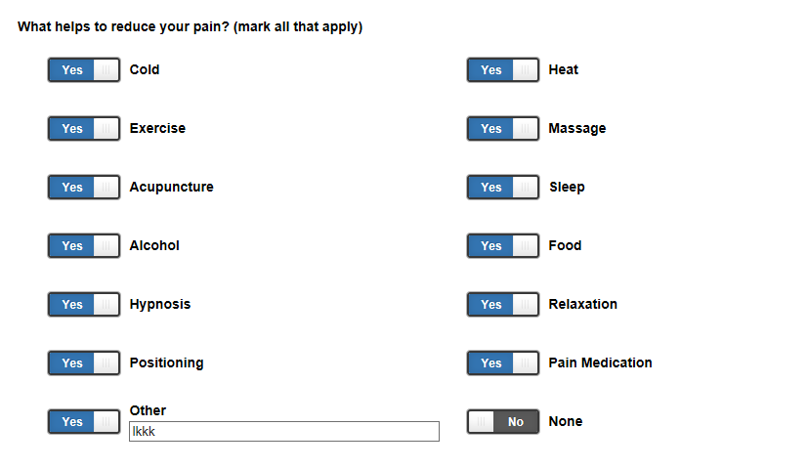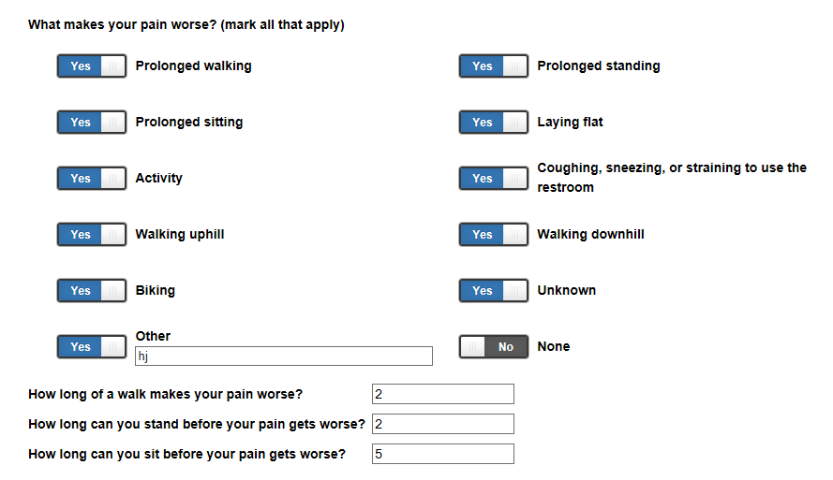

## Pain Chart

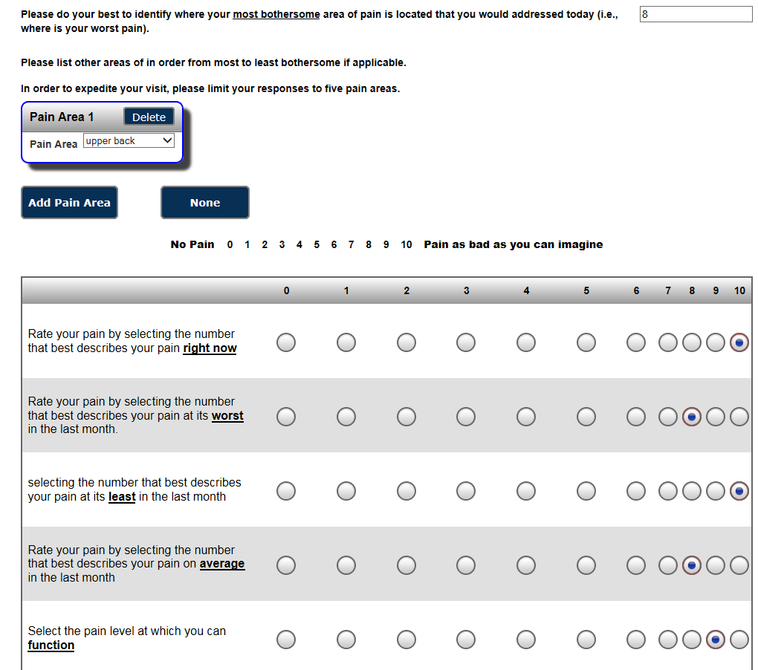

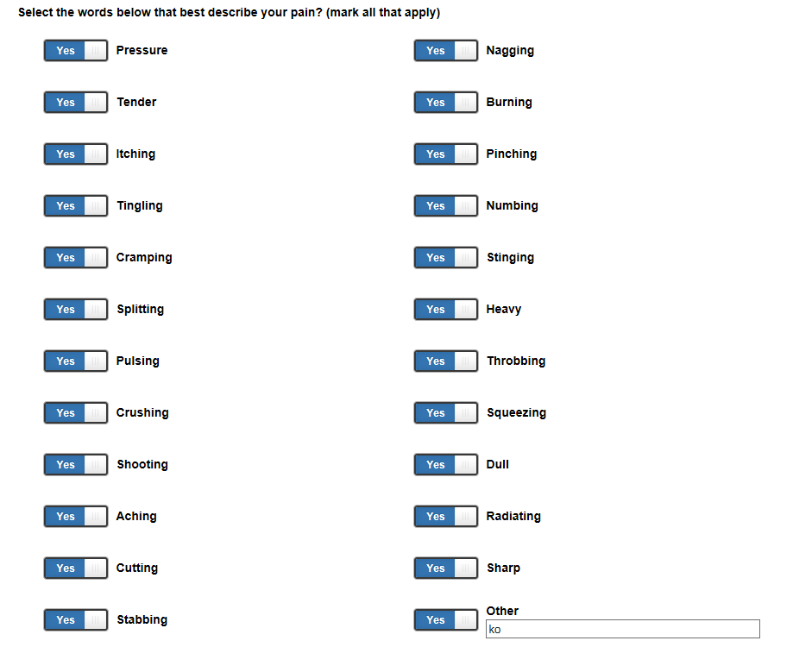

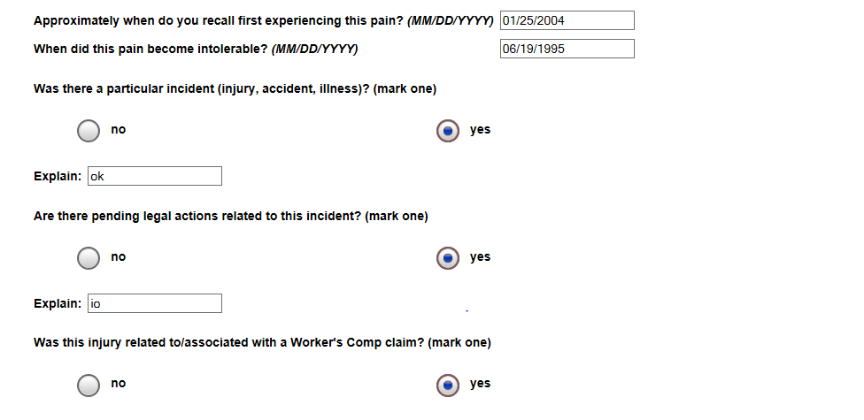

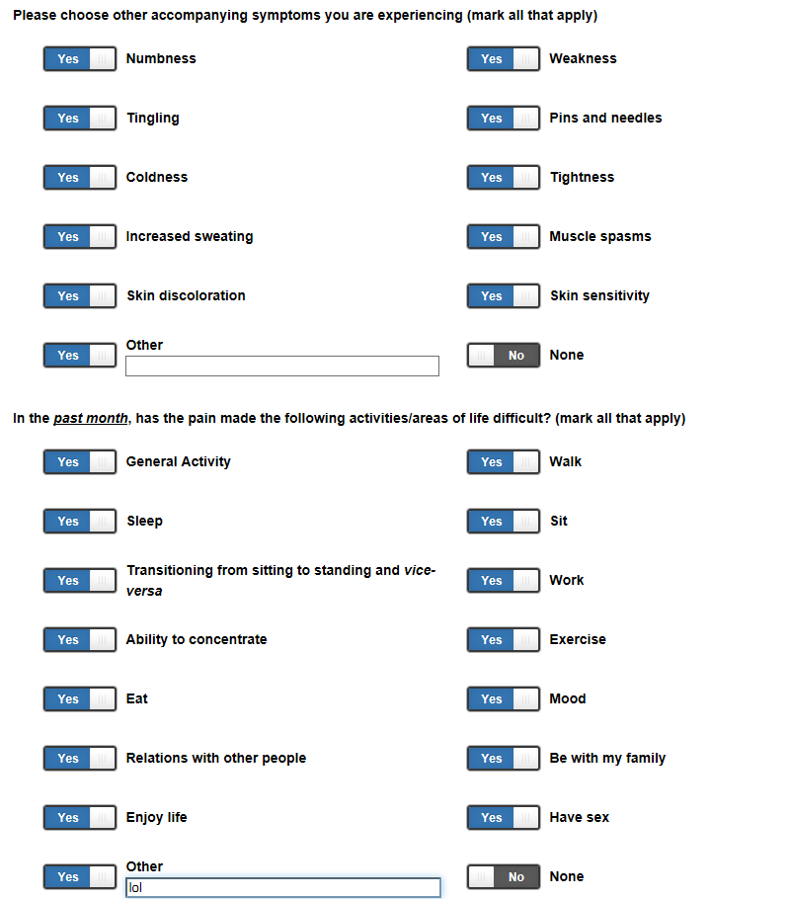 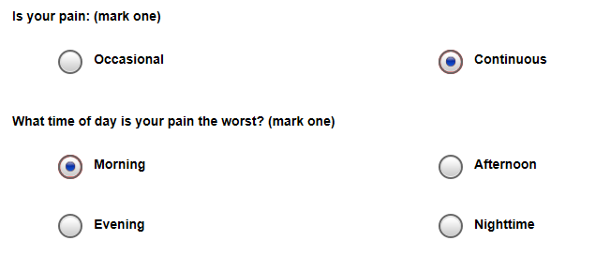

Pain Medications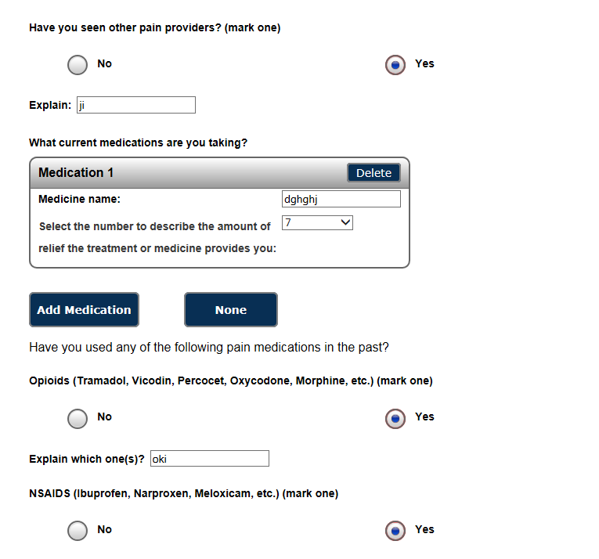  
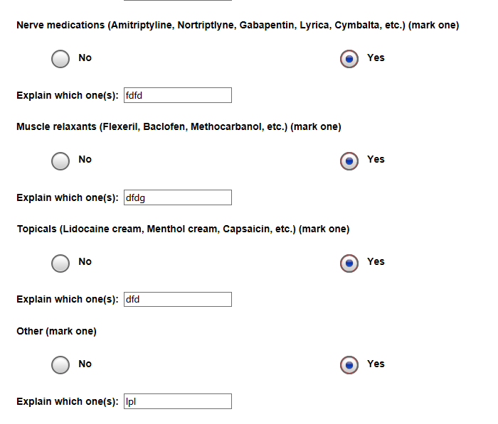

## Past Social History

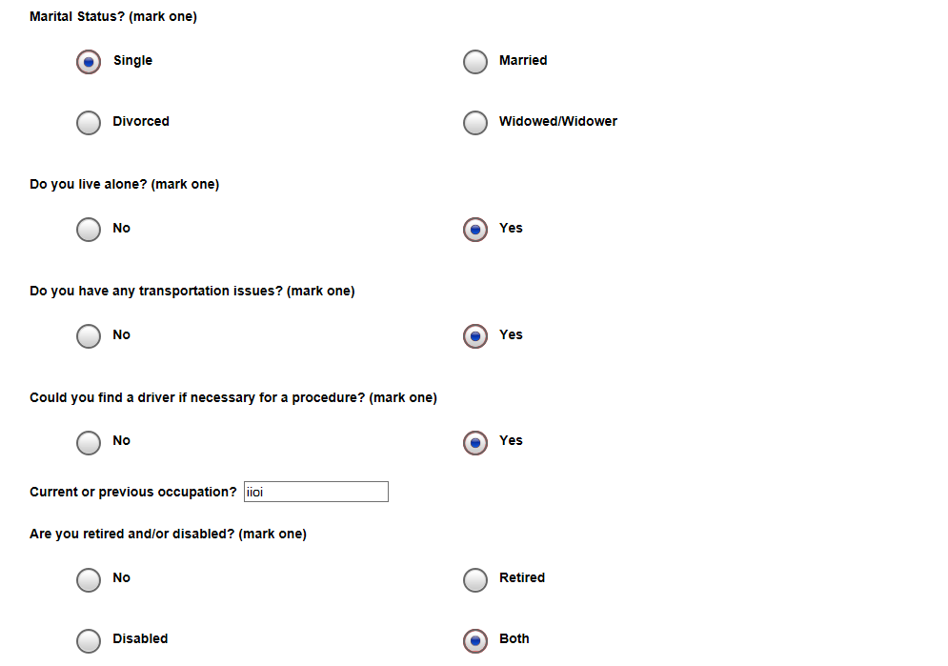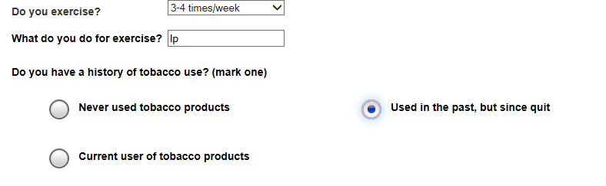

## Pragmatic Concerns

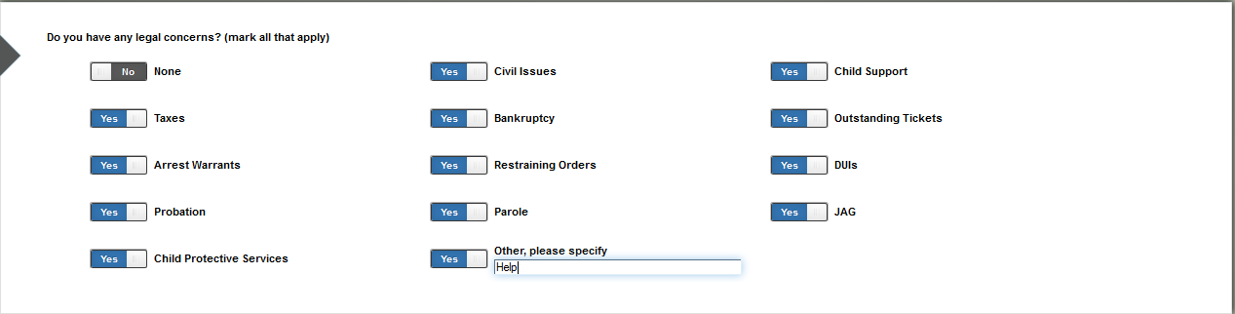

## Premenstrual Symptoms Screening Tool

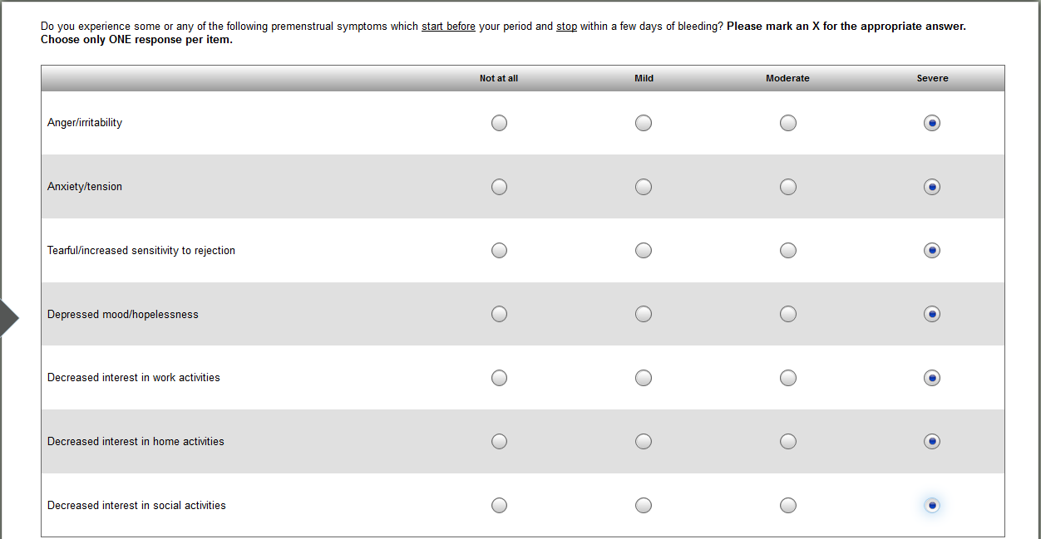

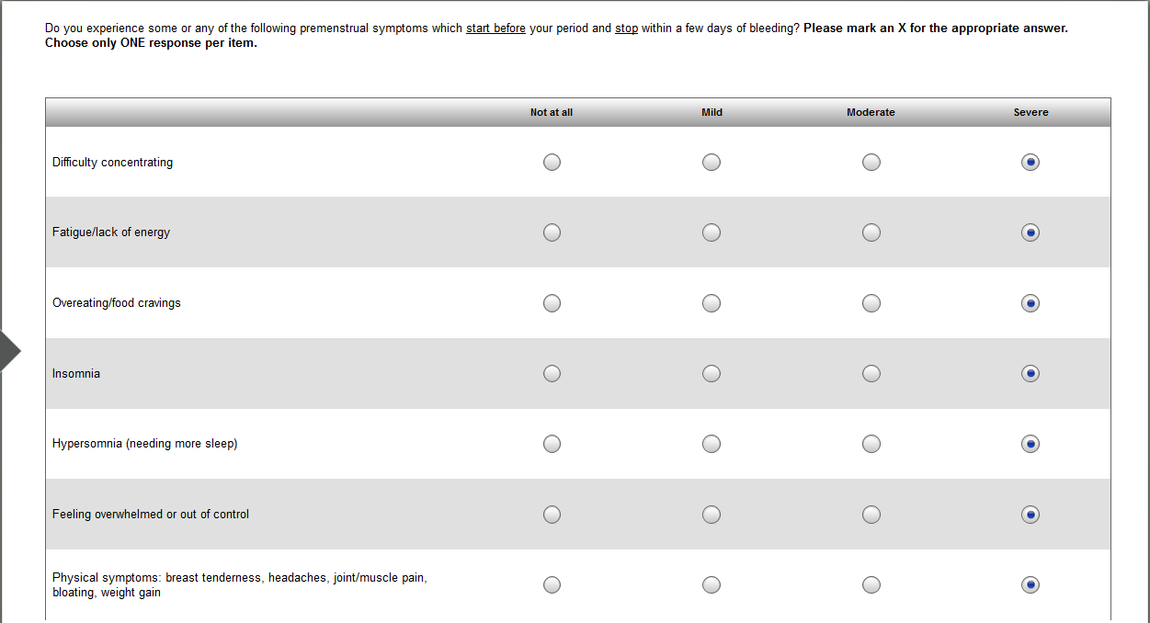

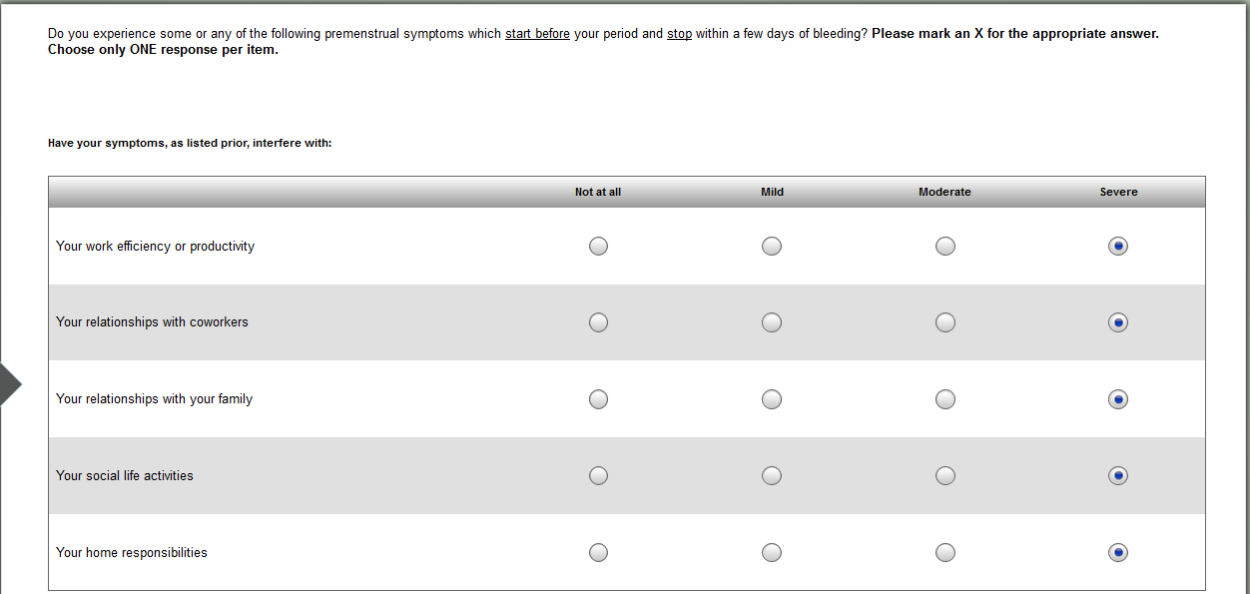

## Presenting Mental Health Issues

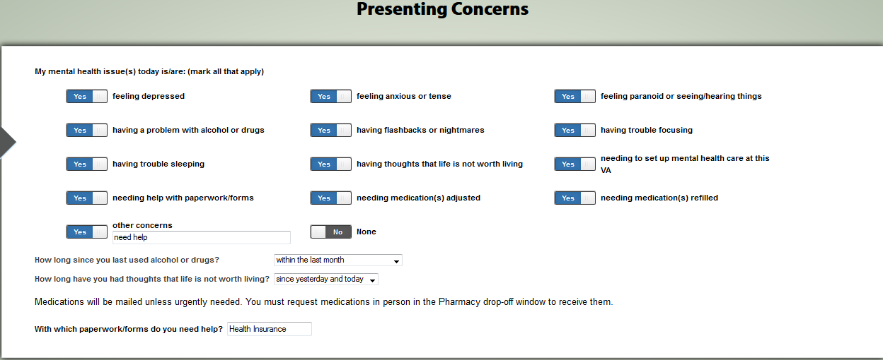

## Presenting Problems

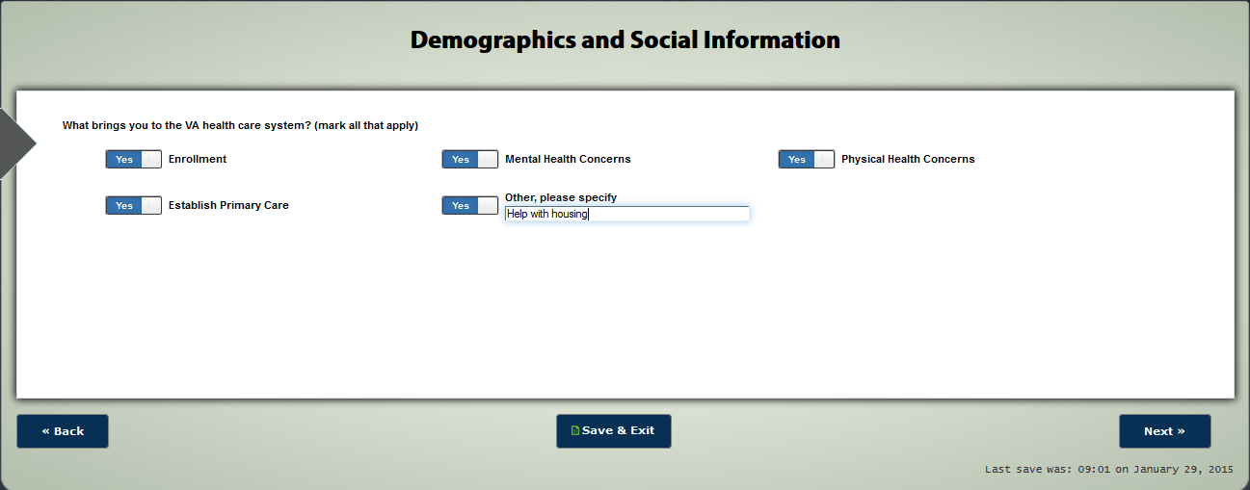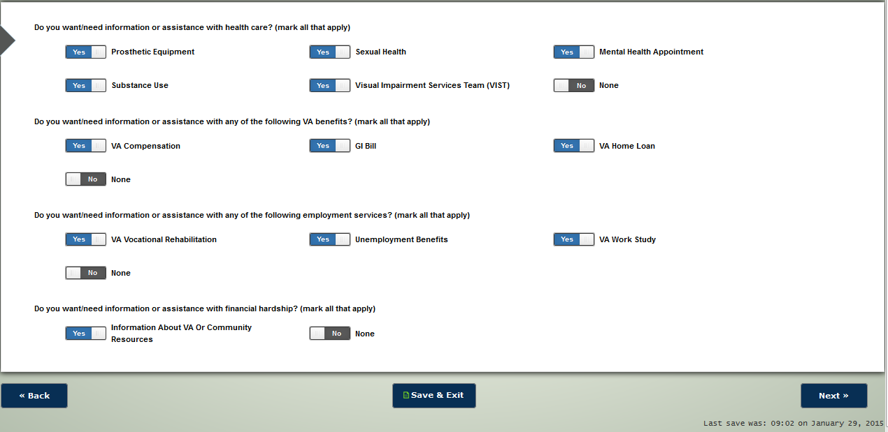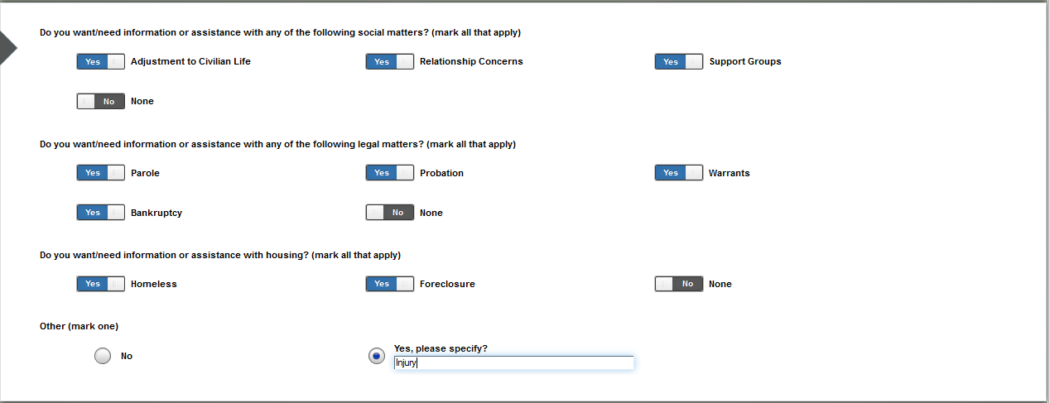

## Prior Hospitalizations and Meds

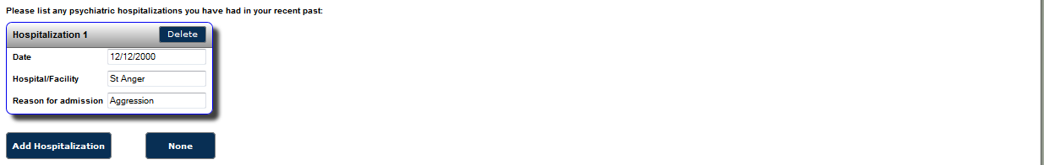 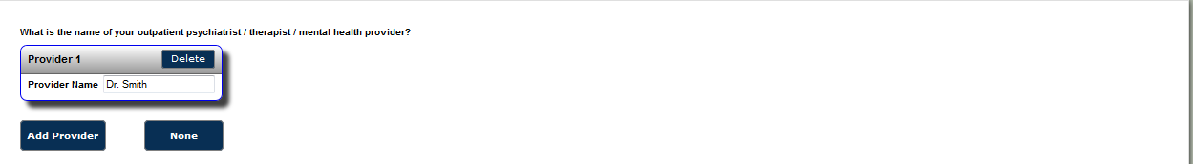 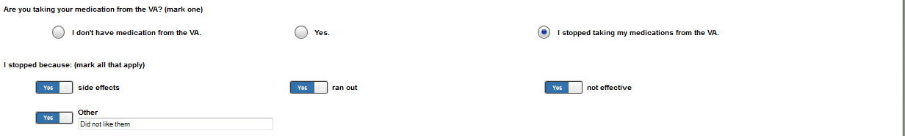

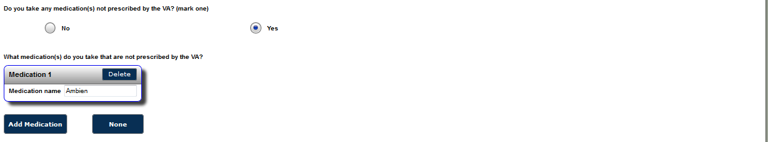 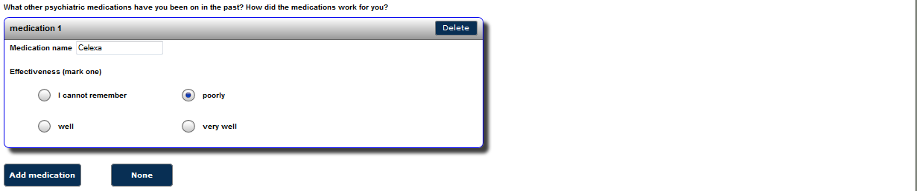

## Prior MH Treatment

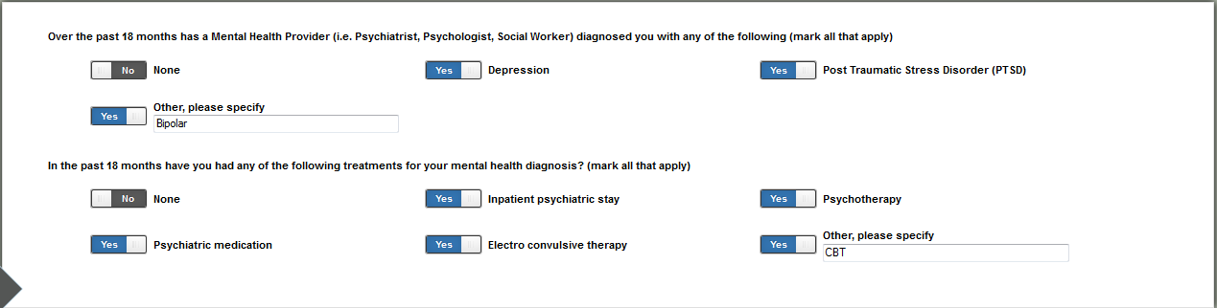

## PROMIS Emotional Support

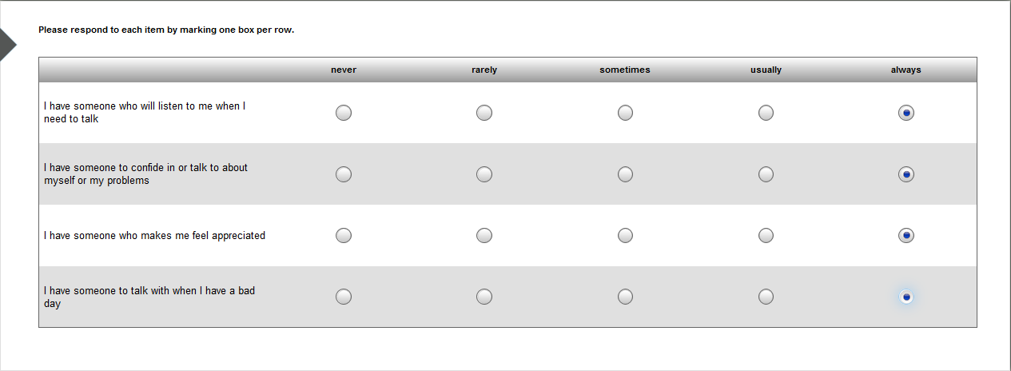

## PROMIS Pain Intensity & Interference

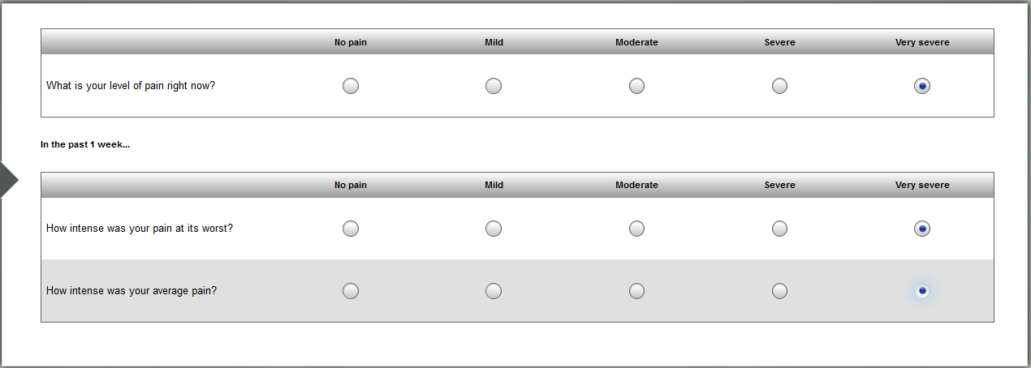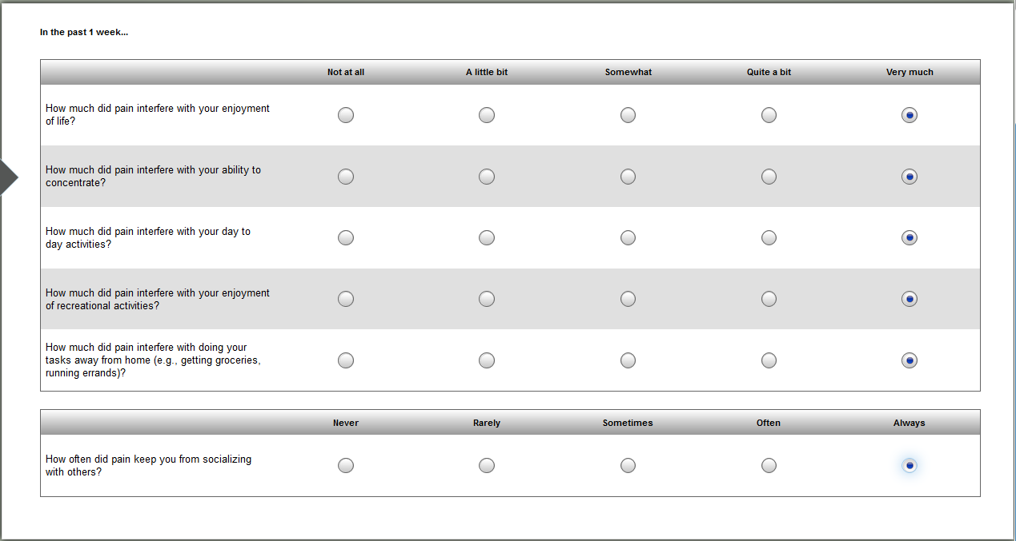

## PSAS

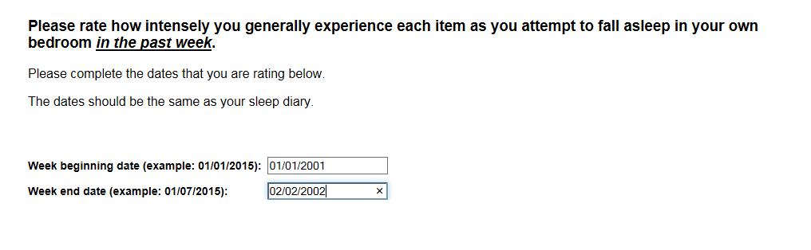 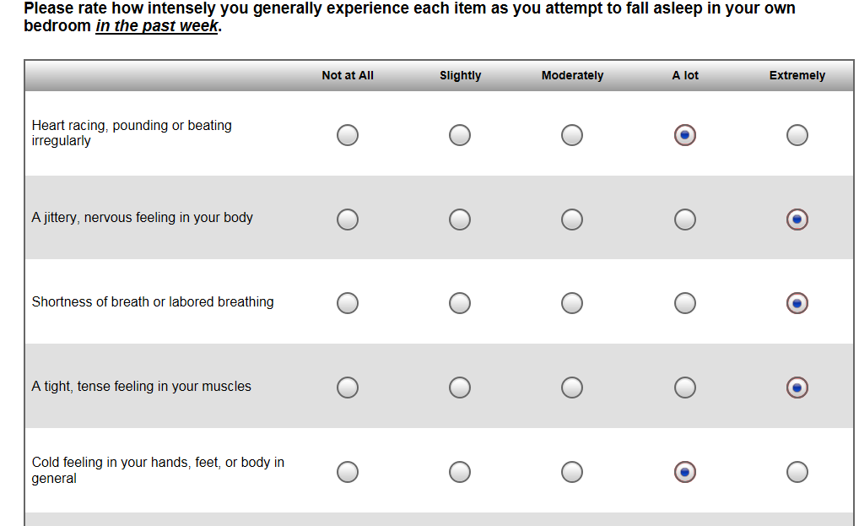 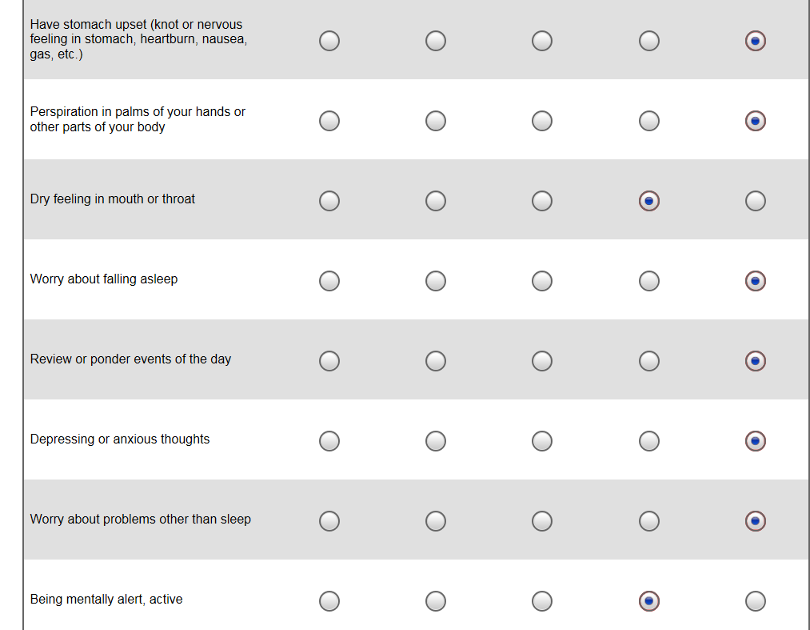 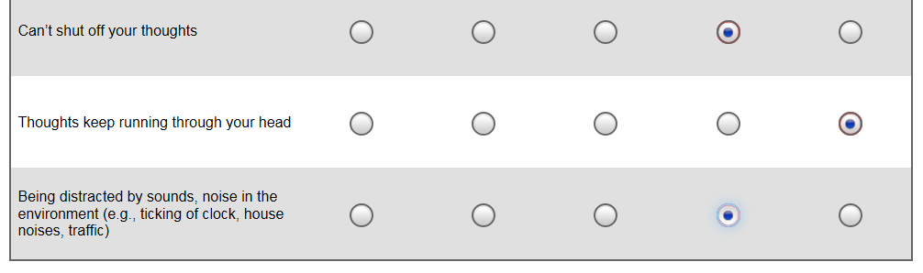

## ROAS

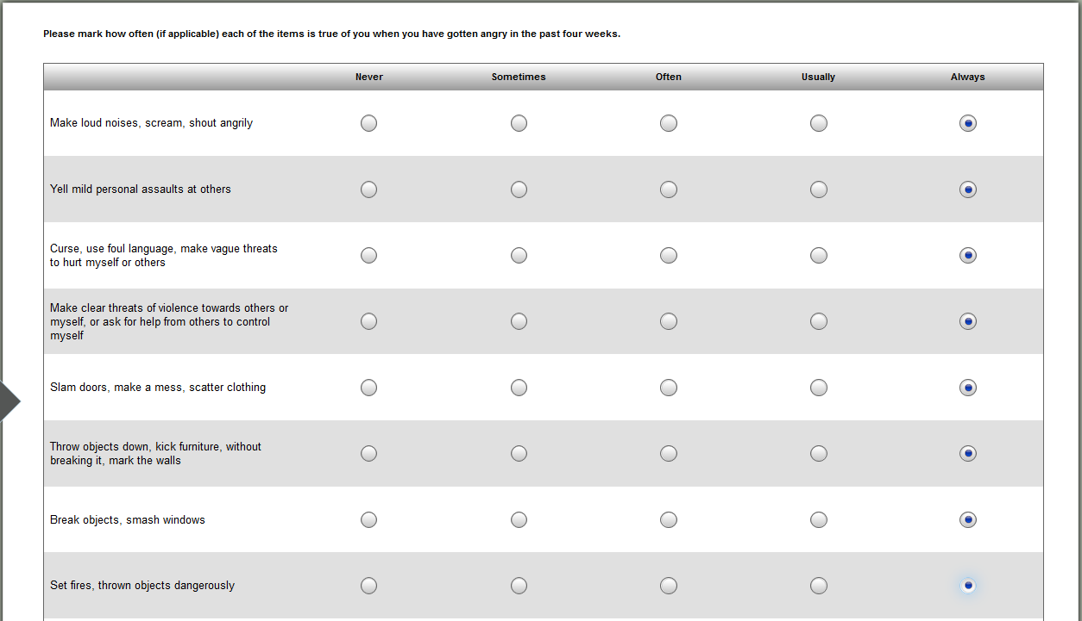

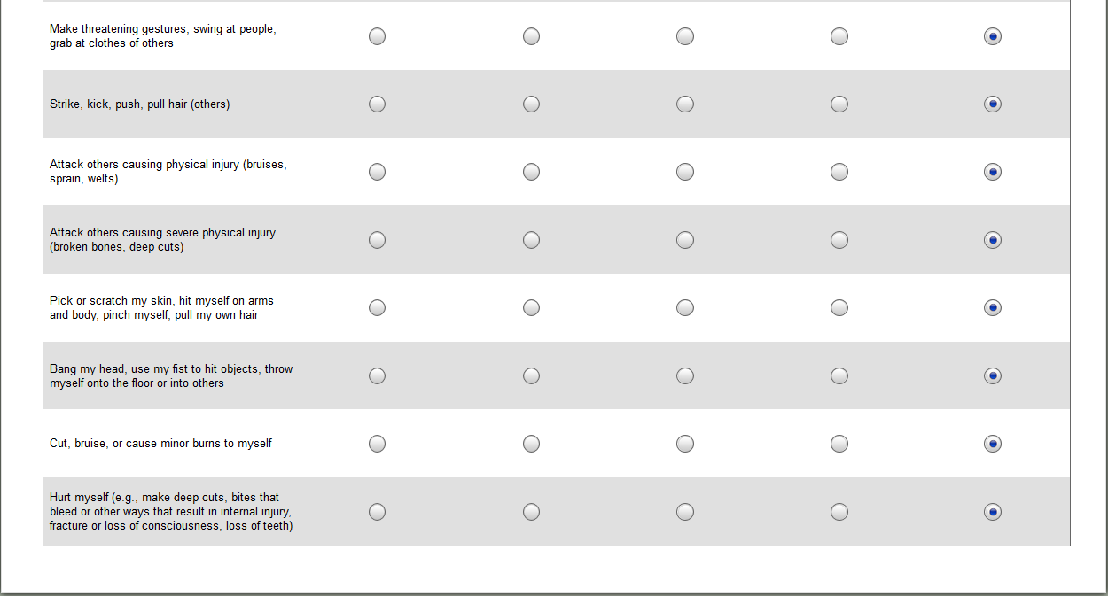

## Service History

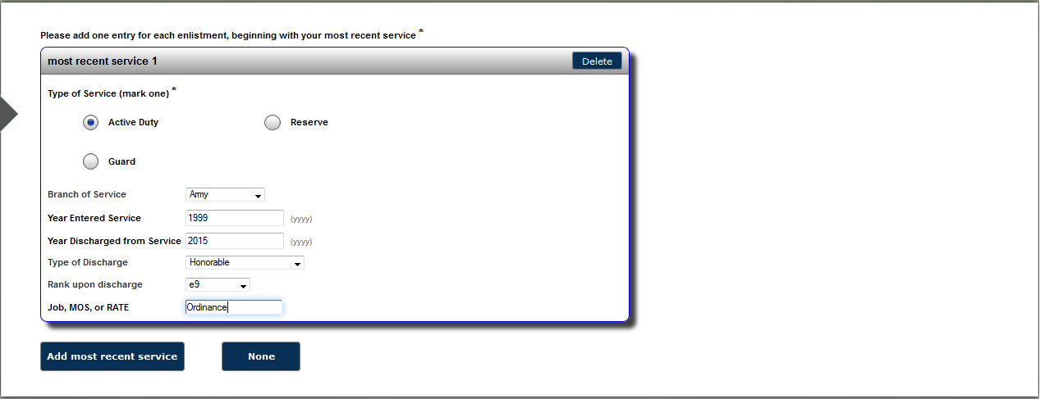

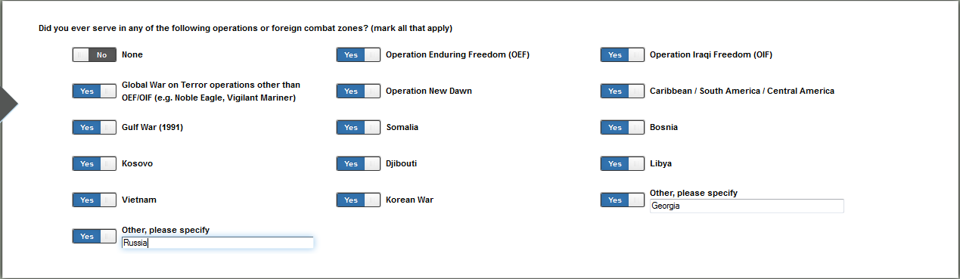

## Service Injuries

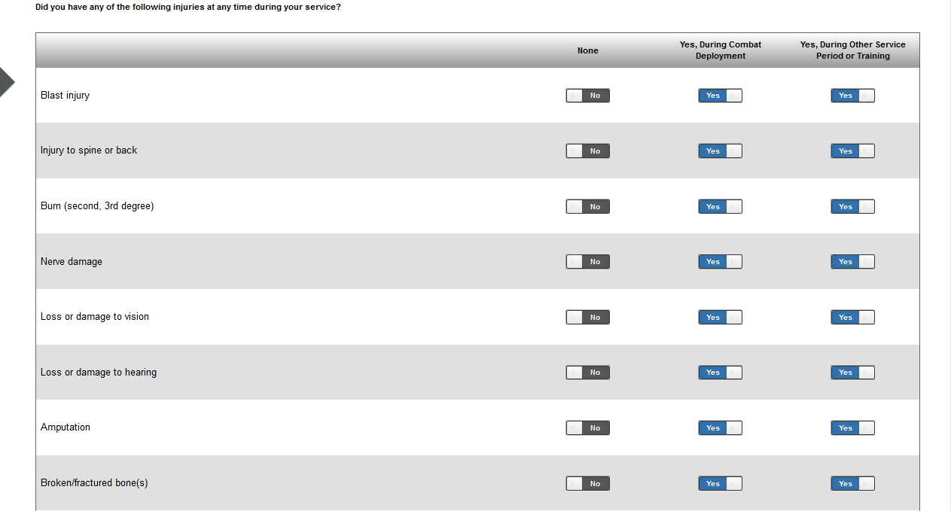

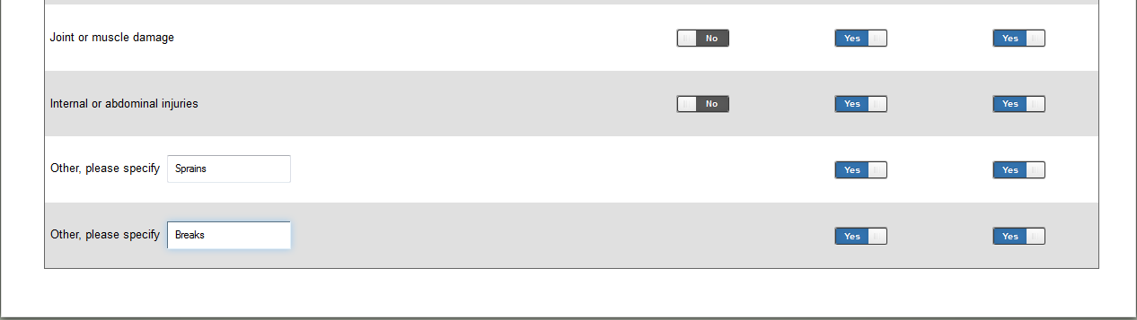

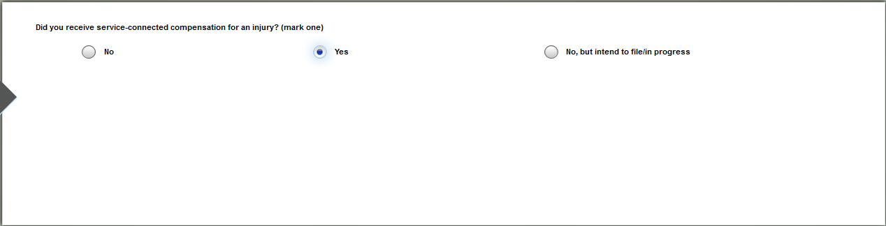

## 

SF McGill Questionnaire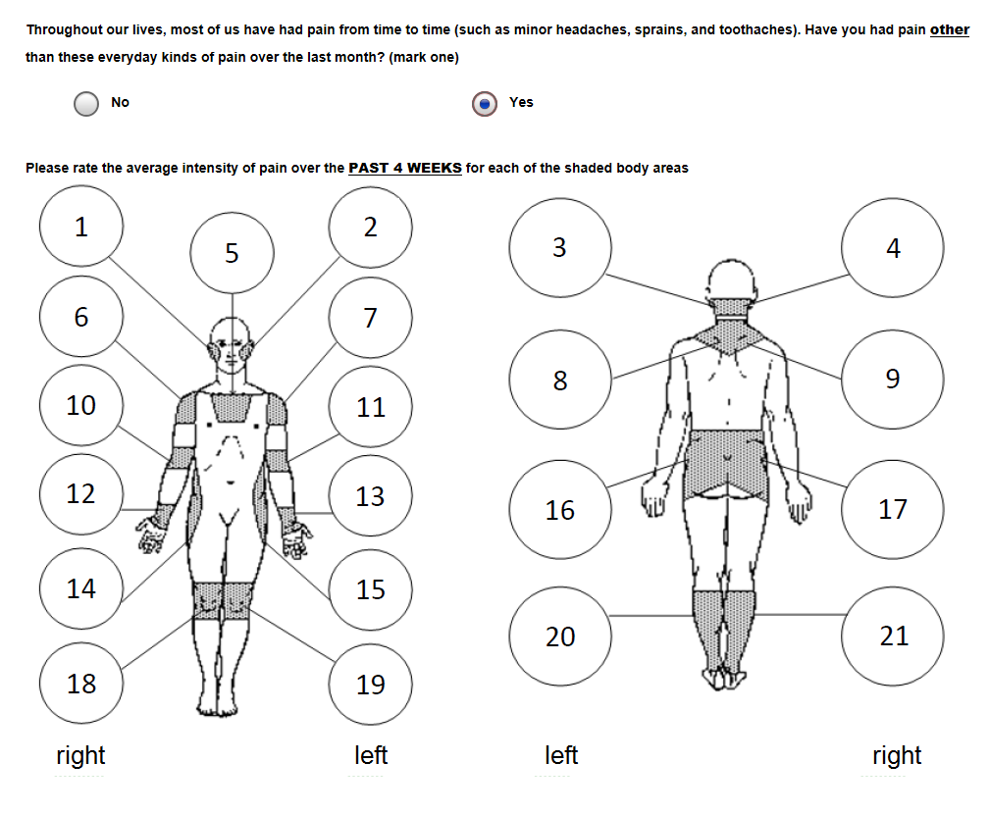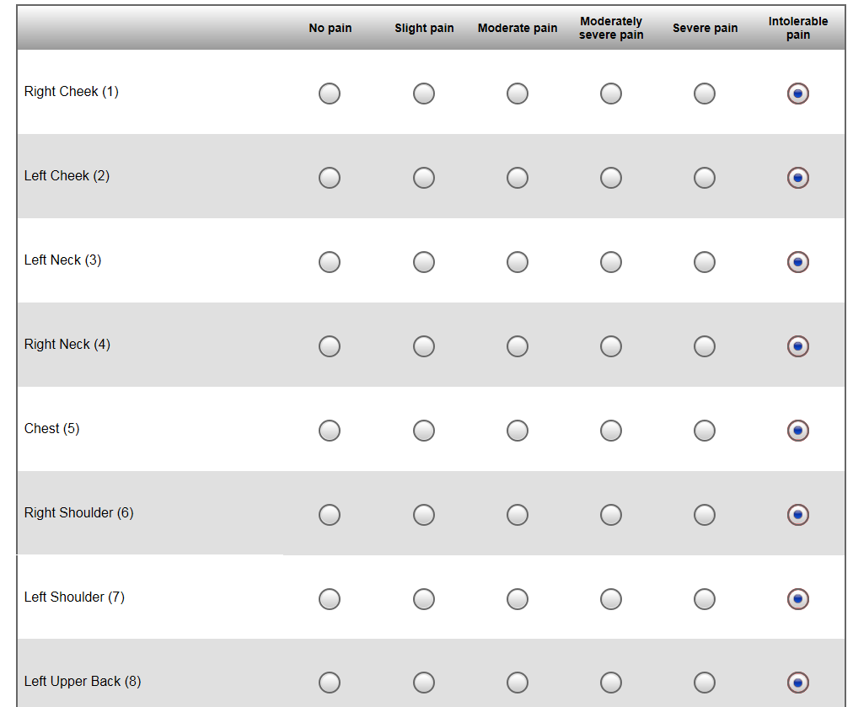 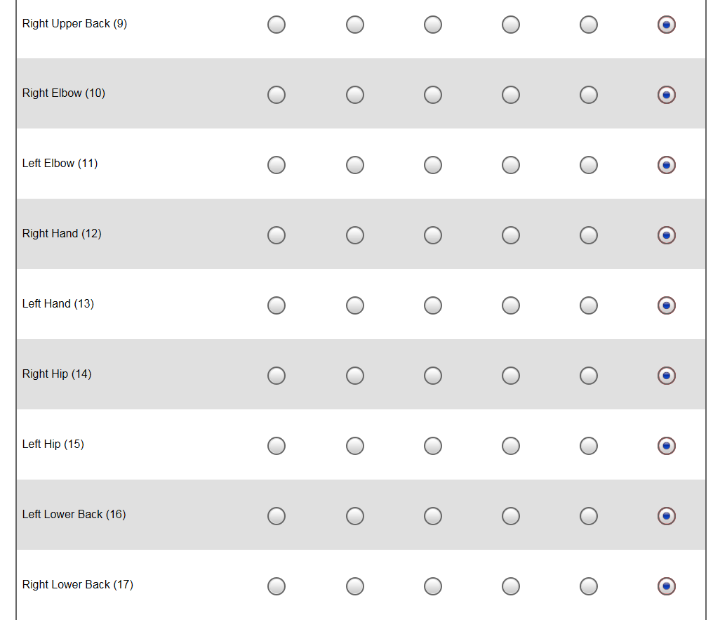 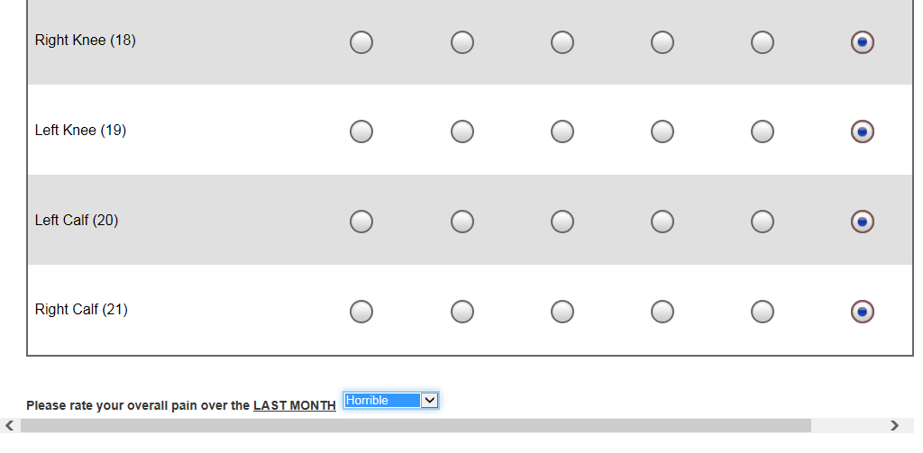 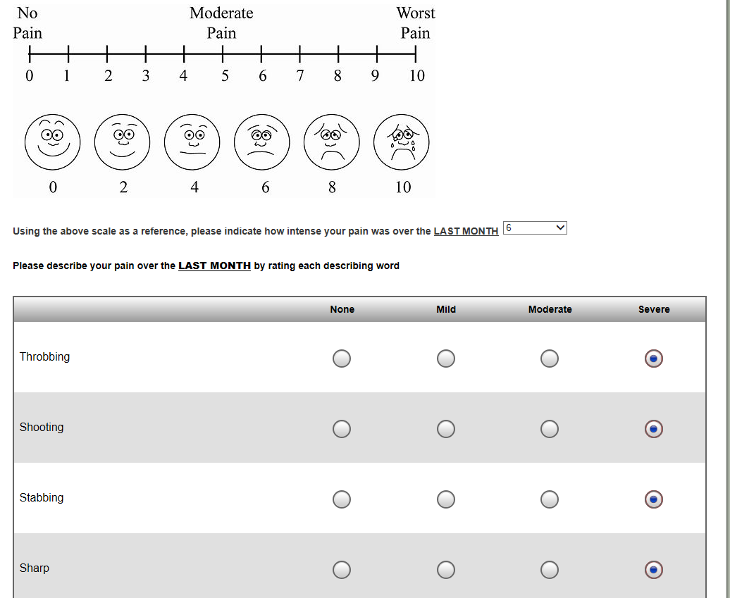 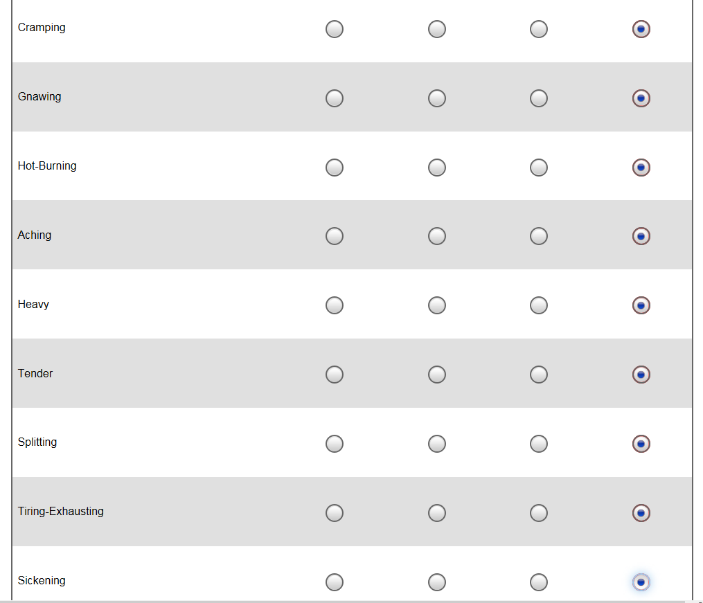 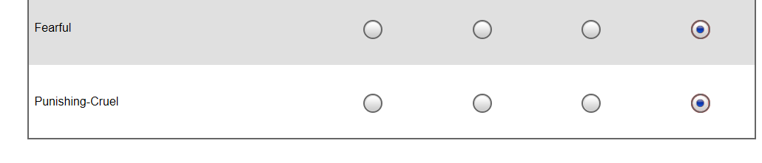

## Surgical History

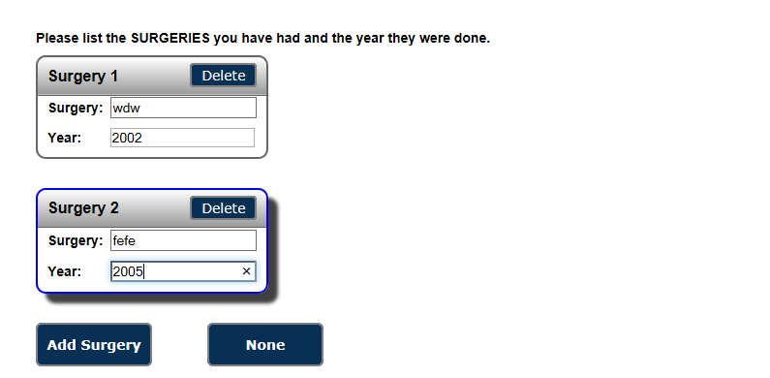

## Social Environment

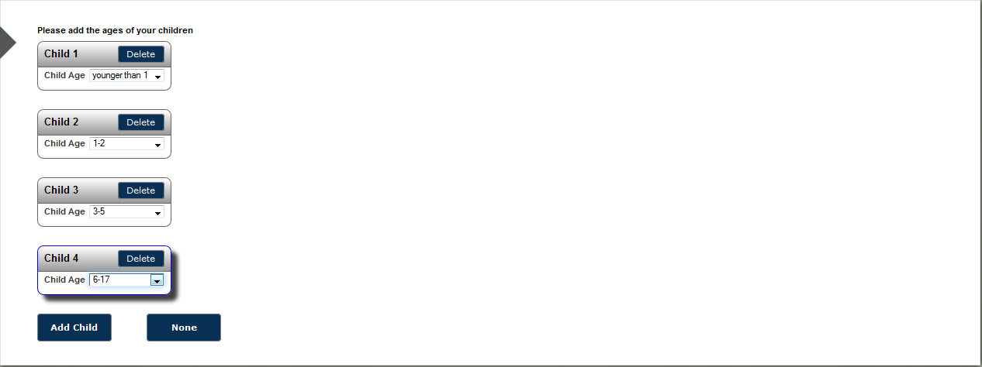

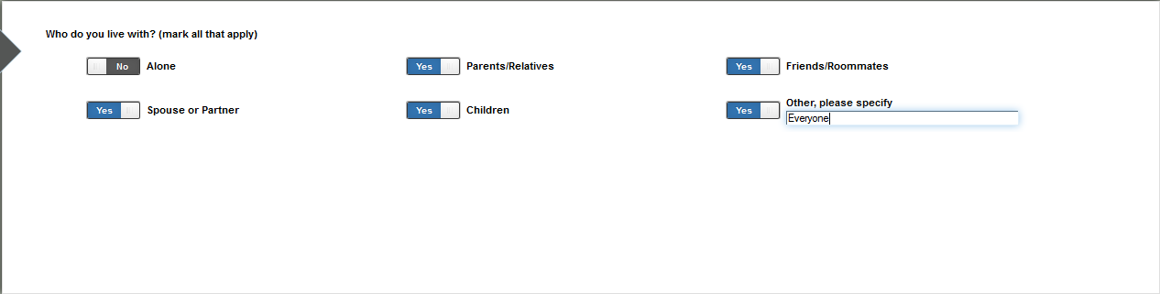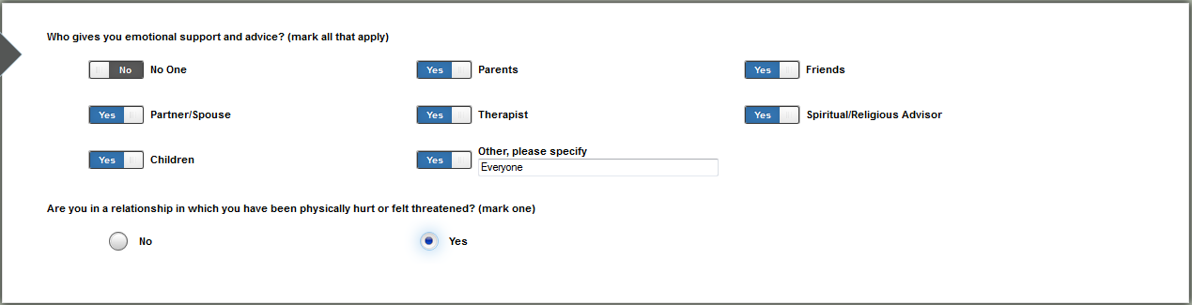

## Spiritual Health

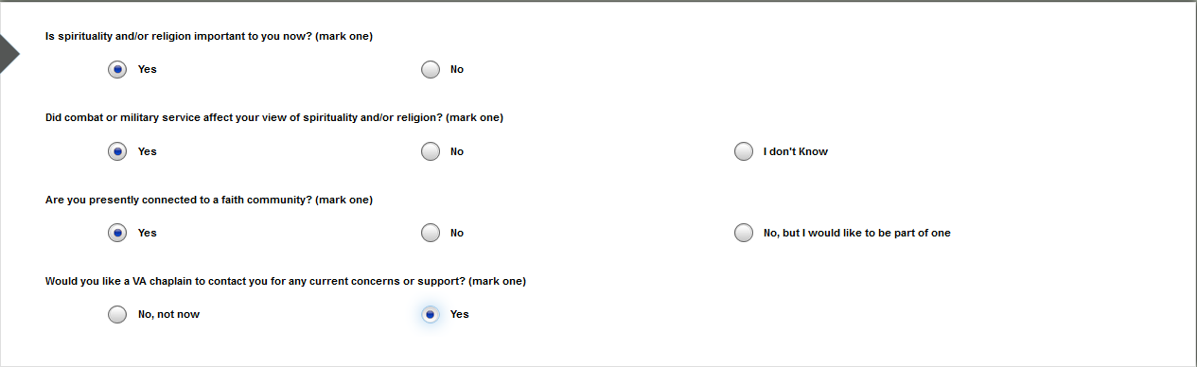

## Stressors and Distressing Symptoms

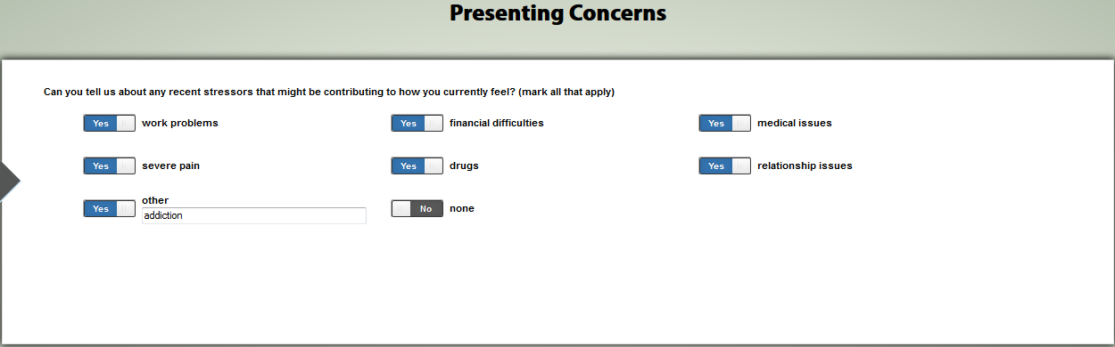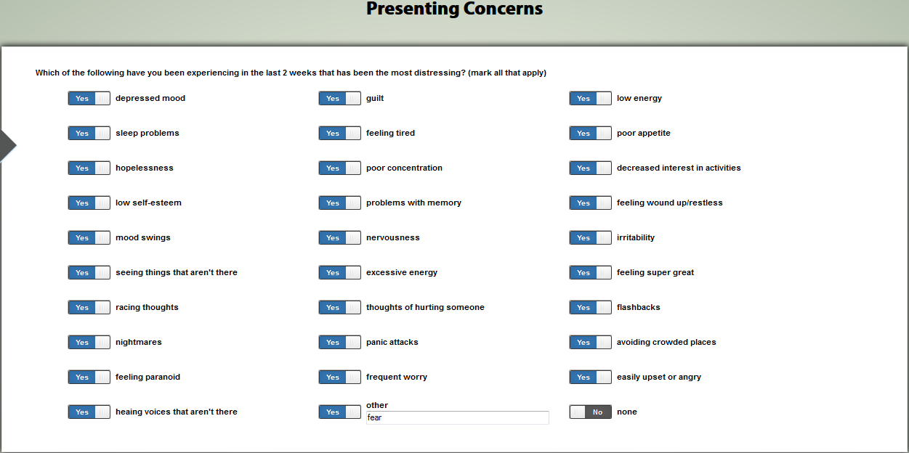

## Therapeutic History

## Tobacco Cessation Screen

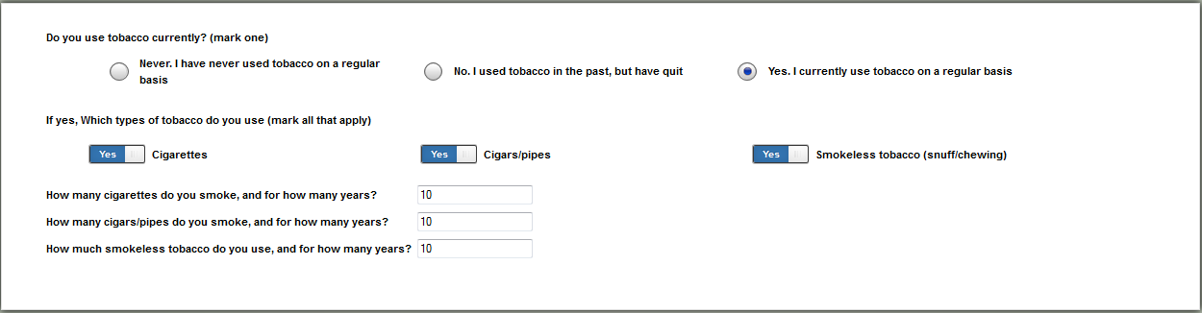

## Trauma-Related Guilt Inventory

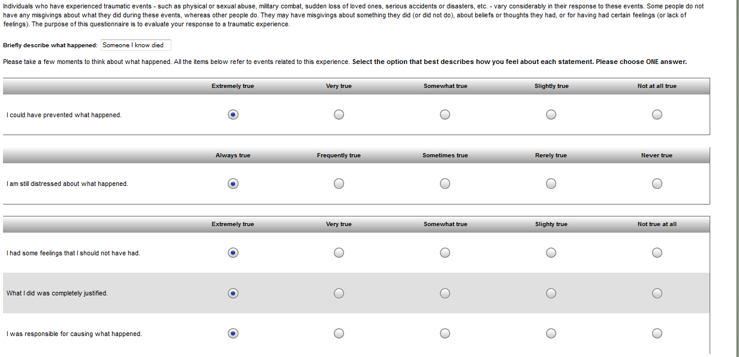

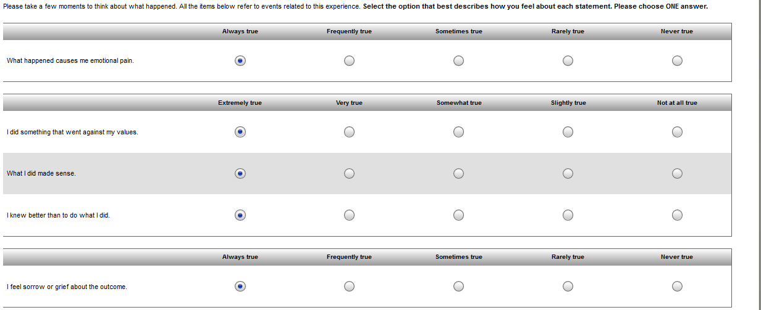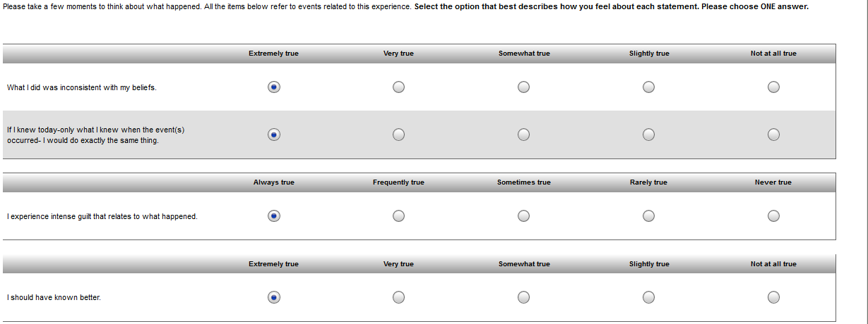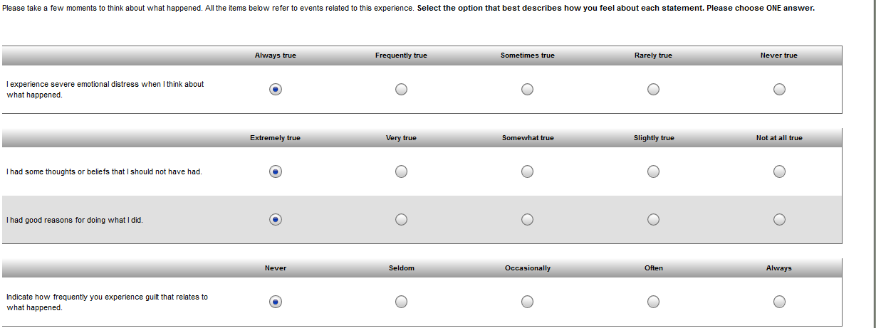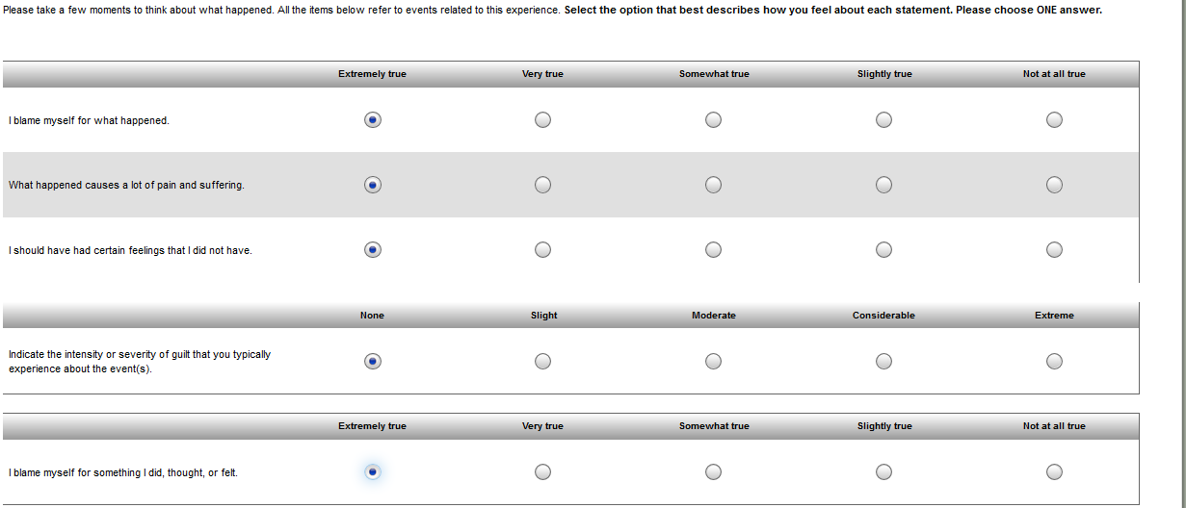

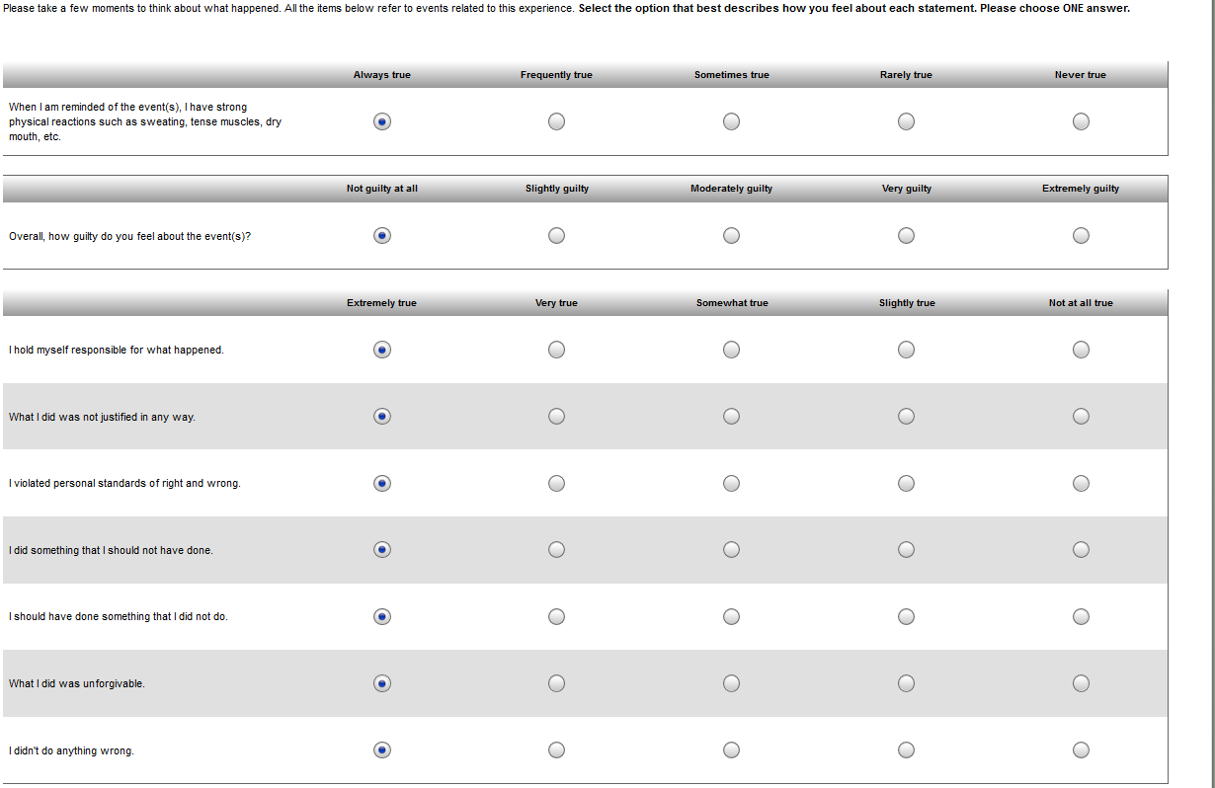

## Veterans RAND-12

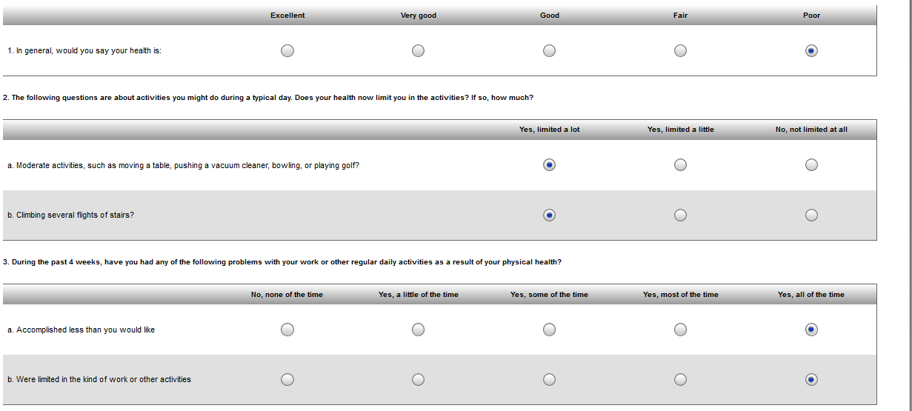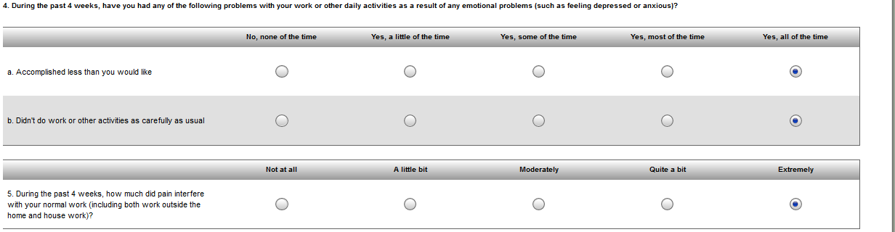

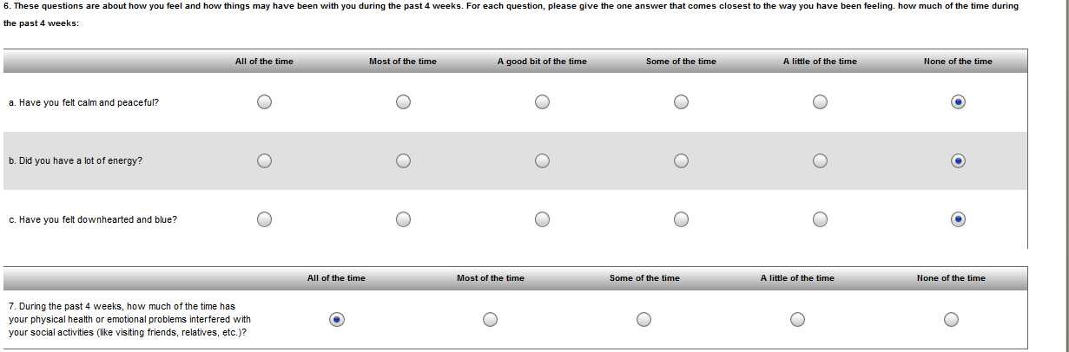

## VR-12

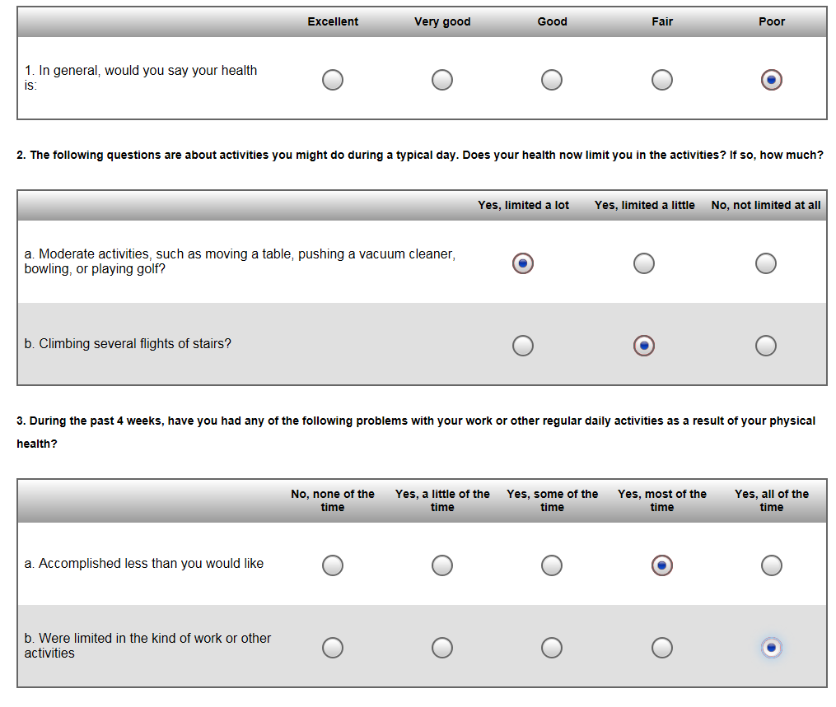 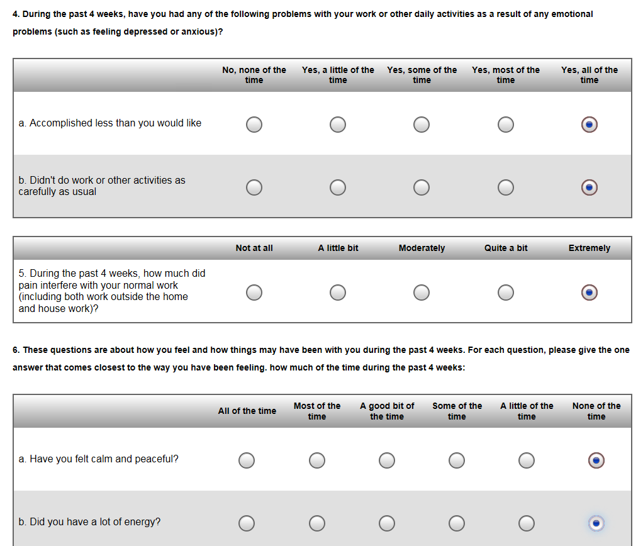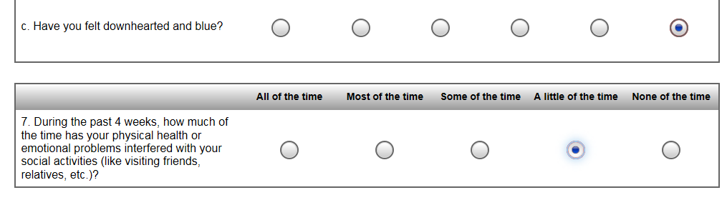

## WHODAS 2.0

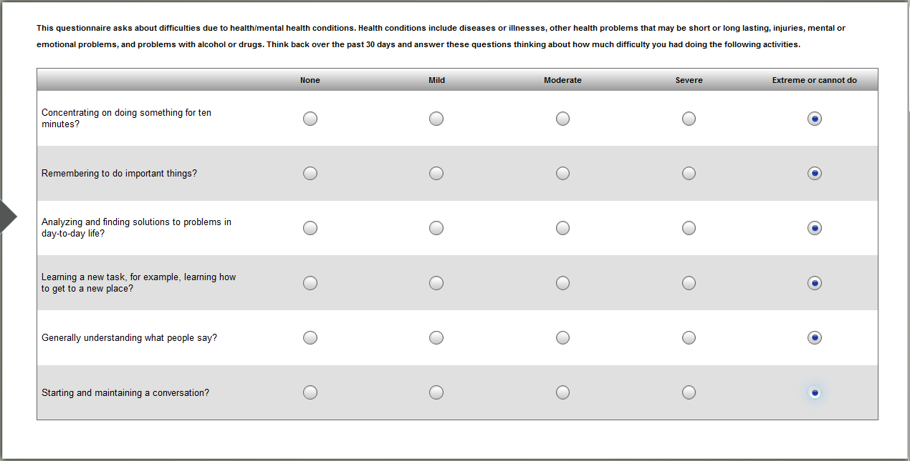

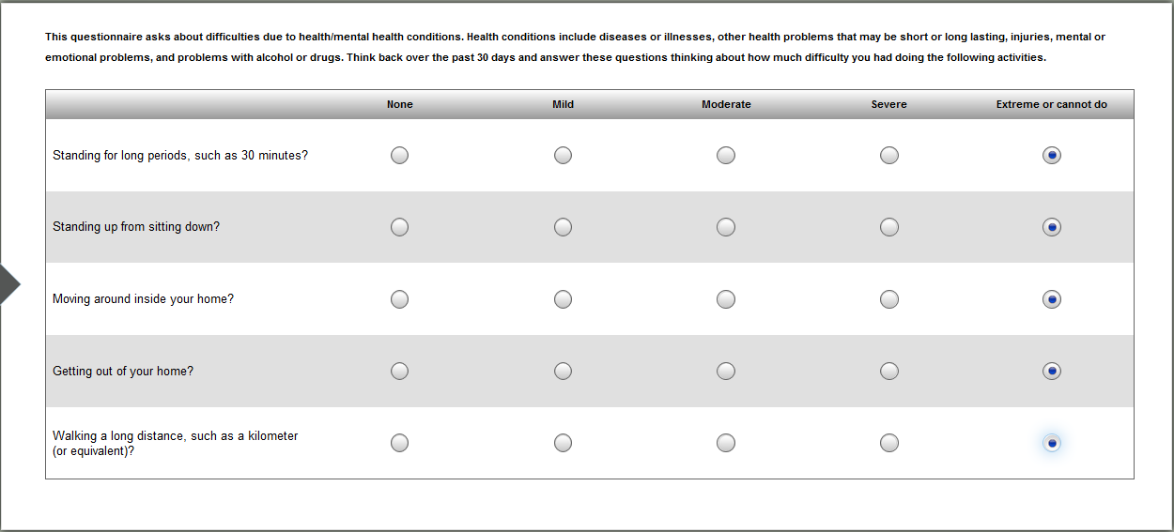

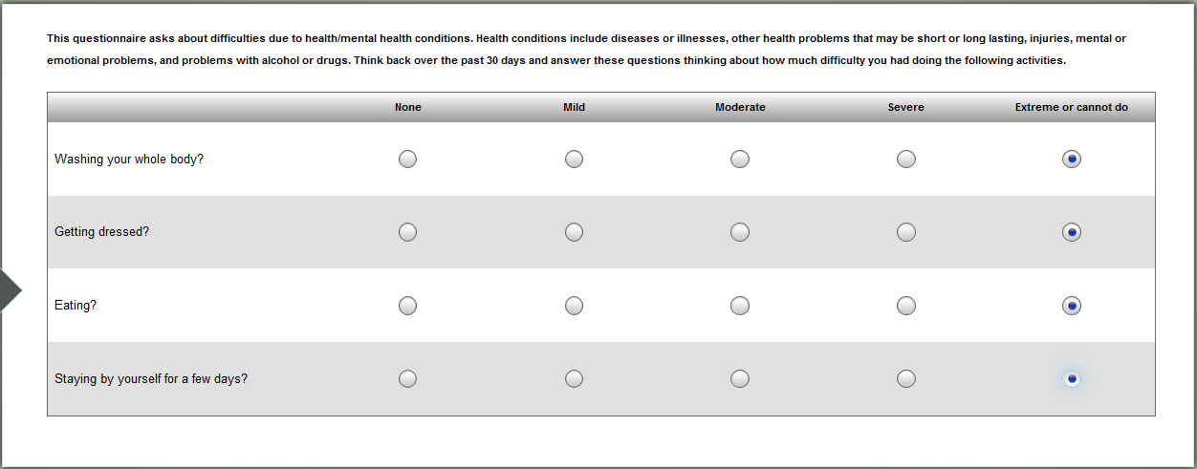

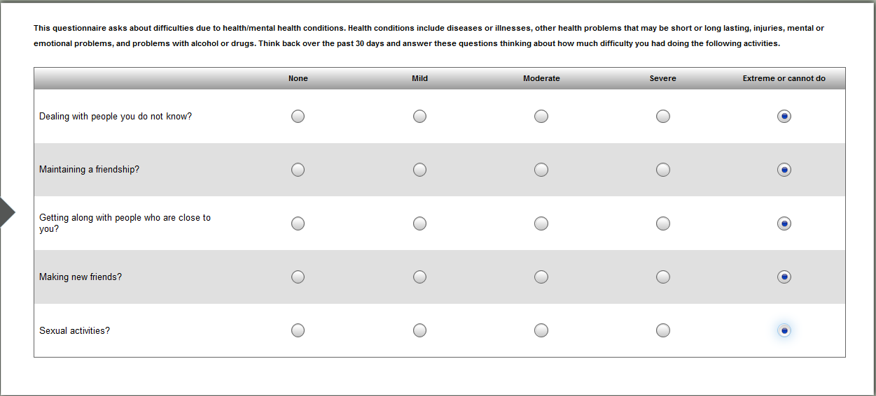

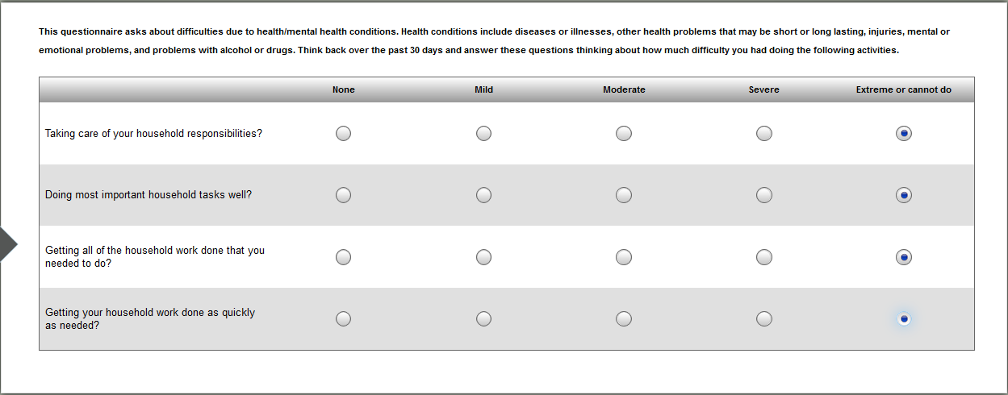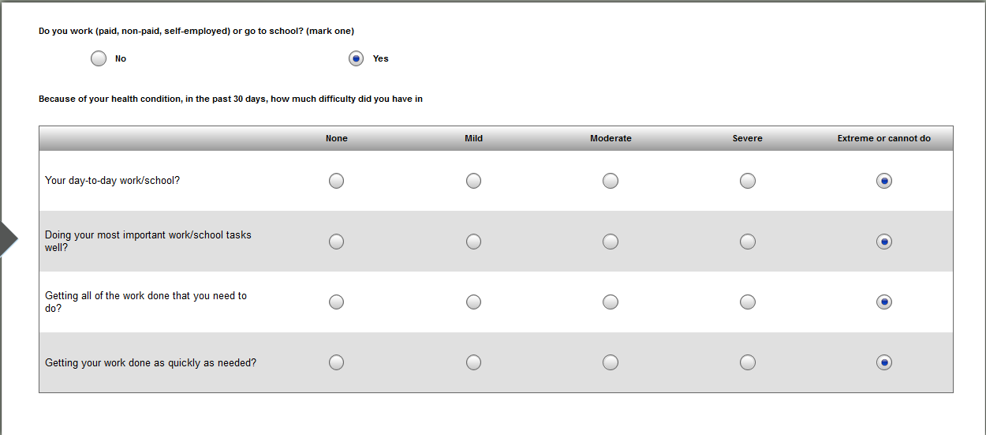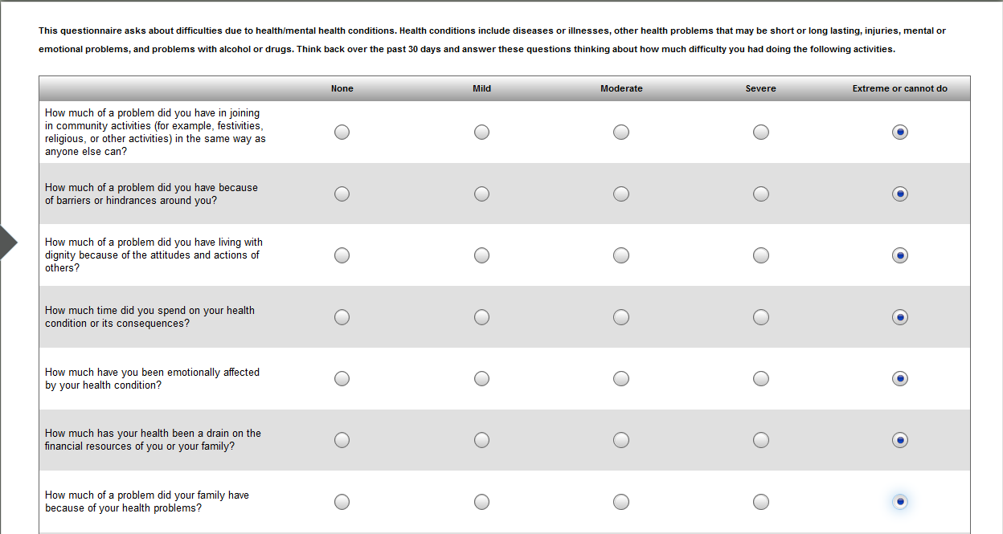

## WHOQOL-BREF

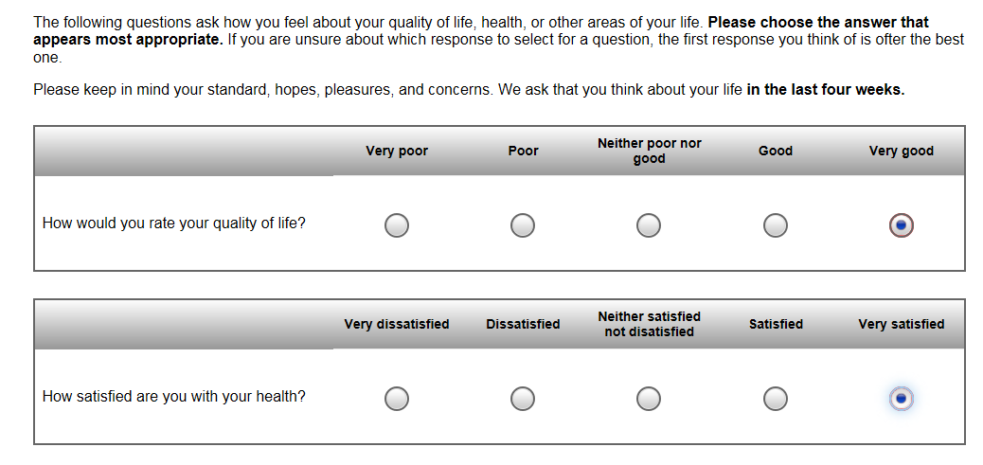 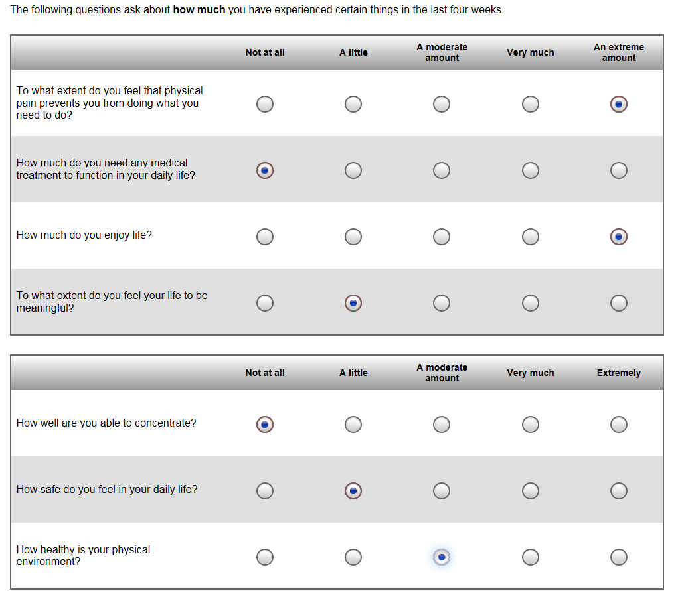 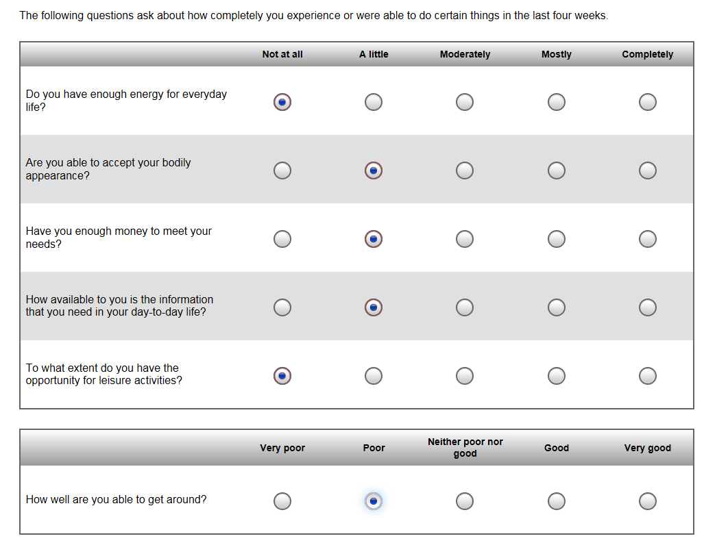 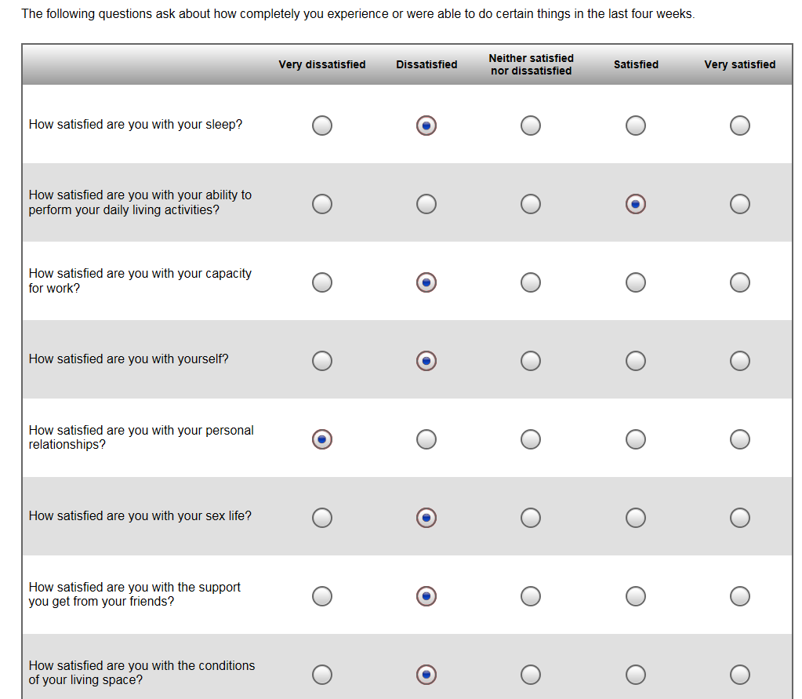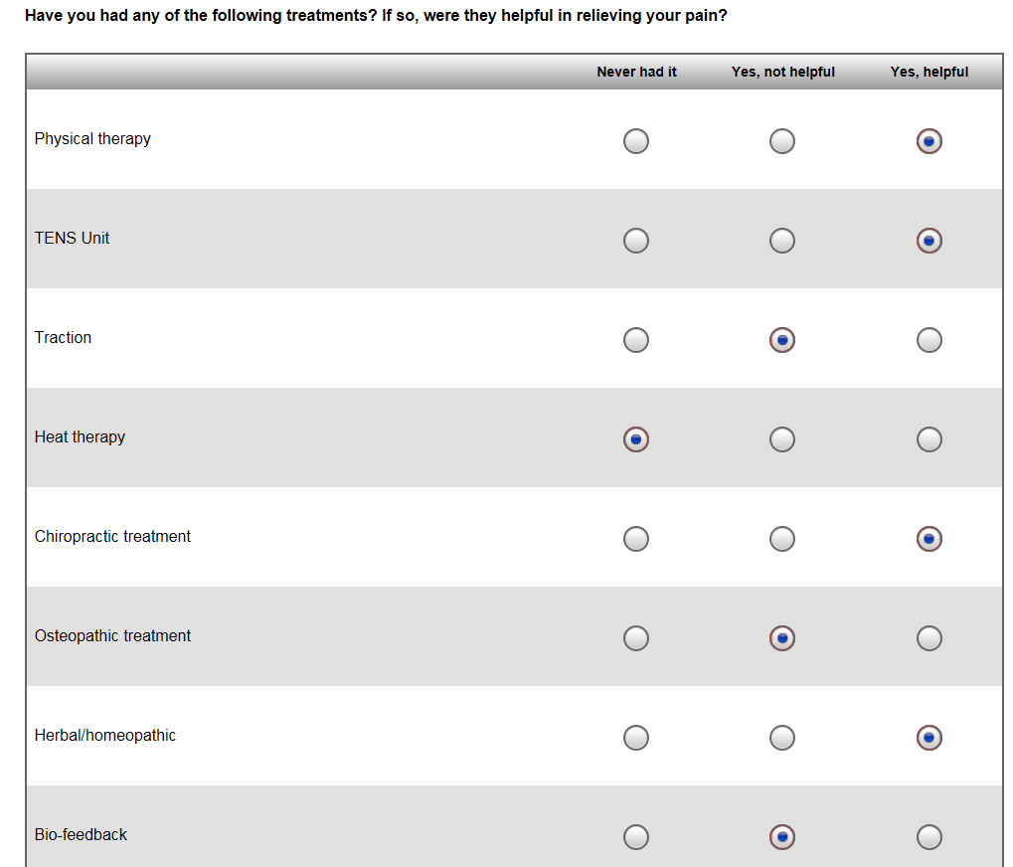   
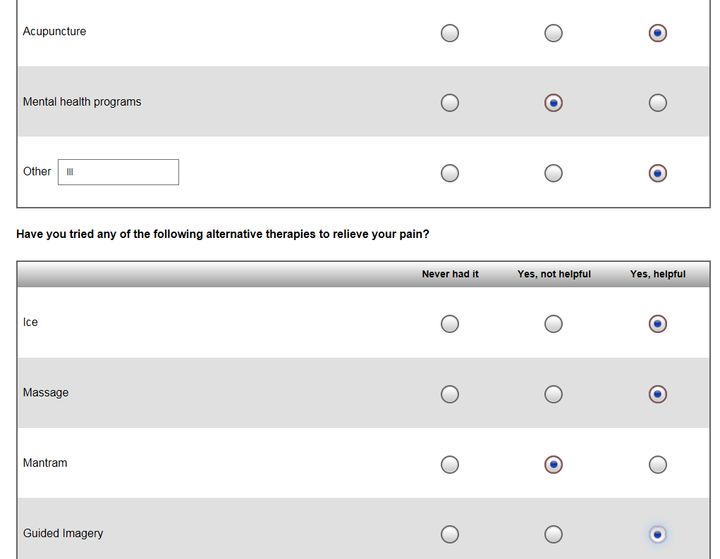 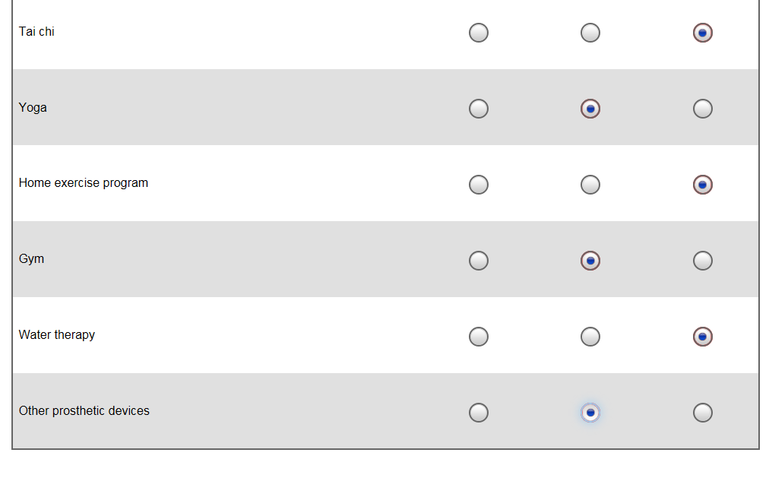 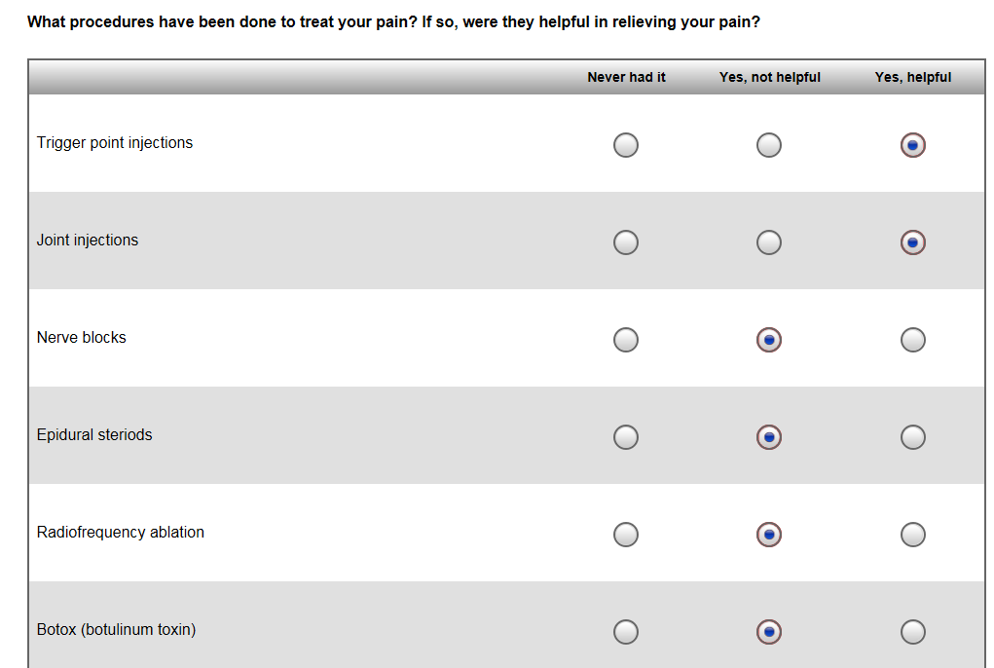 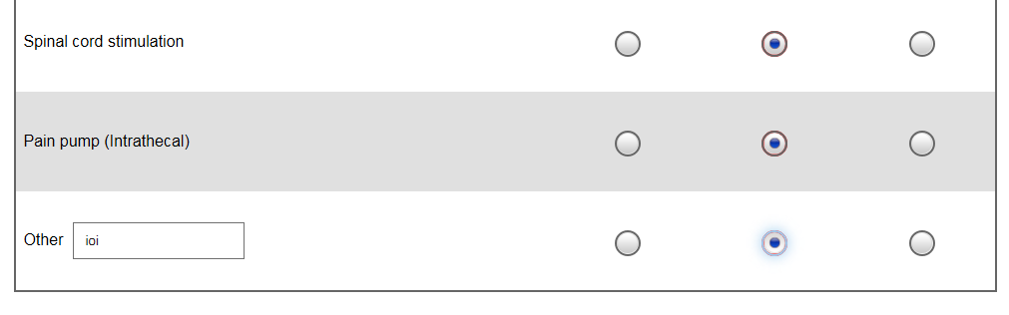

## Completion Screen (Customizable)

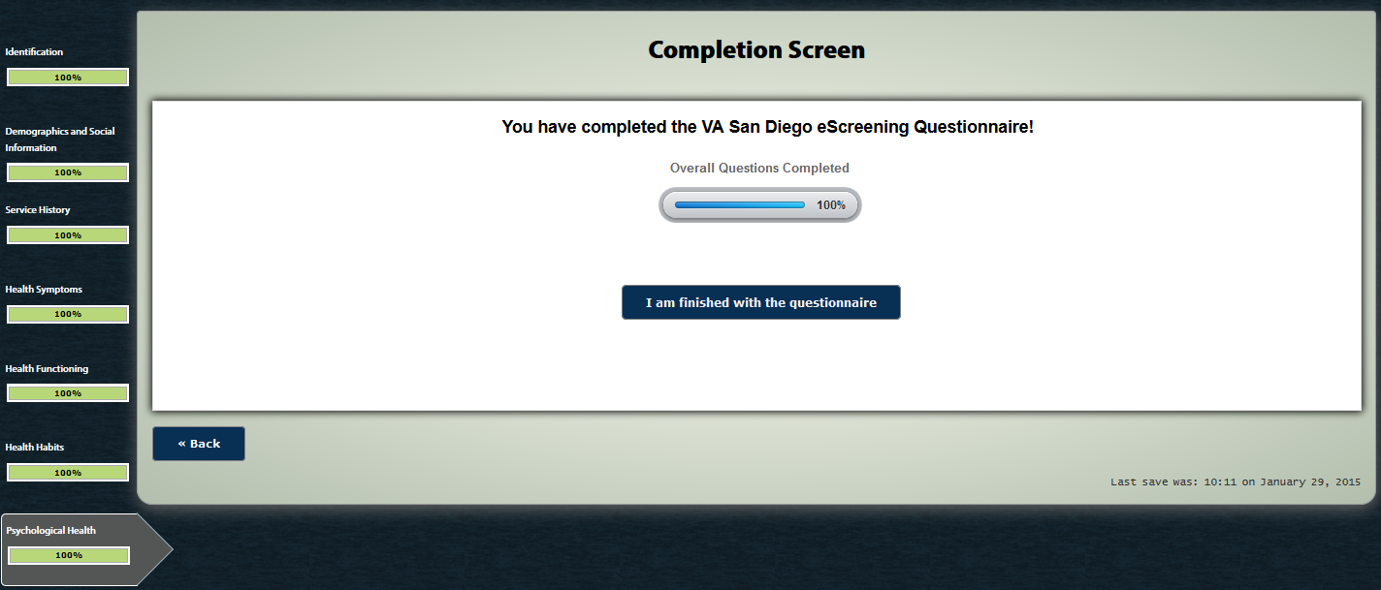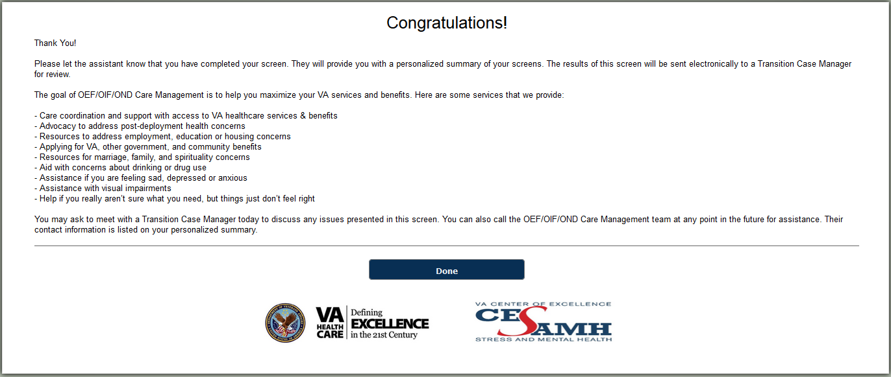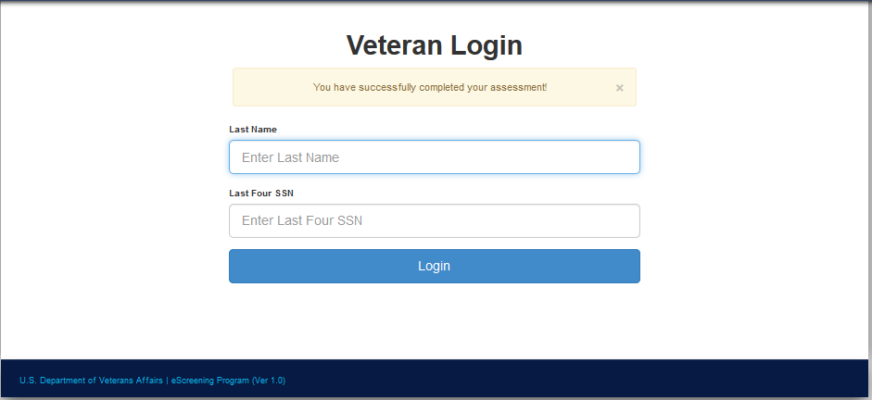

# Users Page

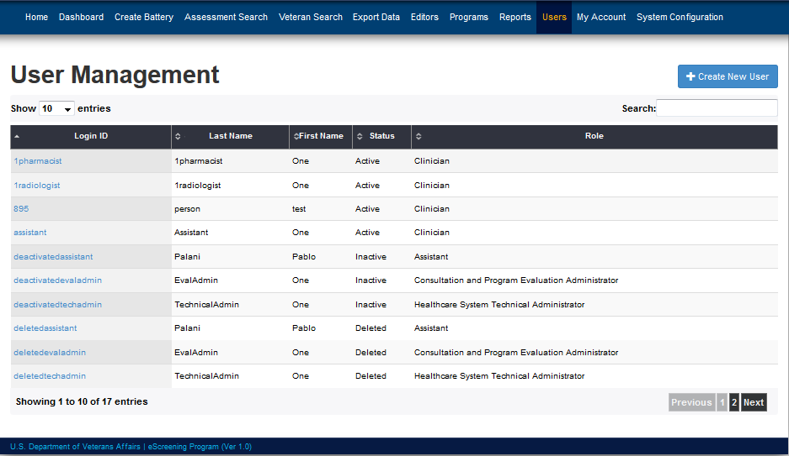

## Edit User Page

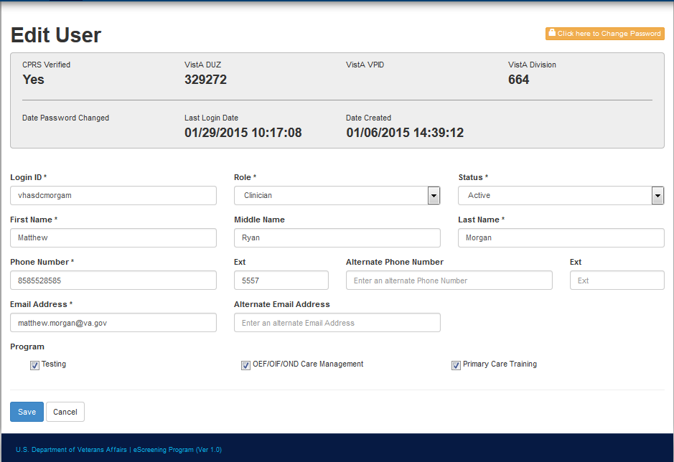

# Editors Page

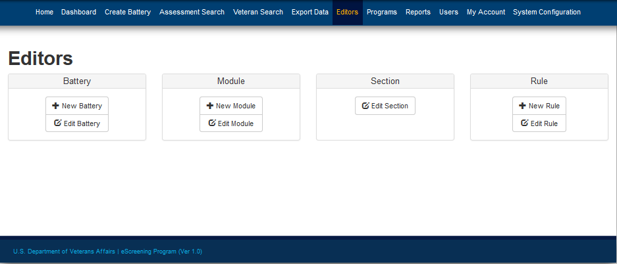

## Manage Batteries

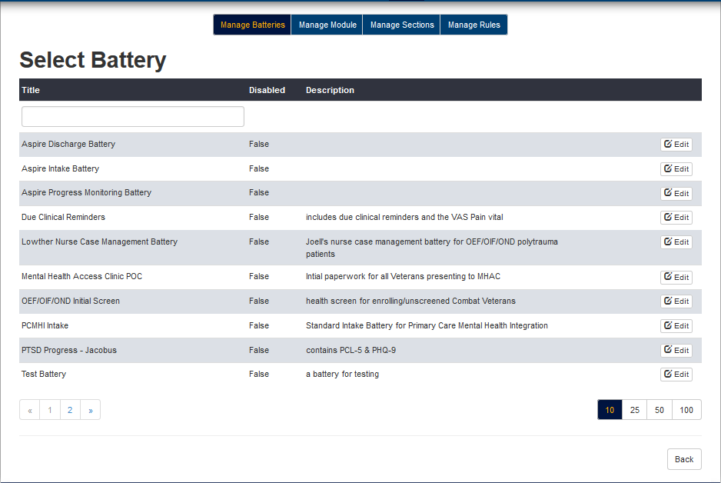

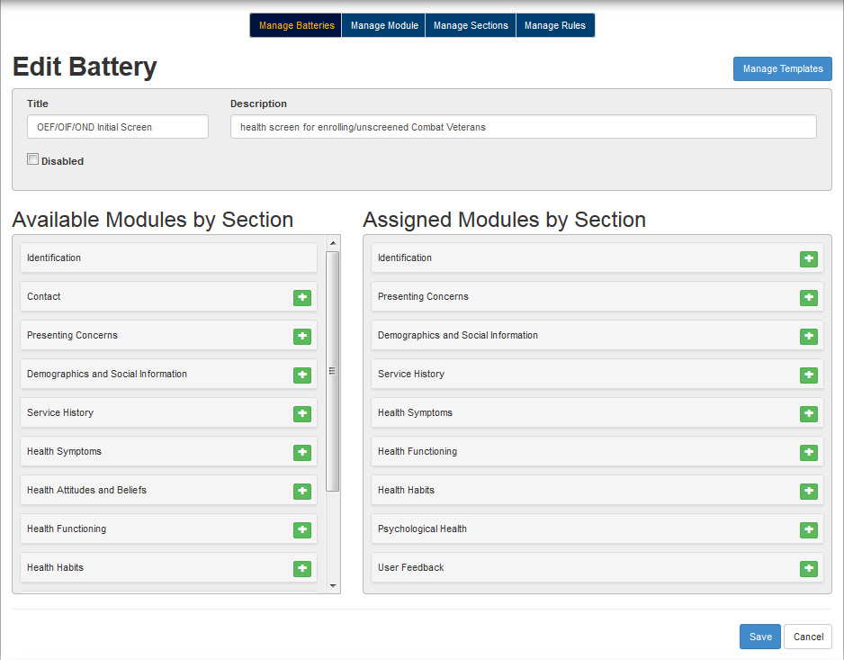

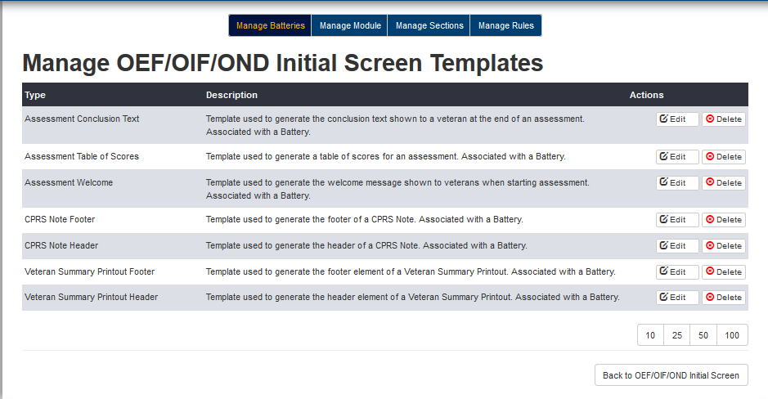

## Manage Modules

### New Module

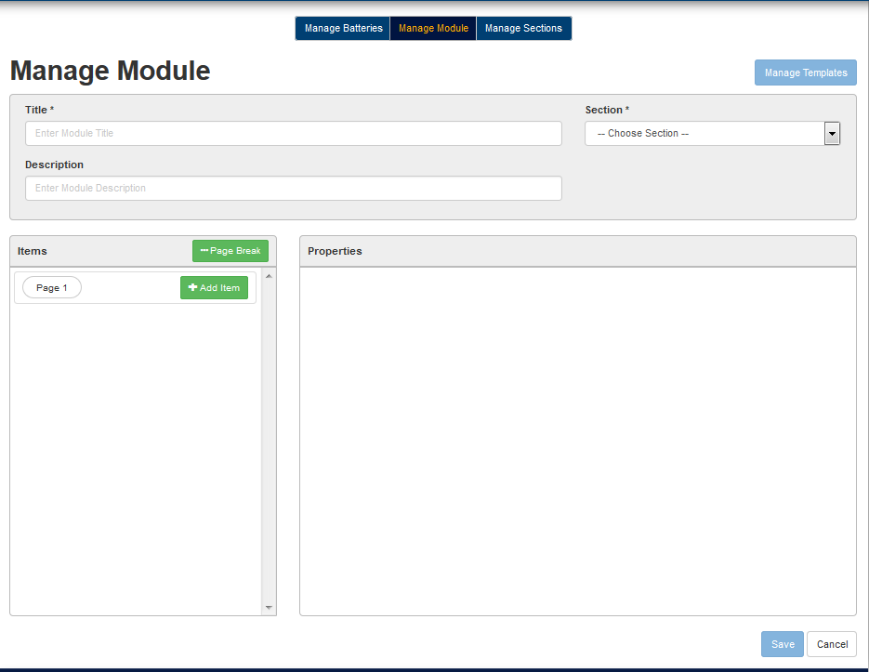

### Edit Existing Modules

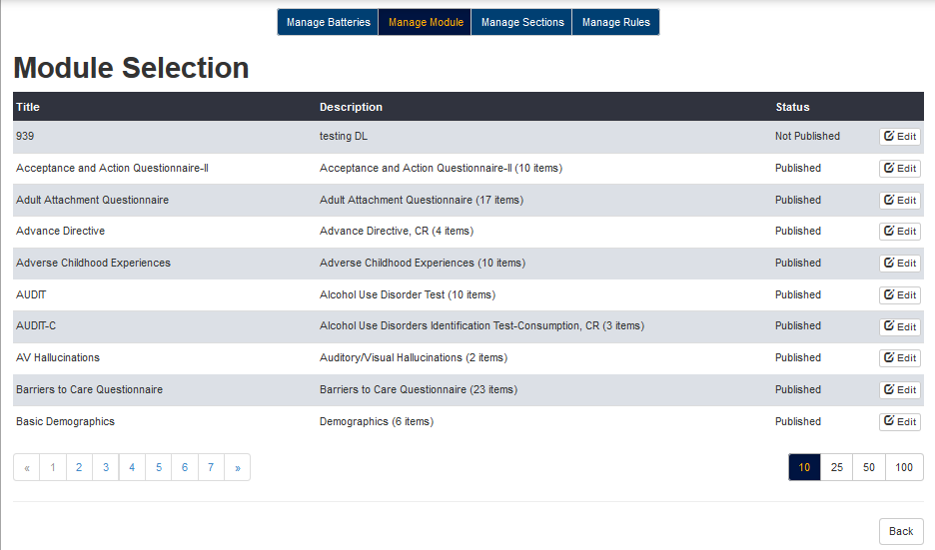

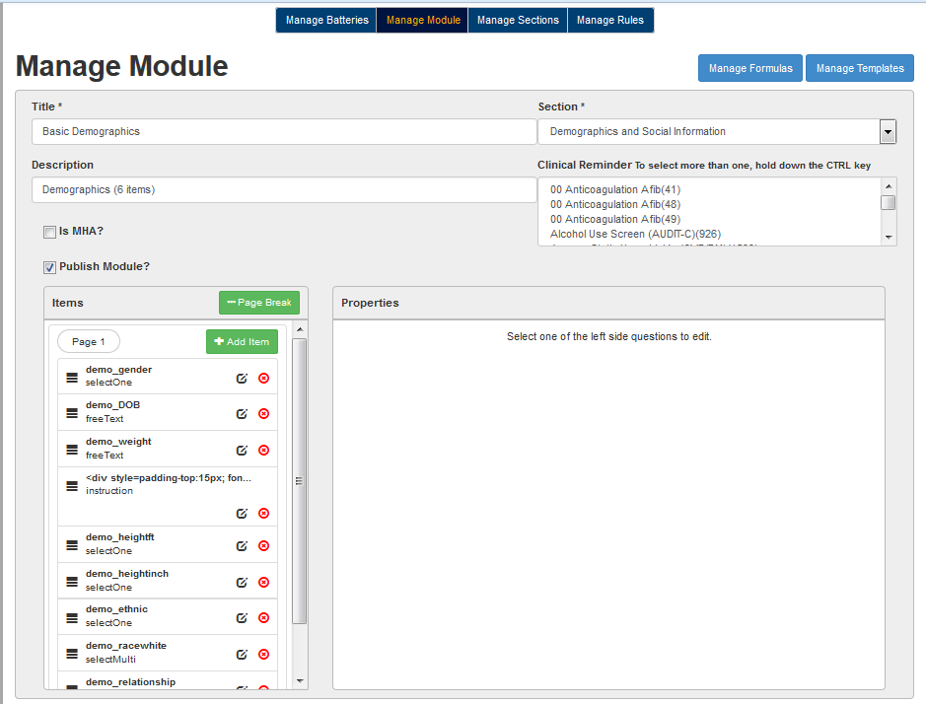

### Question Types

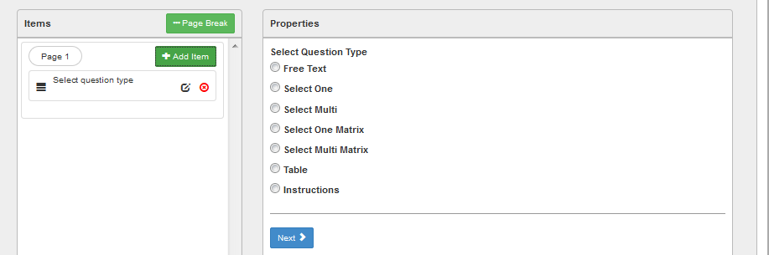

#### Free Text

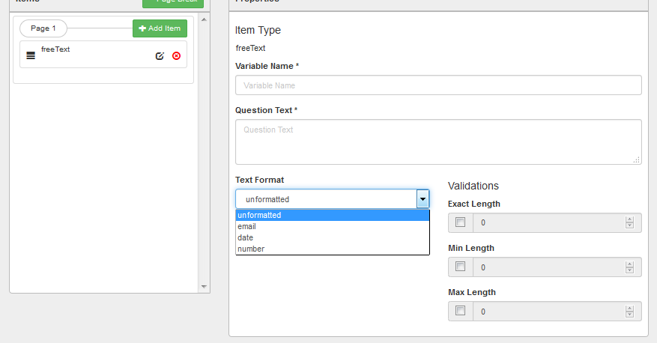

##### Free Text Example



#### SelectOne

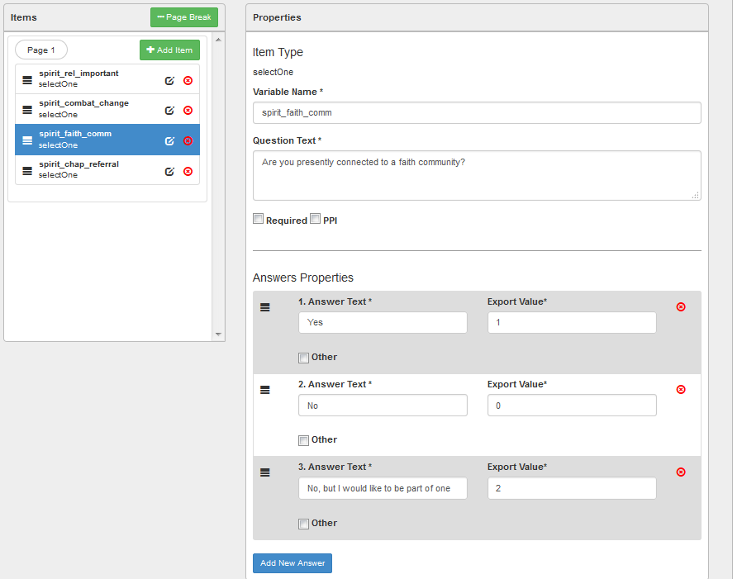

##### SelectOne Example



#### SelectMulti

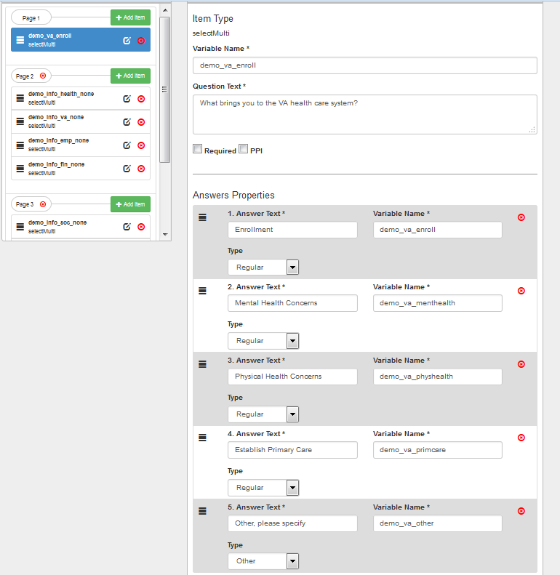

SelectMulti Example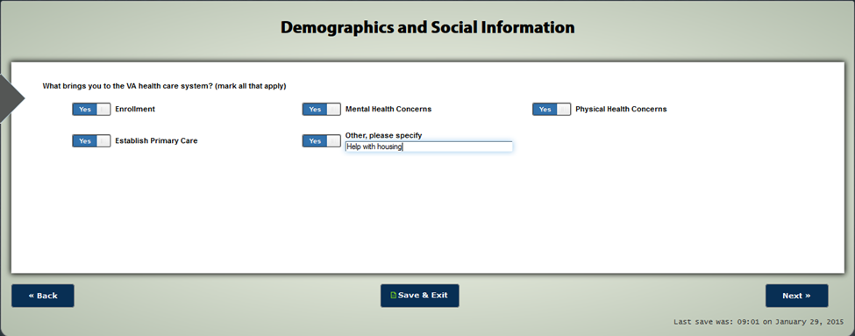

#### SelectOneMatrix

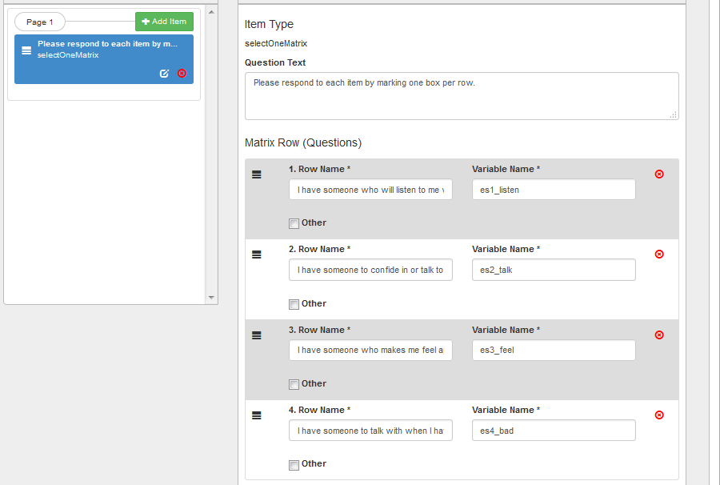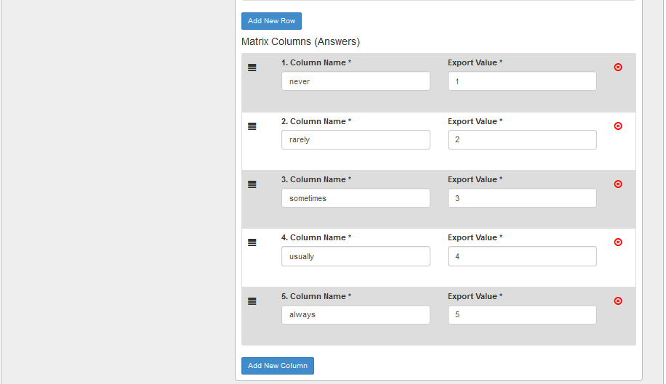

SelectOneMatrix Example



#### SelectMultiMatrix

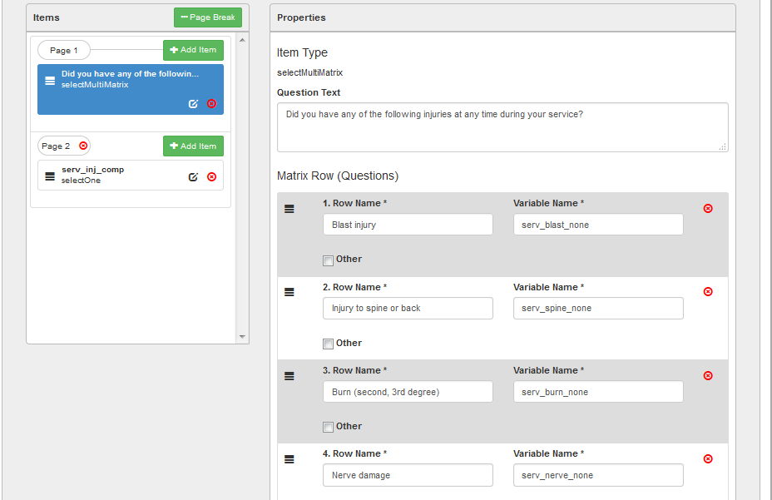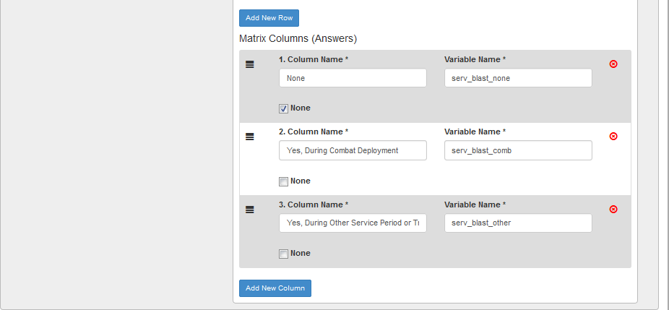

##### SelectMultiMatrix Example



#### Table

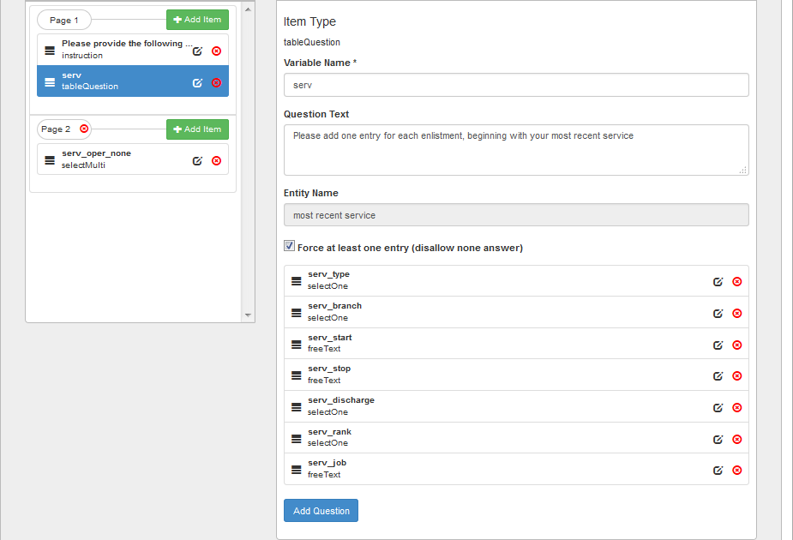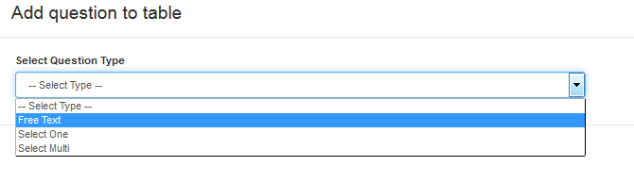

##### Table Question Example



#### Instruction

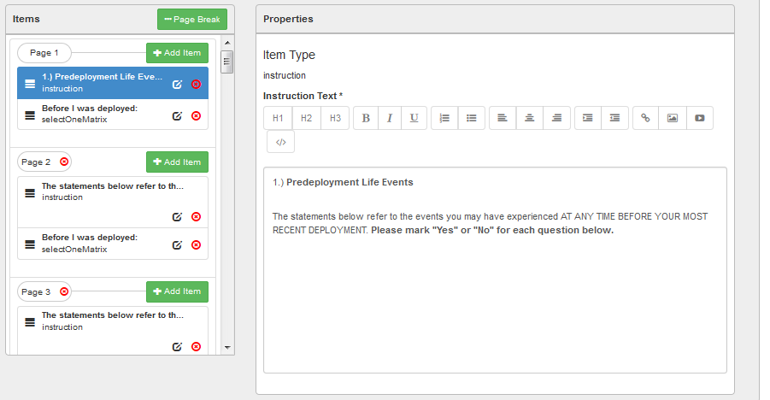

##### Instruction Example



### Manage Formulas

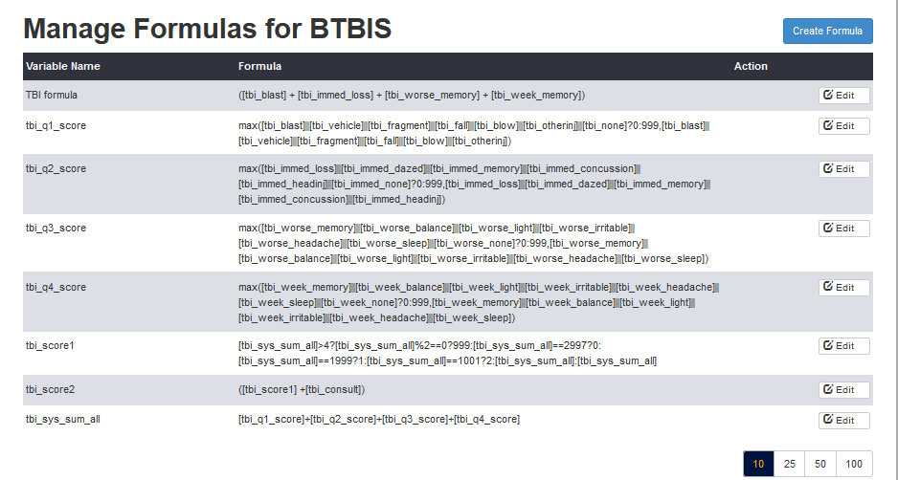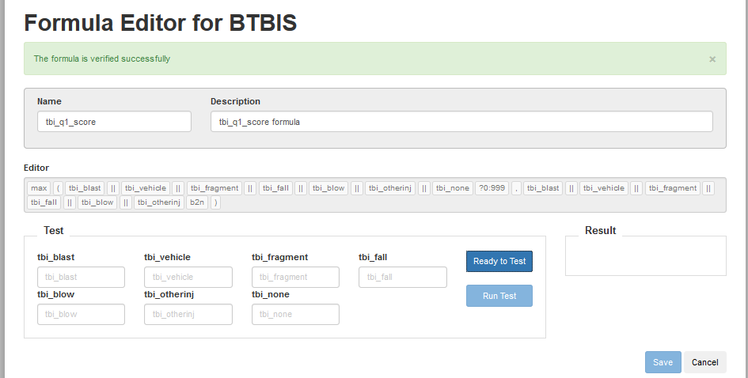

### Manage Templates

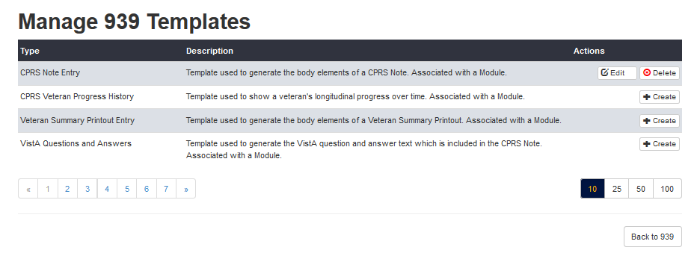

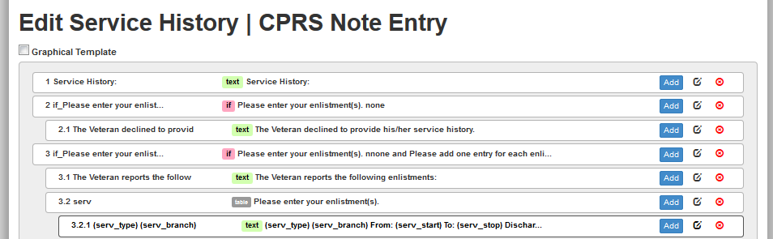

#### Graphical Template

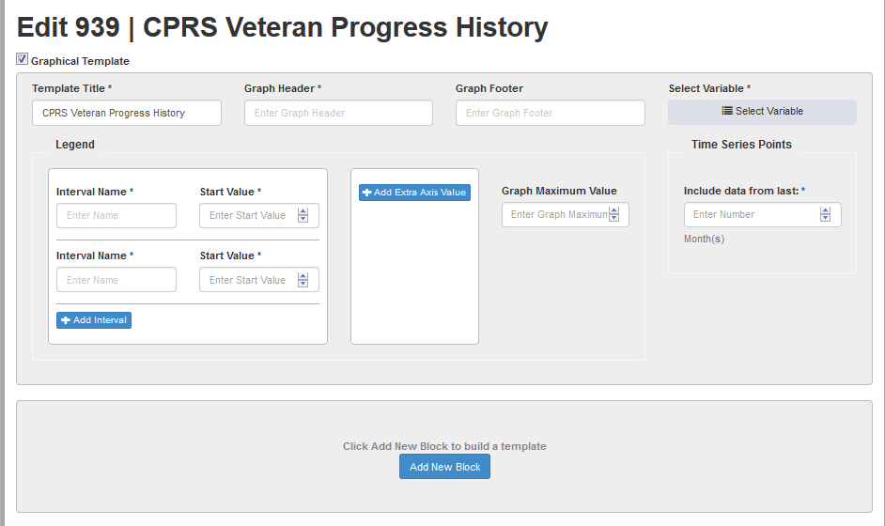

#### If/Else if block

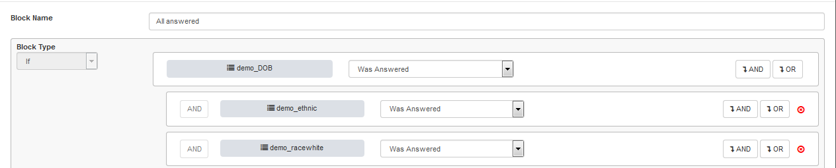

#### Text block

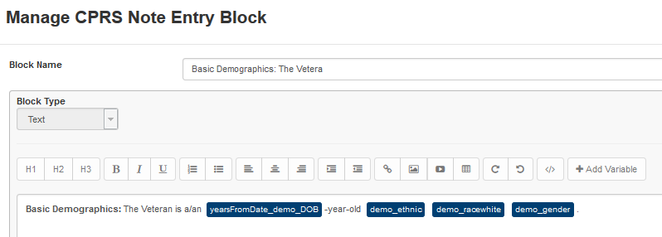

#### Table Block

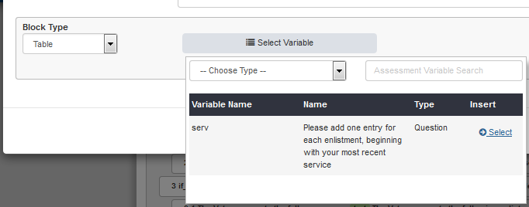

## Manage Sections

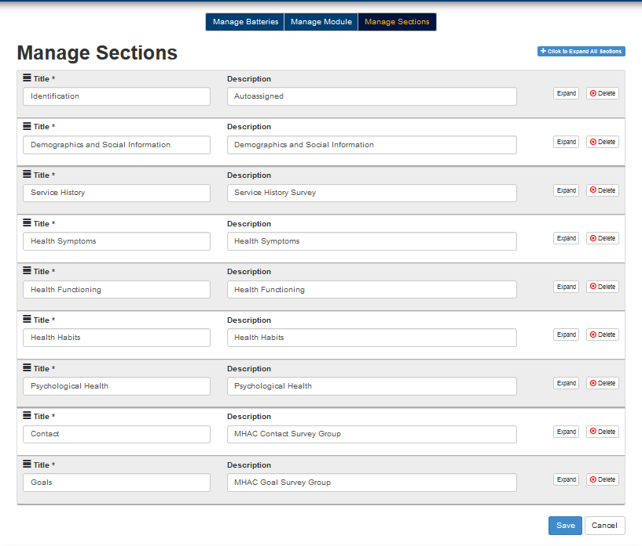

## Manage Rules

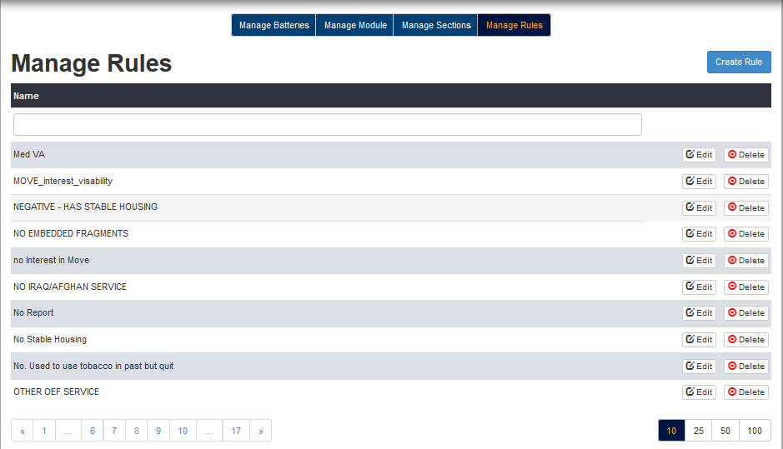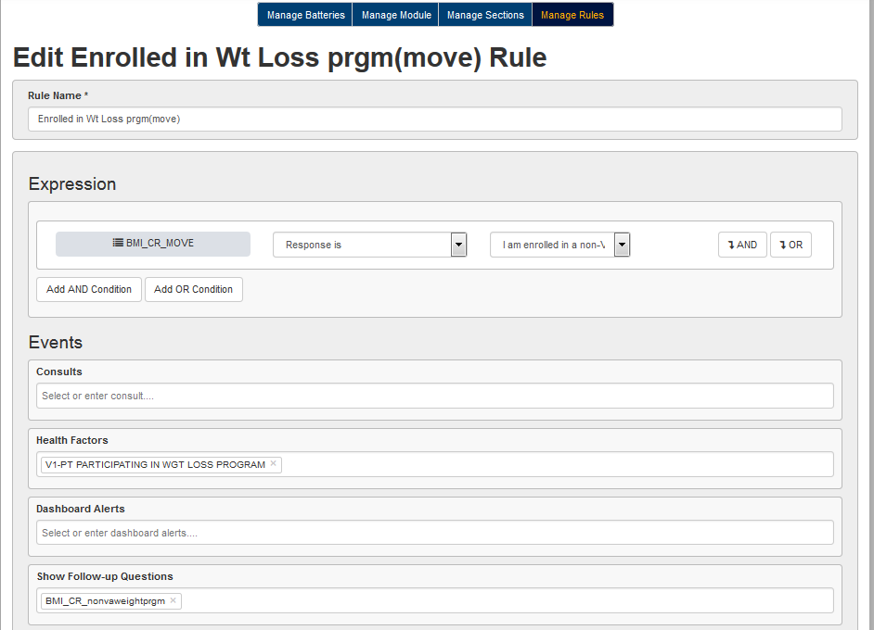

# Dashboard

## List View

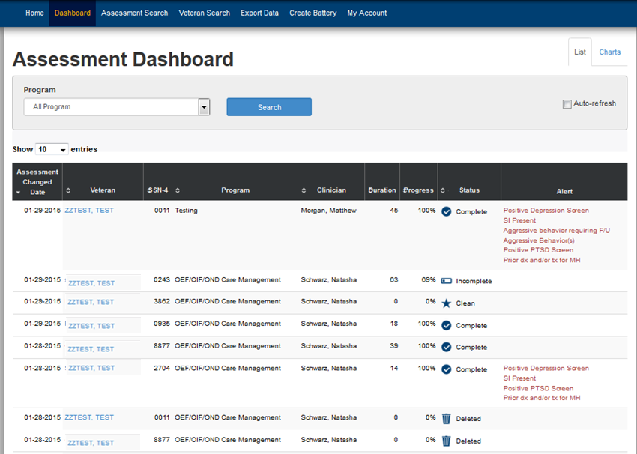

## Charts View

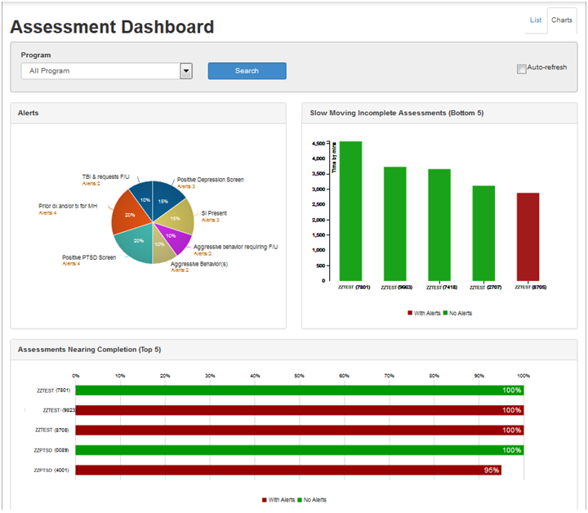

## Assessment Summary Page

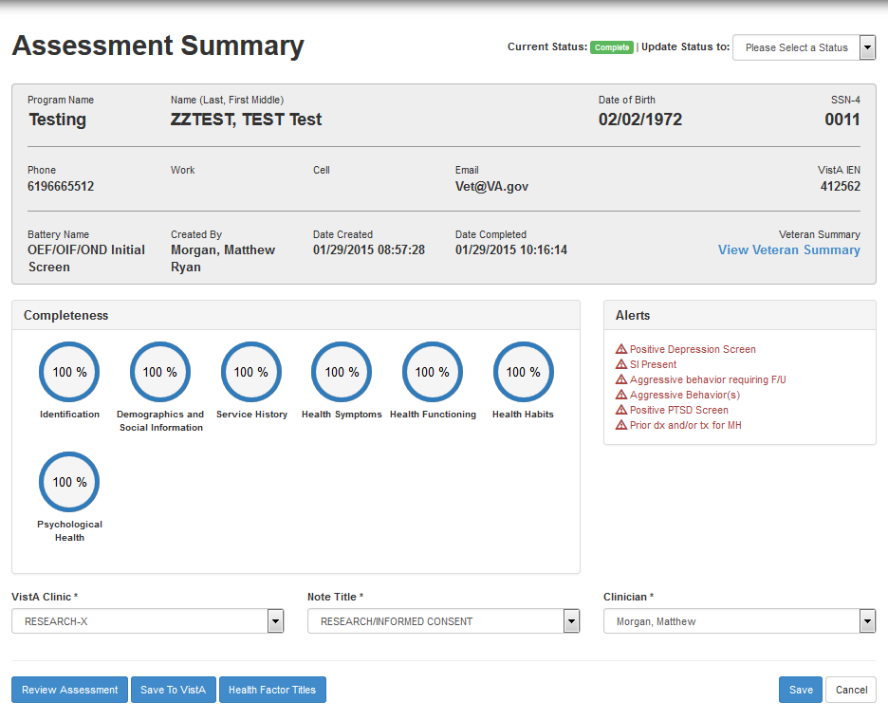

## Veteran Summary Printout (customizable)

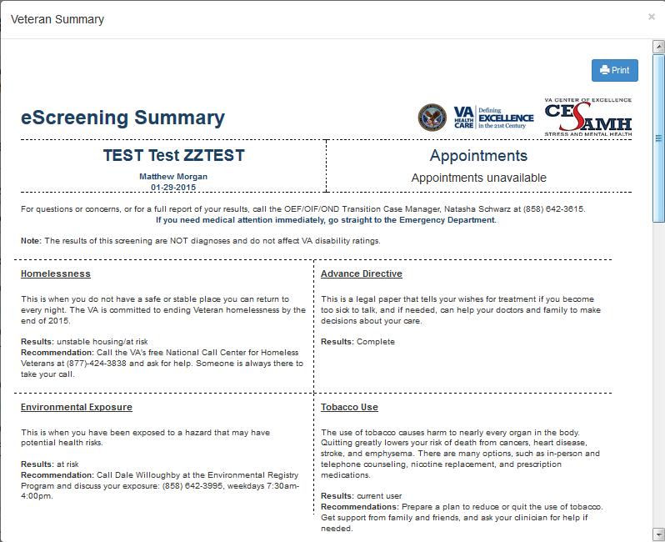

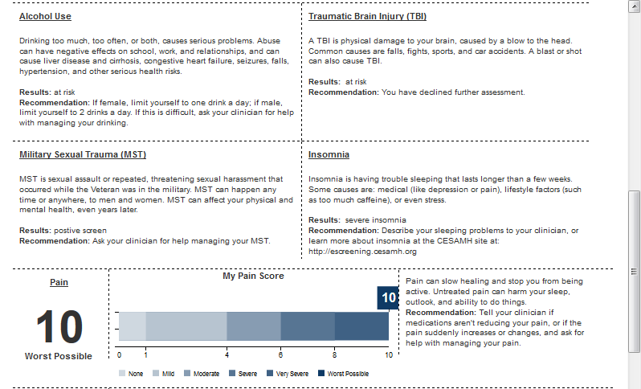

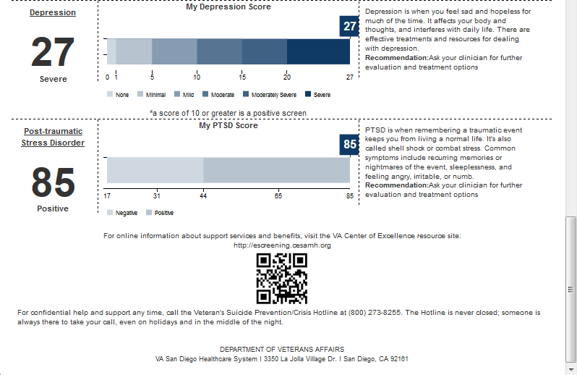

## Review Assessment Preview

**INTRODUCTION:** The Veteran presented to enroll in the VA  
Healthcare System and consented to be screened using the electronic version  
v1.1.801 of the Post-911 Screening Packet. The eScreening was administered  
by Matthew Morgan.   
  
===============================================================================  
**Demographics and Social Information**  
—————————————————————————————————————————————  
  
**PRESENTING CONCERN(S):** The Veteran identified enrollment,  
Mental Health Concerns, physical health, establishing a PCP, and Help with  
housing as the presenting concern(s). The Veteran indicated that he/she would  
like information or assistance with the following: Healthcare (specifically,  
Prosthetic Equipment, sexual health, mental health, Substance Use, and visual  
impairment services team), VA Benefits (specifically, VA compensation, GI Bill,  
and VA home loan), Employment (specifically, VA vocational rehabilitation,  
unemployment benefits, and VA work study), Social (specifically, adjustment to  
civilian life, relationship concerns, and support groups), Legal (specifically,  
parole, probation, warrants, and bankruptcy), Housing (specifically, homeless,  
and foreclosure), Financial (specifically, Financial Information about VA or  
community resources) and Injury.   
  
 **DEMOGRAPHICS:** The Veteran is a 32 year-old whom is  
non-Hispanic/Latino, White/Caucasian, Black/African American, American Indian  
or Alaskan Native, Native Hawaiian or Pacific Islander, and Asian male. The  
Veteran's reported BMI is 23.054, indicating that he/she is at a normal weight.  
  
**EDUCATION, EMPLOYMENT AND INCOME:** The Veteran reported  
completing a 4 year college degree. The Veteran reported being currently  
employed full time, who usually works as a Day Labor. The Veteran reported  
that the primary source of income is work, unemployment, disability, the GI  
Bill, retirement or pension, and Child Support. The Veteran is  
married.   
  
**SOCIAL:** The Veteran lives with parents or relatives, friends or  
roommates, a spouse or partner, children, and everyone.  The Veteran has 4  
children who are younger than 1, 1-2, 3-5, and 6-17 years old.   
  
Source(s) of support is/are: parents, friends, partner/spouse, therapist,   
spiritual/religious advisor, children, and everyone.   
  
The Veteran indicated a history of physical violence or intimidation in a  
current relationship.   
  
**PROMIS EMOTIONAL SUPPORT:** The Veteran had a score of 20,   
indicating that they currently have above average emotional  
support.   
  
**HOUSING:** The Veteran has not been living in stable housing for  
the last 2 months. The Veteran has been living in a homeless shelter. The  
Veteran would like a referral to talk more about his/her housing concerns.   
  
**Pragmatic Concerns:** The Veteran reported the following legal  
concern(s): civil issues, child support, taxes, bankruptcy, outstanding tickets,   
arrest warrants, restraining orders, DUIs, probation, parole, JAG, child  
protective services, and Help.   
  
**ADVANCE DIRECTIVE:** The Veteran requests to receive information  
in English.  
  
The Veteran reported having an Advance Directive or Durable Power of Attorney  
for Healthcare.  
  
The Veteran would like information about an Advance Directive.  
  
**SPIRITUAL HEALTH:** The Veteran reported that spirituality and/or  
religion is important to him/her.  
The Veteran is connected to a faith community and requests a referral to  
see a chaplain at the time of screening.  
The Veteran feels that combat or military service did have an effect on his/her  
religious views.   
  
—————————————————————————————————————————————  
**Service History**  
—————————————————————————————————————————————  
  
**SERVICE HISTORY:** The Veteran reported entering the Active  
Duty Army in 1999, received an Honorable discharge in 2015 at the  
rank of e9.  
  
The Veteran also served in the following operations or combat zones: Operation  
Enduring Freedom (OEF), Operation Iraqi Freedom (OIF), Global War on Terror  
operations other than OEF/OIF (e.g. Noble Eagle, Vigilant Mariner), Operation  
New Dawn, Caribbean / South America / Central America, Gulf War (1991), Somalia,   
Bosnia, Kosovo, Djibouti, Libya, Vietnam, Korean War, Georgia, and Russia.  
  
**OEF/OIF CLINICAL REMINDER:** The Veteran's most recent deployment  
was for Operation Enduring Freedom (OEF) in Tajikistan.   
  
**MILITARY DEPLOYMENTS AND HISTORY:**   
The Veteran reported receiving the following disciplinary actions: formal  
counseling, article 15, court martial, and Brig.  
  
The Veteran reported receiving the following personal awards or commendations:   
Medal of Honor, Distinguished Service Cross, Distinguished Service Medal,   
Meritorious Service Medal, Legion of Merit, Distinguished Flying Cross, Bronze  
Star, Purple Heart, Air Medal, Silver Star, Soldier's Medal, Achievement Medal,   
Commendation Medal, and Medal.  
  
The Veteran was deployed 2 times to the following areas during the following  
time periods:  
  
01/1999-01/2015: Overseas  
01/1999-01/2015: Russia  
  
  
**EXPOSURES:** The Veteran reported persistent major concerns  
related to the effects of exposure to chemical agents, biological agents,  
JP8 or other fuels, asbestos, nerve gas, radiological agents, sand/dust or  
particulate matter, depleted uranium, industrial pollution, exhaust fumes,  
paints, animal/insect bites, smoke from burn pits, pesticides, Mustard gas, and  
Agent Orange.  
  
The Veteran reported being exposed to animal contact during a deployment in the  
past 18 months that could result in rabies.  
  
The Veteran reported the following types of combat experience: being attacked or  
ambushed, firing weapons at the enemy, hand to hand combat, caring for wounded,   
interrogation, receiving rocket or mortar fire, seeing dead bodies, clearing or  
searching buildings, firing from a Navy ship, processing/handling detainees,   
receiving small-arms fire, handling human remains, someone killed near you, and  
caring for enemy wounded.  
  
**Service Injuries:** The following injuries were reported during  
combat deployment: blast injury, injury to spine or back, burn (second, 3rd  
degree), nerve damage, loss or damage to vision, loss or damage to hearing,  
amputation, broken/fractured bone(s), joint or muscle damage, internal or  
abdominal injuries, Sprains and Breaks.  
The following injuries were reported during other service period or training:  
blast injury, injury to spine or back, burn (second, 3rd degree), nerve damage,  
loss or damage to vision, loss or damage to hearing, amputation,  
broken/fractured bone(s), joint or muscle damage, internal or abdominal  
injuries, Sprains and Breaks.  
The Veteran has a service connected disability rating.  
  
—————————————————————————————————————————————  
**Health Symptoms**  
—————————————————————————————————————————————  
  
**Health Status:** The Veteran reported a high number of somatic  
symptoms.  
  
The Veteran endorsed being bothered a lot by the following health symptoms over  
the past four weeks: stomach pain, back pain, pain in arms, legs or joints  
(knees, hips, etc.), menstrual cramps or other problems with your periods,  
headaches, chest pain, dizziness, fainting spells, feeling your heart pound or  
race, shortness of breath, pain or problems during sexual intercourse,  
constipation, loose bowels or diarrhea, nausea, gas or indigestion, feeling  
tired or having low energy and trouble sleeping.   
  
**OTHER HEALTH SYMPTOMS:** The Veteran endorsed being bothered by  
the following health symptoms over the past four weeks: hearing loss, tinnitus   
(ringing in the ears), problem with vision, weight gain, weight loss and  
forgetfulness.  
  
**Screen for Infectious Disease and Embedded Fragments:** The  
Veteran endorsed other health problems of: chronic diarrhea or other  
gastrointestinal, with symptoms of Pain, unexplained fevers, with symptoms of  
Hot all the time, persistent papular or nodular skin rash that began after  
deployment to Southwest Asia, with symptoms of Rashes and suspects that he/she  
has retained fragments or shrapnel as a result of injuries, with symptoms of  
Metal detectors going off.   
  
**Promis Pain Scales:** The Veteran endorsed having very severe  
pain currently. Over the past week the veteran reported a pain intensity of very  
severe with very severe average pain.  
  
The pain does significantly interfere.   
  
**PAIN:** Over the past month, the Veteran's reported pain level  
was 10 of 10.The pain was located in: Knees, Lungs, and Back.  
  
**MEDICATIONS:** MEDICATION/SUPPLEMENT: Ambien  
DOSAGE: 10mg  
FREQUENCY: As needed  
DURATION: 5 years  
PRESCRIBER NAME AND/OR FACILITY: Wilson  
  
MEDICATION/SUPPLEMENT: Vicodin  
DOSAGE: 10mg  
FREQUENCY: As needed  
DURATION: 5 years  
PRESCRIBER NAME AND/OR FACILITY: House  
  
—————————————————————————————————————————————  
**Health Functioning**  
—————————————————————————————————————————————  
  
**PRIOR TREATMENT:** The Veteran endorsed being diagnosed with  
depression, Post-Traumatic Stress Disorder (PTSD), and Bipolar within the last  
18 months.  
  
The Veteran endorsed having received the following treatments within the last 18  
months for a mental health diagnosis: inpatient psychiatric stay, psychotherapy,   
psychiatric medication, electro convulsive therapy, and CBT.  
  
**WHODAS 2.0: The Veteran was given the WHODAS 2.0, which covers six  
domains of assessing health status and disability on a scale of one to five.  
  
Understanding and Communicating** - the Veteran had an  
average score of 5.0 which indicates extreme disability.  
  
**Mobility** - the Veteran had an average score of 5.0, which  
indicates extreme disability.  
  
**Self-Care** - the Veteran had an average score of 5.0 which  
indicates extreme disability.  
  
**Getting Along** - the Veteran had an average score of 5.0 which  
indicates extreme disability.  
  
**Life Activities (Household/Domestic)** - the Veteran had an average  
score of 5.0 which is a rating of extreme disability.  
  
**Life Activities (School /Work)** - the Veteran had an average score of 5.0  
which is a rating of extreme disability.  
  
**Participation in Society** - the Veteran had an average score of 5.0  
which indicates extreme disability.   
  
—————————————————————————————————————————————  
**Health Habits**  
—————————————————————————————————————————————  
  
**Caffeine:** The Veteran reported consuming 5+ caffeinated  
beverages per day.   
  
**TOBACCO:** The Veteran endorsed using cigarettes, cigar/pipes,   
and smokeless tobacco.  
  
**ALCOHOL:** The Veteran's AUDIT-C screen was positive with a score  
of 12.   
  
**Drugs:** The Veteran's Drug screen was positive with a severe  
level of problems reported.   
  
—————————————————————————————————————————————  
**Psychological Health**  
—————————————————————————————————————————————  
  
**A/V HALLUCINATIONS:** The Veteran reported hearing things  
other people can't hear, The Veteran  reported seeing things or having  
visions other people can't see.  
  
**TBI:** The Veteran's TBI screen was positive.   
Veteran declined TBI consult for further evaluation.   
  
**Depression:** The Veteran's PHQ-9 screen was positive. The  
score was 27 which is suggestive of severe depression.   
  
**Mood Disorder:** The MDQ (Hyper mood) screen was positive  
indicating that the Veteran may benefit from further assessment for possible  
symptoms of mania or other mood disorders.  
  
Symptoms endorsed: so hyper got into trouble, so irritable started fights, felt  
much more self-confident than usual, got less sleep, was much more  
talkative/spoke much faster, racing thoughts, could not concentrate, more  
energy, more active/did more things, more social/outgoing, much more interested  
in sex, was excessive/foolish/risky and got in trouble spending money.  
  
**MST:** The Veterans MST screen was positive. The Veteran requests  
a referral to discuss the sexual trauma further.   
  
**Anxiety:** The Veteran's GAD-7 screen was positive. The  
Veteran endorsed the following symptoms were occurring more than half of the  
days in the past two weeks: feeling nervous, can't control worrying, worrying  
too much, trouble relaxing, restlessness, irritability and feeling afraid.   
  
**PCLC:** The Veteran's PCL-C Screen was positive with a PCL-C  
score of 85.   
  
**PC-PTSD:** The Veteran's PC-PTSD Screen was positive with a  
PC-PTSD score of 4.   
  
**SLEEP:** The Veteran's ISI was positive indicating severe  
insomnia for the past week.   
  
**AGGRESSION:** The Veteran had a score of 240.0 on the  
Retrospective Overt Aggression Scale (range 0-240).  
  
The Veteran indicated the following concerning aggressive behaviors in the past  
month: Verbal Aggression (shouting angrily, yelling mild insults, making vague  
threats and making clear threats of violence), Physical aggression toward  
objects (slamming doors, throwing objects, breaking objects or smashing windows  
and setting fires or throwing object dangerously), Physical aggression toward  
self (hitting self or pulling own hair, banging head or fists against objects,  
cutting or bruising self and other serious self-injury) and Physical aggression  
towards others (swinging at people or grabbing others, striking or pushing on  
others, bruising or causing welts on others and attacking others causing severe  
physical injury).   
  
**Resilience and Strengths:** The Veteran had a score of 0  
indicating minimal resilience.  
  
The Veteran reported the following resilience beliefs at least sometimes during  
the past four weeks: none.   
  
**SCORING MATRIX:**

|  |  |  |  |
| --- | --- | --- | --- |
| **Screen** | **Result** | **Raw Score** | **Cut-off Score** |
|  |  |  |  |
| AUDIT C | Positive | 12 | 3-women/4-men |
| BTBIS (TBI) | Positive | N/A | N/A |
| DAST-10 (Substance Abuse) | Positive | 10.0 | 3 |
| GAD-7 (Anxiety) | Positive | 21.0 | 10 |
| Homelessness | Positive | N/A | N/A |
| ISI (Insomnia) | Positive | 28.0 | 15 |
| MST | Positive | N/A | N/A |
| PCL-C (PTSD) | Positive | 85.0 | 44 |
| PC-PTSD | Positive | 4.0 | 3 |
| PHQ-9 (Depression) | Positive | 27.0 | 10 |
| Prior MH DX/TX | Positive | N/A | N/A |
| Tobacco Use | Positive | N/A | N/A |
| VAS PAIN | Positive | 10 | 4 |

—————————————————————————————————————————————  
  
**INTERVENTIONS:**   
*Explained confidentiality and the limits of confidentiality.  
*Educated the Veteran on VA health care benefits and OEF/OIF care coordination  
services.  
*OEF/OIF Case Management not indicated at this time.  
*Veteran endorsed mental health concerns, recommend outpatient consult to  
Psychiatry for MH.  
*Veteran endorsed substance abuse concerns, recommend outpatient consult to  
ADTP.  
*Discuss Veteran's prosthetics needs.  
*Veteran requested Chaplain Consult.  
*Recommend ADTP referral for alcohol abuse.  
*Recommend ADTP referral for Substance Abuse.  
*Recommend tobacco cessation.  
*Recommend psychiatry outpatient consult for depression.  
*Recommend psychiatry outpatient consult for mood.  
*Recommend MST consult.  
*Recommend psychiatry outpatient consult for anxiety.  
*Recommend OEF/OIF PTSD clinic consult.  
*Recommend psychiatry outpatient consult for insomnia.  
*Recommend Anger Management consult.  
*Provided the Veteran employment resource information.  
*Provided the Veteran information on housing resources and the VA homeless  
resources including HCHV outreach schedule.  
*Educated the Veteran on chaplain services.  
*Provided information on financial resources.  
*Provided information on legal resources.  
*Educated Veteran about Veteran's Justice Outreach Program.  
*Provided the Veteran information on the GI Bill, eBenefits, VA Work Study.  
*Provided the Veteran information on accessing unemployment resources.  
*Educated Veteran on Tobacco cessation support services.  
*Provided information on Audiology and Optometry services.  
*Encouraged the Veteran to meet with VSO for further advocacy and assistance  
with VA SCD claims process & provided VSO contact list.  
*Provided VA Advanced Directives brochure & form.  
*Educated Veteran on available VA mental health services (including outpatient  
general and specialty psychiatry clinics, PTSD and MST services, Anger  
Management, CORE and Family MH Clinic).  
*Provided the Veteran information on the VA Vet Centers services.  
*Educated the Veteran on alcohol and drug treatment services and reviewed ADTP  
walk-in hours & location.  
*Alerted the PCP to the Veteran medical/health concerns & requests.  
*Directed Veteran to Primary Care Call center for appointment scheduling.  
*Provided VA environmental registry POC information.  
*Educated the Veteran about same-day access clinic on 2North.  
*Reviewed available resources including PEC, Emergency Dept., VA-Telecare and  
Suicide hotlines.  
*Contact information of this writer, OEF/OIF brochure, and suicide prevention  
card were given to the Veteran. Veteran encouraged to call for any further  
questions or concerns.  
  
PLAN:  
*Veteran plans to continue to access physical and mental healthcare through VA  
San Diego Healthcare System as needed.  
*Veteran's Future Appointments:  
*Veteran agreed to the following consults:  
*This writer will remain available to assist Veteran with transition and  
accessing VA Healthcare services as needed.  
*Veteran to contact this writer for resources, referrals and other VA related  
healthcare inquiries.

## Health Factor Titles

124 SKIN LESION SCREEN POSITIVE  
612929 TBI-BLOW TO HEAD  
612930 TBI-OTHER INJURY TO HEAD  
671323 CURRENT TOBACCO USER  
618373 TBI-SECTION I - YES  
126 GI SYMPTOMS SCREEN POSITIVE  
618335 TBI-BLAST  
77 MST YES REPORTS  
618333 TBI-VEHICULAR  
128 UNEXPLAINED FEVERS SCREEN POSITIVE  
618331 TBI-FRAGMENT/BULLET  
618334 TBI-FALL  
618343 TBI-HEAD INJURY  
618375 TBI-SECTION II - YES  
618347 TBI-MEMORY PROBLEMS  
618341 TBI-UNCONSCIOUS  
618337 TBI-DAZED/CONFUSED  
618338 TBI-NO MEMORY OF INJURY  
618342 TBI-CONCUSSION  
664658 PREFERRED HEALTHCARE LANGUAGE-ENGLISH  
3140 LIVES IN SHELTER  
618353 TBI-SLEEP PROBLEMS  
618382 TBI-CURRENT MEMORY PROBLEMS  
3126 POSITIVE - HAS NO STABLE HOUSING  
618377 TBI-SECTION III - YES  
618354 TBI-VISUAL PROBLEMS  
618346 TBI-DIZZINESS  
3134 BEST WAY TO REACH  
618345 TBI-HEADACHES  
618352 TBI-IRRITABILITY  
618395 TBI-CURRENT SLEEP PROBLEM  
618379 TBI-SECTION IV - YES  
618384 TBI-CURRENT VISUAL PROBLEMS  
618383 TBI-CURRENT DIZZINESS  
618386 TBI-CURRENT HEADACHES  
618385 TBI-CURRENT IRRITABILITY  
613038 EMBEDDED FRAGMENTS PRESENT  
664501 ADV DIRECTIVE OUTPT SCREEN COMPLETED  
618394 TBI-REFERRAL DECLINED  
612686 TAJIKISTAN SERVICE  
125 IRAQ/AFGHAN SERVICE

## Save to VistA

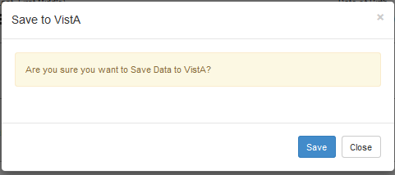

# Assessment Search Page

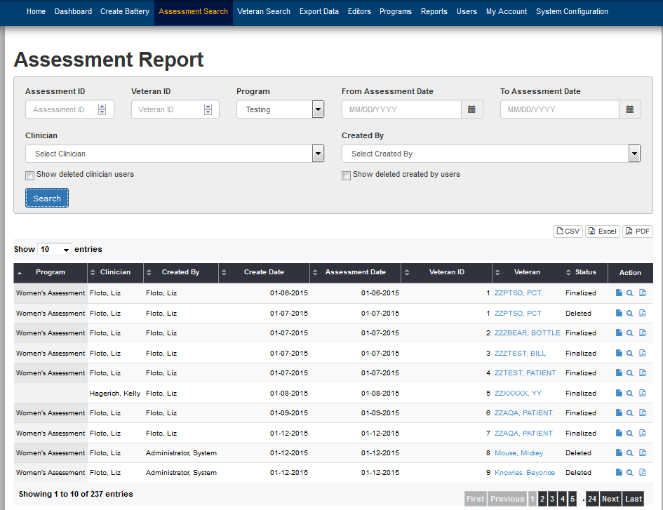

# Veteran Search Page

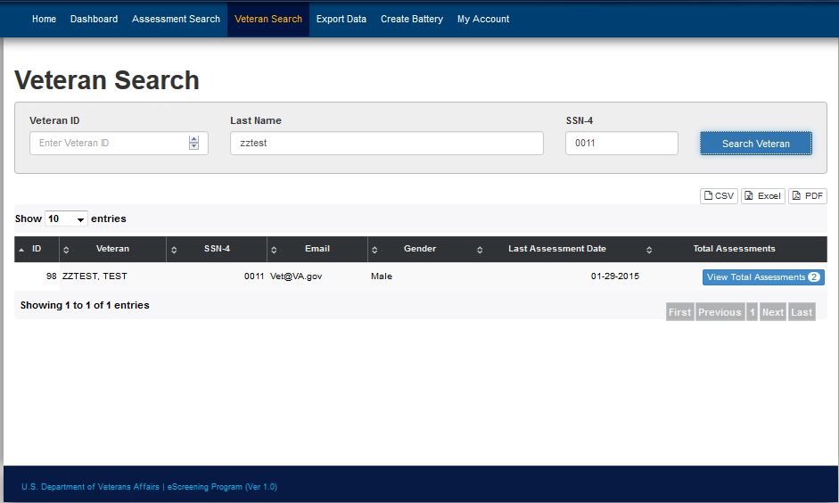

# Export Data Page

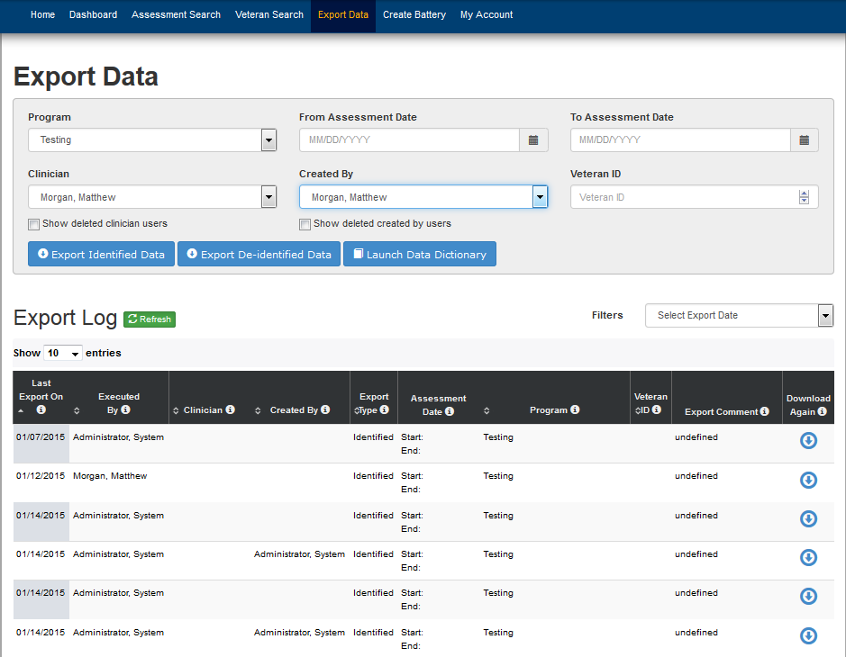

## Export Identified Data Prompt

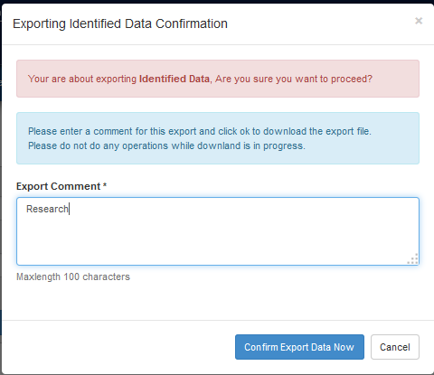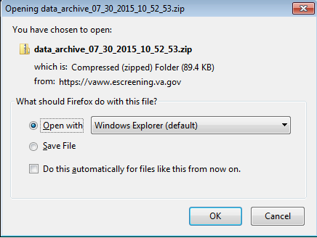

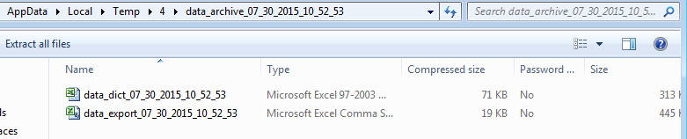

## Data Dictionary in Excel

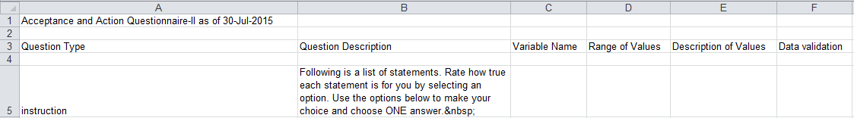

## Data Export in Excel

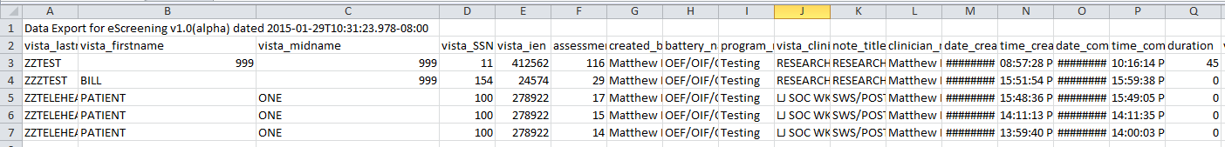

# Programs

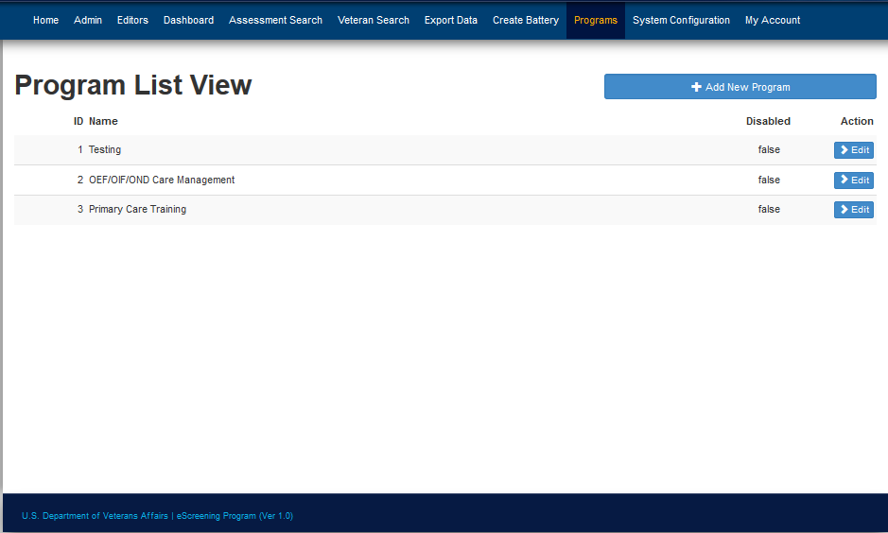

## Add New/Edit Program

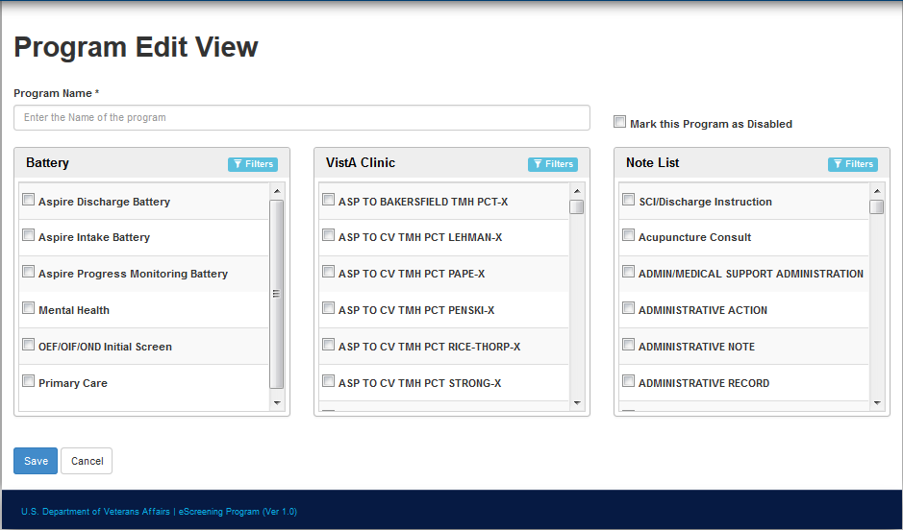

# Reports

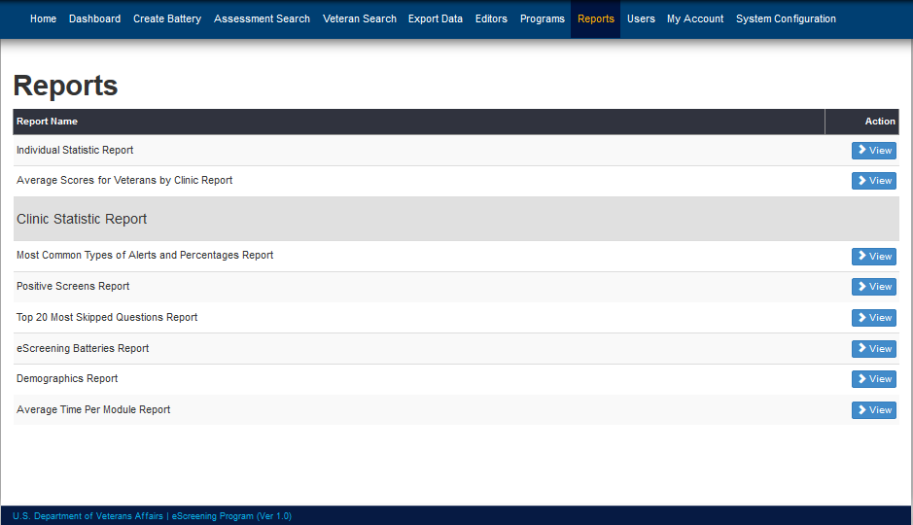

## Individual Statistic Report

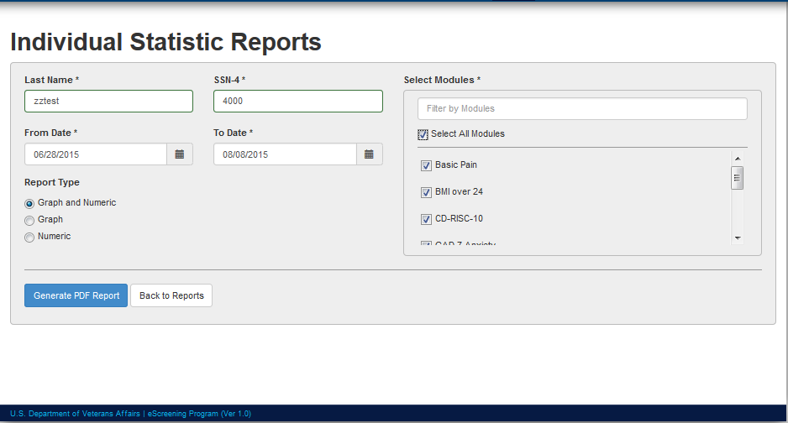

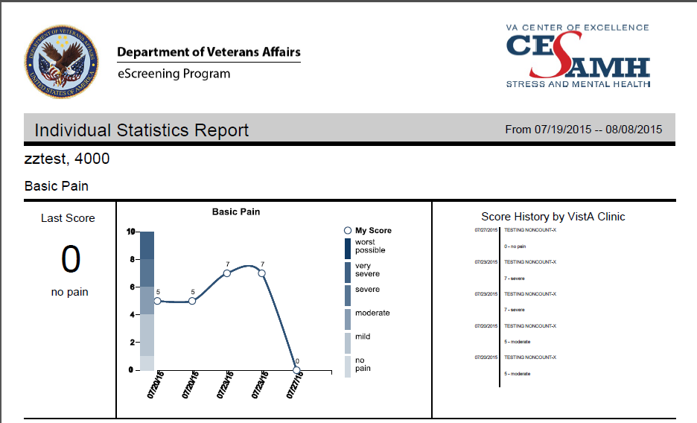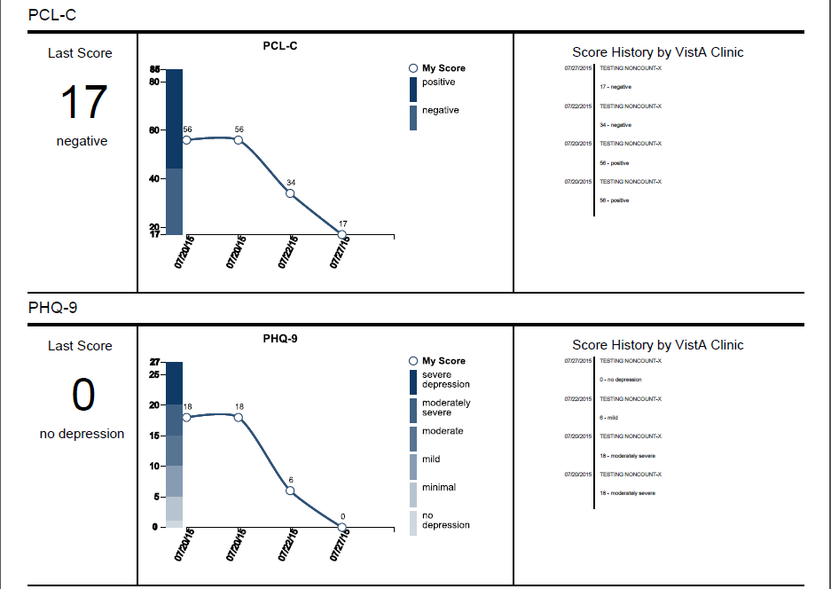

## Average Scores for Veterans by Clinic Report

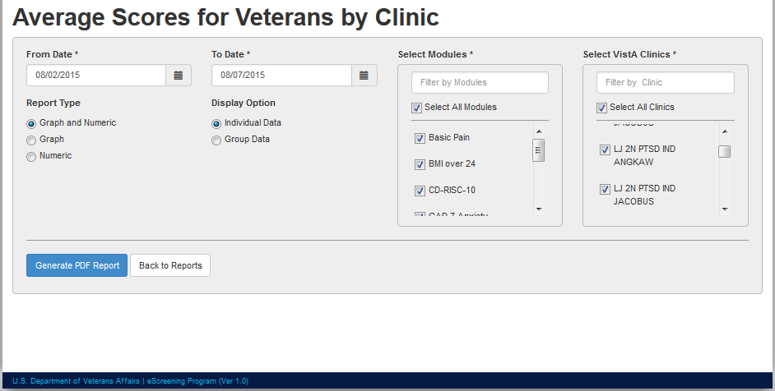

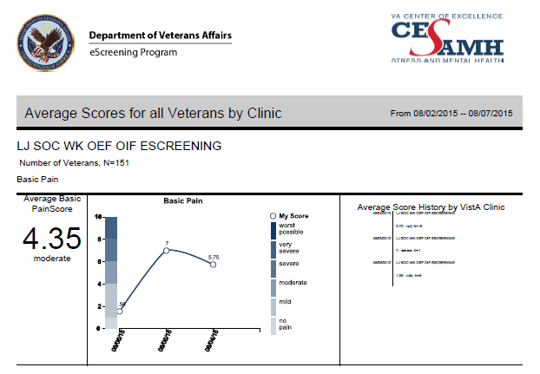

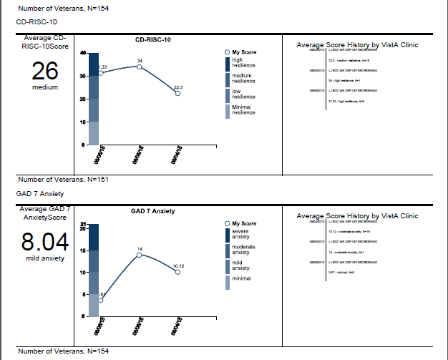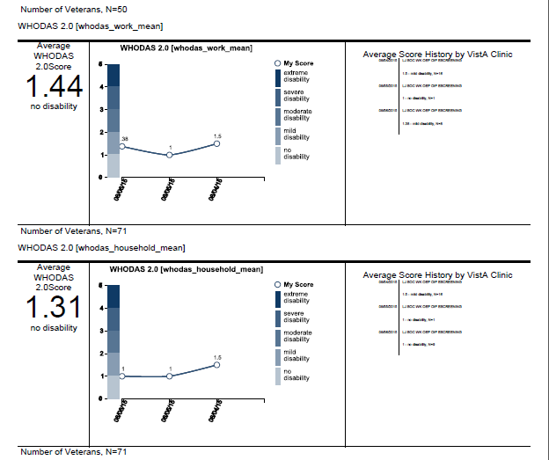

## Most Common Types of Alerts and Percentages Report

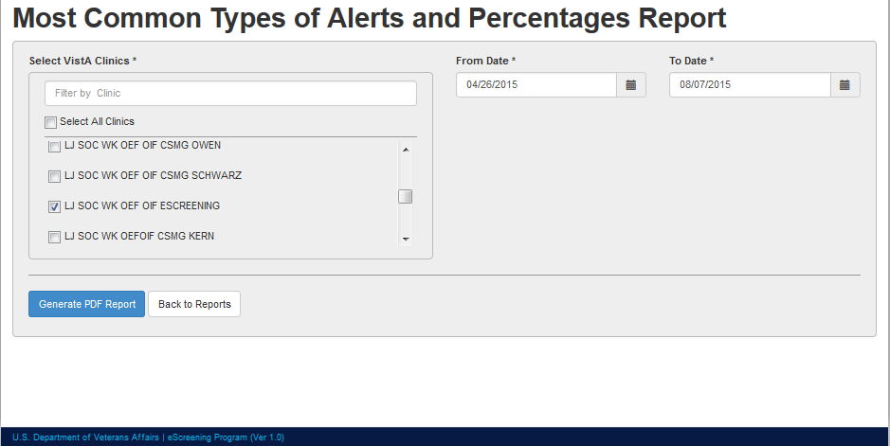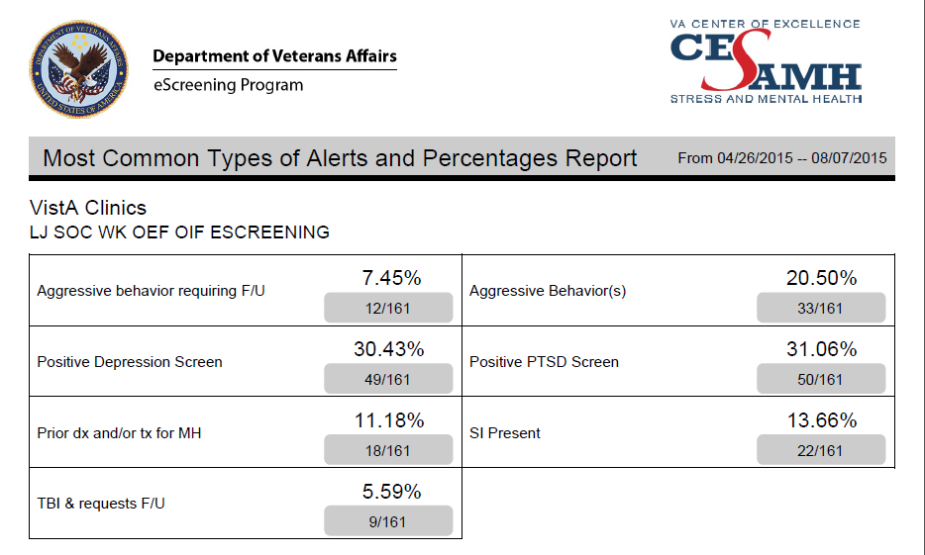

## Positive Screens Report

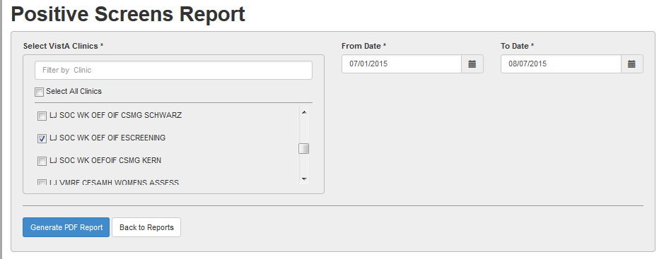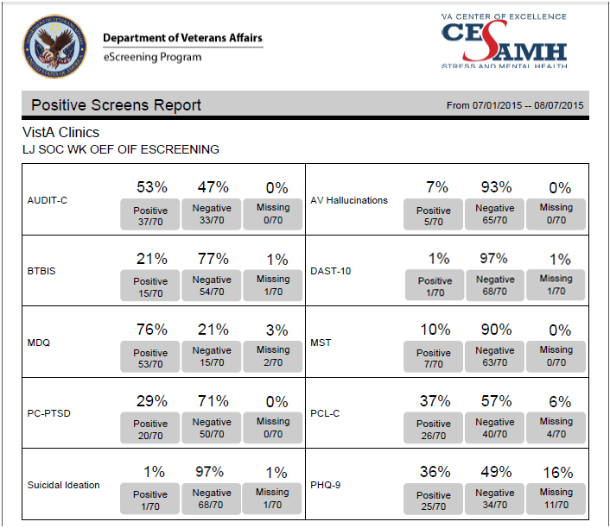

## Top 20 Most Skipped Questions Report

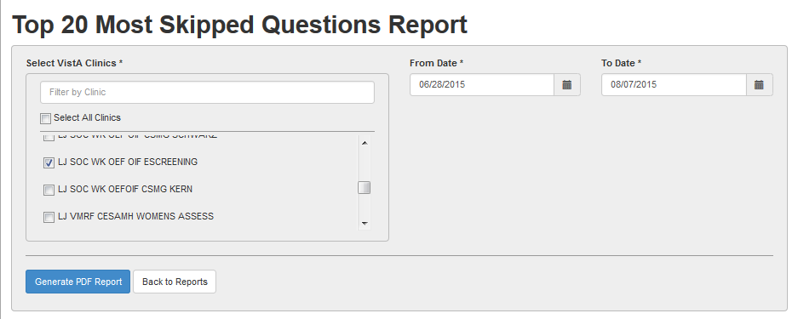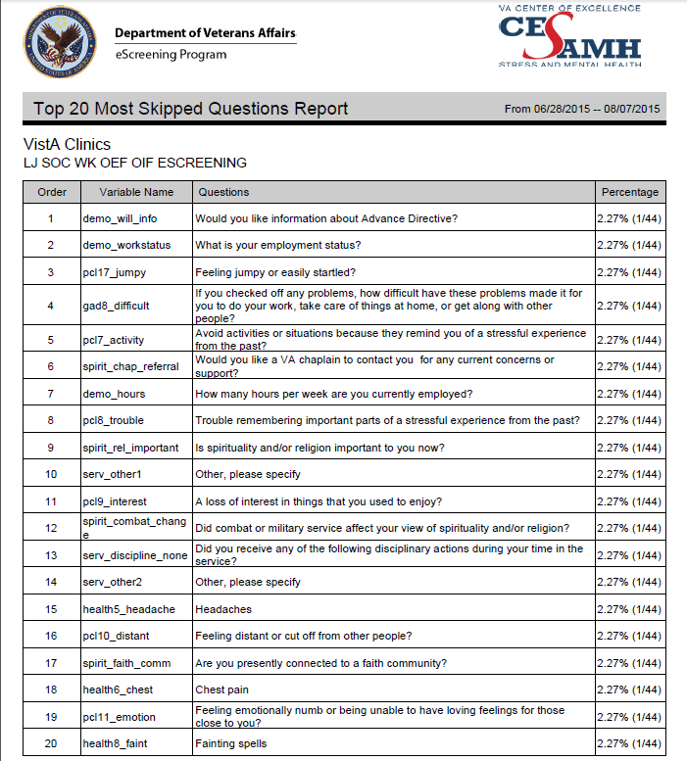

## eScreening Batteries Report

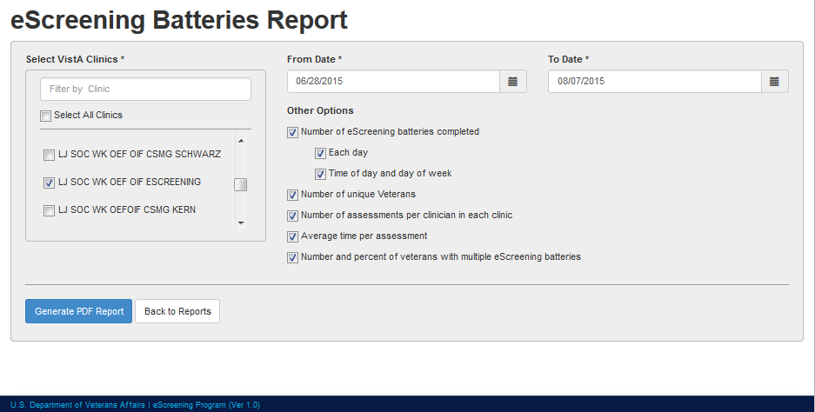

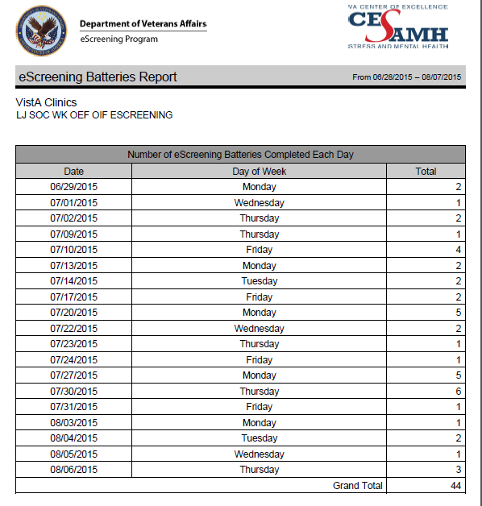

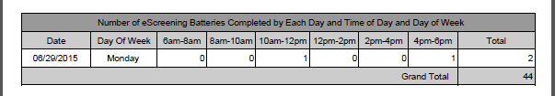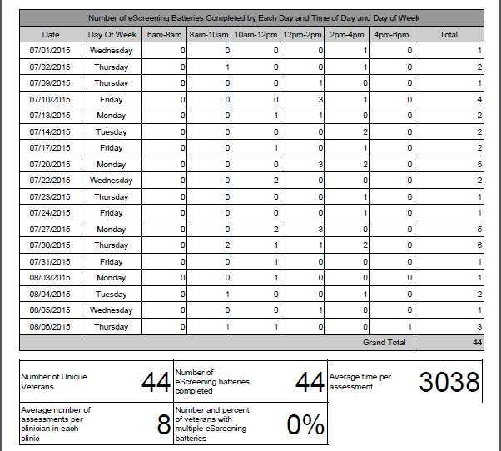

## Demographics Report

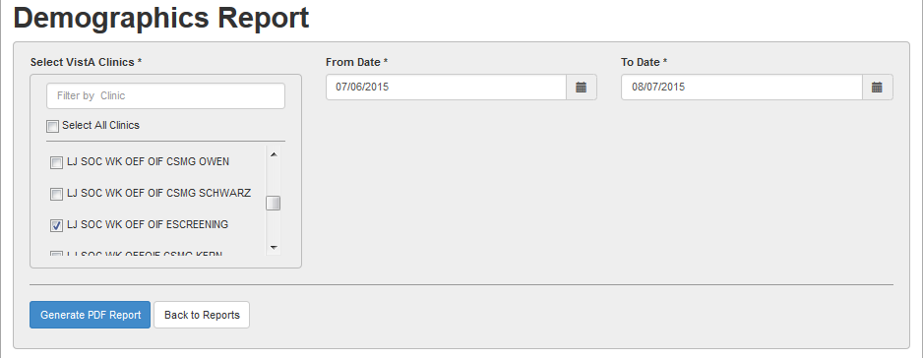

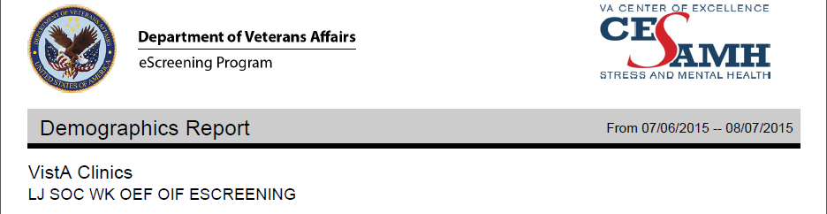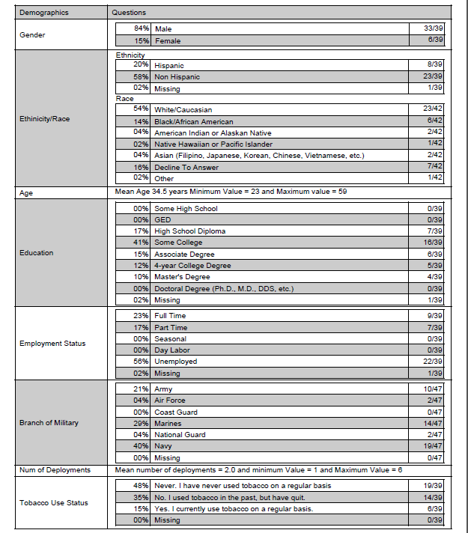

## Average Time Per Module Report

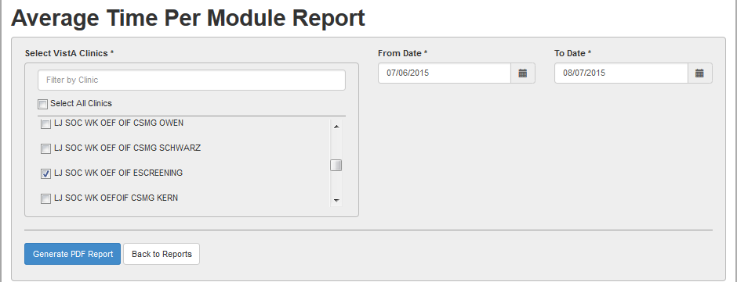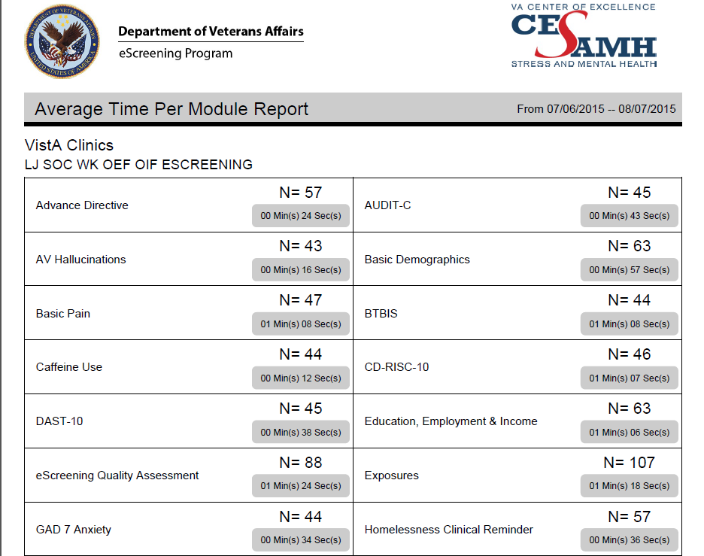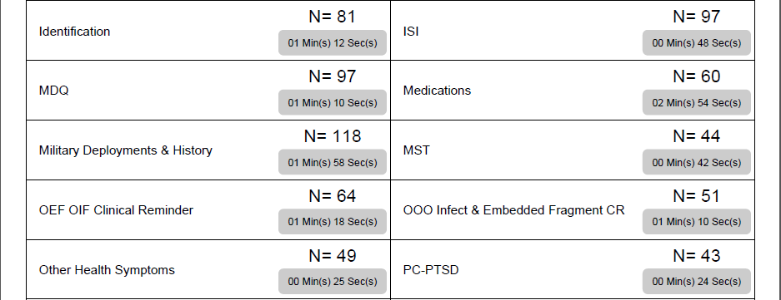

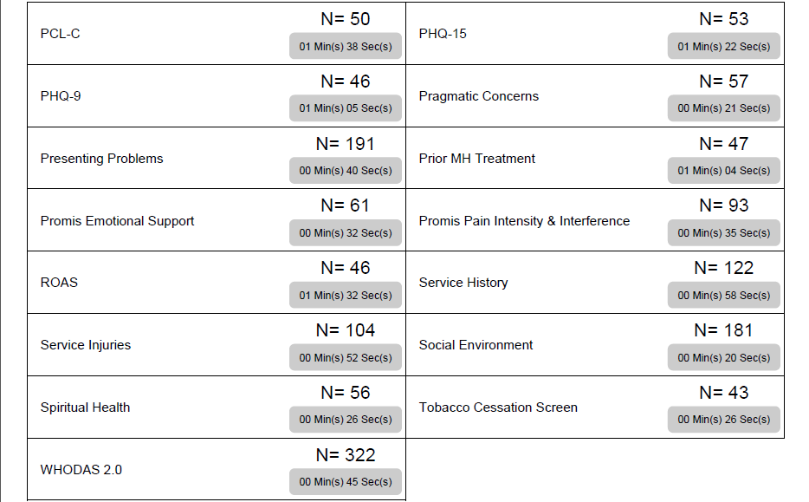

# System Configuration

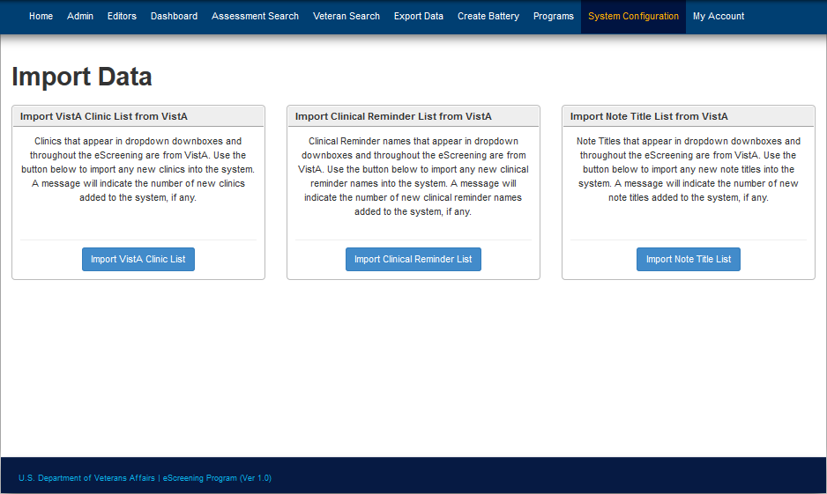

# My Account

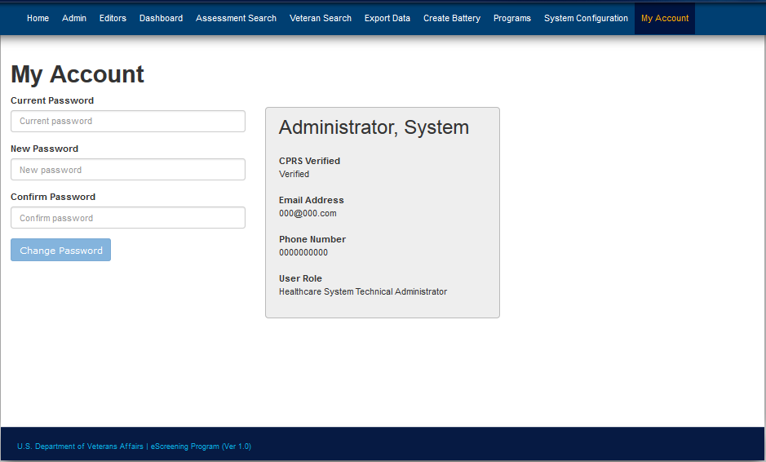

# CPRS

## Generated Note

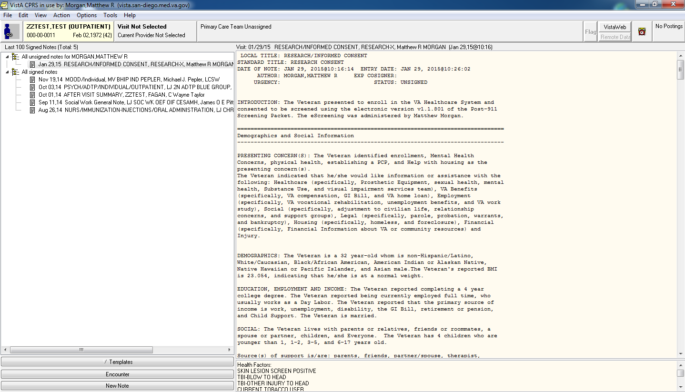

## Clinical Reminders

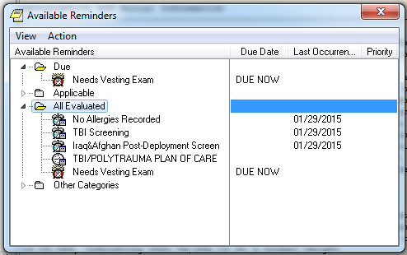

## TBI Consult



